Forecasting Ammonia Concentrations and Color Levels using Machine Learning for Reclaimed Water Treatment Operation and Management

Ting Hsi LEE

Water scarcity is a global challenge, and one of the promising ways to mitigate the water resource crisis is via wastewater reclamation. Water quality and aethetics are the primary concern in reclaimed water since undertreated water can pose health risks and unpleasant colour are likely to induce public misgiving. Ammoniacal nitrogen (NH $​_{3}$-N) and colour substances exist in the reclaimed water and can severly affect the reclaimed water quality in different ways. Chlorine is commonly used for reclaimed water disinfection and requires precise dosing to satisfy endorsed quality standards, however, NH $​_{3}$-N consumes chlorine and affects the chlorine dosing. Colour substances do not consume chlorine, but it requires additional efforts and strategies to remove them from the reclaimed water. Therefore, the on-line monitoring of NH $​_{3}$-N and colour are usually practiced in reclaimed water facilities for assisting the removal of both substances.However, the conventional on-line analyzers are wet-chemistry-based, and the measurement takes time. The limitation creates a potential issue: there may not be sufficient time for the downstream chlorine dosing system to respond to sudden surges in color and ammonia levels. To tackle this challenge, this thesis work developed time-variant models based on machine learning to predict the NH $​_{3}$-N concentrations and colour levels in the reclaimed water three hours into the future. For the training dataset, the NH $​_{3}$-N and colour data were collected by an on-line analyzer and a customized auto-sampling spectrophotometer, respectively. Both are installed in a reclaimed water treatment facility in Hong Kong. Baseline models for forecasting ammonia concentrations and colour levels were first developed with five machine learning algorithms. Long Short-Term Memory (LSTM) was found to be the most effective algorithm, with the lowest MSE values of 0.0405 and 0.0148 for ammonia and colour forecasting models, respectively. In the training processes, novel data pre-processing methods and feature engineering techniques were implemented to enhance predictive model performance. The data pre-processing methods were proved to enhance the quality of training datasets and improved the performance of ammonia and colour forecasting models by reducing the MSE values by 4.2% and 8.1%. The feature engineering results supported that the daily fluctuations in NH $​_{3}$-N and colour have correlations with the urban water consumption patterns. This finding further enhanced the NH $​_{3}$-N and colour forecasting model performance by reducing MSE by 8.9% and 28.6% compared to baseline models. The established models can be used to assist the disinfection control strategies based on the model predictions with the use of traditional process control systems. This research offers novel methods and feature engineering processes for NH $​_{3}$-N concentrations and colour levels forecasting in reclaimed water for treatment optimization.

# 1 Introduction

## 1.1 Background

Urban water challenge increases as the cities grow larger. The World Bank estimates that the urban population worldwide will double by 2050—with severe implications of escalating water demands in cities by 50–70 percent (TheWorldBank, 2021). Global climate change has primarily affected the amount, distribution, and quality of the available fresh water in the urban water cycle. The report from (UNICEF, 2021) points out that one in four cities is facing challenges in supplying adequate water to inhabitants, and the situation is even worse in cities in the developing world. The rise of urban water usage will generate more wastewater. Thus, converting municipal/industrial wastewater into reusable water has recently drawn much attention. Reuse water increases availability by substituting freshwater for non-potable (drinkable) uses for agricultural irrigation, industrial and urban water reuse, etc. The alternative reuse water can supply many activities and save drinking water for other purposes elsewhere (Adewumi et al., 2010).

The construction of reclaimed water facilities often requires a huge amount of capital investment. Upgrading available wastewater treatment plants with reuse water treatment facilities is an economical solution accompanied by the potential of realizing resource recovery (e.g., nitrogen and phosphorus recovery) (Kehrein et al., 2020; Maryam and Büyükgüngör, 2019). The primary concern of reusing treated wastewater is the potential risks caused to public health. Under unexpected circumstances, the reclaimed water facilities can produce unqualified reclaimed water, which is harmful to the living beings (i.e., as reused water is ingested directly or through irrigated crops) and irrigated soil (Adewumi et al., 2010). In Hong Kong, reclaimed water quality is regulated with up to 10 or more water quality parameters, and any parameters that fail to meet the standard will lead to disqualification. The common practice for controlling the treated water quality is achieved through water quality control strategies. The market controllers have evolved from a simple on-off logic controller called Programmable Logic Controller (PLC), to a more advanced multi-step response controller called proportional-integral-derivative (PID), and finally to the controller consists of machine learning models.

The uses of machine learning models in the water quality controllers for assisting water quality control strategy are ground-breaking applications. Many research papers have proposed various machine learning models for replacing the PLC and PID controllers and demonstrated the benefits of machine learning models. From the study of (Librantz et al., 2018), PID and machine learning-based controllers were deployed to compare the operational costs of dosing the chlorine to the setpoint concentration in a drinking water treatment plant. The results showed that the Artificial Neural Network-based model has a more satisfactory cost reduction in a chlorination dosing control system than the PID controller. Another research finding suggests using a Support Vector Regression (SVR) model as the controller required less time to reach the setpoint concentration of free chlorine residual compared to the PID controller in both simulation and experimental conditions Wang et al. (2020). Incorporating machine learning models in traditional process control systems has also been practiced by Santín et al. (2015) for avoiding violations of total nitrogen in the effluent using the decisions made by Artificial Neural Networks. Long Short-term Model was also used to predict which process control strategy should be selected for eliminating violations of total nitrogen concentrations in the effluent (Pisa et al., 2019). Forecasting water quality or predicting future events using machine learning are proved to be effective measures for controlling effluent water quality in wastewater treatment plants, making these approaches to be promising solutions for the reclaimed water treatment operation and management.

The superior performance of machine learning models comes from training high-quality datasets with a good amount of data that can fairly represent the system’s dynamic. Most studies have only focused on evaluating the model performance by comparing the test loss values between models and the improvements over PID controllers without considering the collected dataset’s quality. The noises in the data and the number of features (i.e., inputs or variables) are the two critical factors affecting machine learning models’ accuracy and robustness. Many data pre-processing techniques are proposed and applied to enhance the dataset’s quality. For instance, some papers discussed pre-processed data for removing the noise in raw datasets using data smoothing filters (Cheng et al., 2020), or creating new features in addition to the original ones (Mamandipoor et al., 2020) to achieve data augmentation. Despite the efforts being made, the influences of the proposed data pre-processing techniques on the final model performance have not yet been established.

Machine learning models for water quality control have two main types of algorithms, regression and classification. The former provides forecasting results of specific values, while the latter offers a decision of yes or no (i.e., 1 or 0). The regression model is also called the forecasting model, which plays a vital role in water quality control in drinking water treatment plants (DWTPs) and wastewater treatment plants (WWTPs). The forecasted results can be effectively used to provide critical information for the water quality control strategy. The need to use forecasting models is to cope with the unpredictable nature of water quality and to plan control strategies ahead. Without future information, the treatment operations are less likely to guarantee the production of effluent quality satisfying the government regulation (Chen et al., 2003) regardless of how the influent water quality may vary daily. In the reclaimed water system in Shek Wu Hui Effluent Polish Plant (SWHEPP), forecasting models are recommended for effluent treatment management and operation. From the available datasets, we noticed SHWEPP effluent contains ammonia concentrations and colour levels which exceed the reclaimed water standard. To generate non-potable resue water, it is critical to use on-line data to assist water quality control strategy. Currently, the available on-line sensors on-site are limited. Although the model can only train on limited data, it is still possible to train forecasting models with one feature, known as the univariate forecasting model. In this study, we will attempt to install one more on-line sensor and build machine learning models for forecasting water quality parameters in the reclaimed water system. Meanwhile, data pre-processing techniques will be proposed and evaluated to address the research gap of insufficient understanding of data pre-processing in modeling in the reclaimed water system.

## 1.2 Objectives

The specific objectives of this thesis work are:  
(1) To build baseline univariate forecasting models using machine learning and deep learning models.  
(2) To develop data pre-processing techniques for removing data noise for enhancing model performance.  
(3) To extract relevant information from reclaimed water system using domain knowledge for feature engineering.  
(4) To create new features for augmenting dataset’s quality for further improving forecasting model performance.

## 1.3 Organization of the thesis

In Chapter 1, “Introduction,” the background information, objectives, and organization of the thesis were presented.

Chapter 2, “Literature Review”, provides an overview of water quality control strategies in water treatment plants, wastewater treatment plants, and reclaimed water systems.

In Chapter 3, “Materials and Methods,” the instruments for data collection of ammonia concentrations and colour levels, computer programming environment, and data preparation techniques were summarized. The processes of formulating extra features for training forecasting models were illustrated.

In Chapter 4, “Results and discussion,” the performance of machine learning and deep learning models were compared. Forecasting models trained by different data pre-processing techniques and the influences of feature engineering on model performance were compared with the baseline model performance in test loss.

In Chapter 5, “Conclusions and Recommendations,” the findings obtained from this thesis work were summarized, and possible future studies were recommended.

# 2 Literature Review

## 2.1 Introduction to water quality control

### 2.1.1 Automated system for water quality control

A programmable logic controller (PLC) is an industrial computer system designed for any process requiring a series of devices and equipment to operate cohesively to achieve multiple purposes in manufacturing or treatment processes. The main components of PLC include a central process unit (CPU), input modules, and output modules (I/O). CPU is responsible for processing digital signals from input modules and sending commands through output modules based on the control logic programmed on the PLC. For chemical dosing control in water treatment plants (WTPs), the PLC system receives readings from turbidity and pH sensors and uses pumps to dose aluminum solution automatically (Andhare and Palkar, 2014). The PLC system with the capability of producing real-time output commands in response to the input signals also makes it widely used in wastewater treatment plants (WWTPs). For oxygen concentration control in the aeration tank, the PLC system receives signals from dissolved oxygen (DO) detectors and transmits signals to open or close the electric butterfly valves to alter the DO concentration (Zhu and Qiu, 2017). Although PLC systems are the most used systems across industries for their easy programming and reliable control, PLC system is merely a device that can be programmed to control operative devices with on-off logic (i.e., a logic control with two states). The straightforward implementation of the PLC system compromised its ability to perform complex tasks in a more dynamic water treatment environment. In reality, many WTPs or WWTPs require precise control of the treatment processes. Being aware of the limitations of the PLC systems, a more advanced controller called proportional–integral–derivative (PID) controller for receiving analog signals was developed to obtain more sophisticated controls over the operative devices.

To react to rapidly-changing environments in wastewater treatment plants, a PID controller generates an output value based on the continuous calculation of an error value e(t), which is the difference between the desired setpoint (SP) and a measured process variable. Then, the controller applies a correction based on proportional, integral, and derivative terms in the control functions. The use of the "P," "I," and "D" allows the system to quickly reach steady-states with feedback control systems (i.e., the system output is returned to the system input, which is included in the decision-making process of PID controller). Generally speaking, a PID controller is a technology (i.e., a specialist algorithm) for controlling a single device with more complex logic, while a PLC system is a physical system consisting of different modules capable of controlling dozens of devices only with two-state logic. In addition, A PID controller can be designed to operate on a PLC device and provide a more specific control strategy to a designated device. In WWTPs, a single-variable feedback analog control loop in PID can be used to control the temperature in the activated sludge treatment by stabilizing the system temperature in a shorter time (Bados and Morejon, 2020). The feedback control scheme is also applied in DWTPs to adjust the addition of chlorine dosage (i.e., also known as the disinfection process, chlorination, or post-chlorination) to reach the target concentration of free chlorine residual (FRC) (Wang and Xiang, 2019). The disinfection process is carried out in a chlorine contact tank, which provides sufficient time for the chlorine to disinfect pollutants. Since the chlorine added by the dosing device requires time to travel from the entry to the exit, the system output can only reflect the changes in water quality in a delayed time of 30 minutes. In the case of chlorination, the time lag makes feedback control difficult (Kobylinski et al., 2006) as the system is delayed in responding to any sudden surge of the pollutants when it can only receive output at the end of the disinfection process. PID controllers in WWTPs also encounter similar challenges as the increasing complexity of water quality and stricter regulations on the discharged water quality.

Many control strategies are proposed to address the challenges encountered in the process control system. For instance, feed forward-feedback control, linearized and optimal control, model-predictive control, fuzzy control (Demir and Woo, 2014), etc. Among the algorithms used in control strategies, Artificial Intelligence (AI) modeling has gained the most attention in recent years compared to modeling based on mathematical or empirical formulas. In DWTPs or WWTPs, fully understanding the treatment plants’ physical, biological, and chemical interactions is very difficult. The unpredictable behaviors during the water treatment can be the significant changes in influent flow rate, water quality fluctuations, the complexity of the biological treatment process, and the large time delay between control variables and the process inputs, etc. Therefore, AI modeling shows great potential in dealing with the highly complex conditions in the treatment process (Li et al., 2021). The next sections will discuss the applications of different AI modeling methods.

### 2.1.2 Artificial Intelligence

Artificial intelligence (AI) can perform cognitive tasks with the development of computational solutions. The concepts of AI are usually confused, and in fact, AI is a broad term, and any kind of algorithms or models involved in decision-making with computation fall in the domain of AI. For example, AI can be fuzzy logic and optimization algorithms, which are formulated with human design and involved in the computer decision-making processes. Another subset of AI is called machine learning (ML), but generating an ML model is different from generating a fuzzy logic model. ML uses learning algorithms to generate a model via learning from the historical or large amount of data without being explicitly programmed. ML algorithms can be classified into three categories, which are Supervised, Unsupervised, and Reinforcement learning. In the training process of supervised learning, input variables (x) and output variables (Y) will be provided. The model will learn from the provided datasets to map the x to the Y. A supervised model can generate a prediction based on the new input data (i.e., also called the unseen data). Unsupervised learning is when the dataset is not labeled, the model can learn to infer patterns in the dataset without reference to the known outputs. This type of algorithm can find similarities and differences in the data. In reinforcement learning, models are designed to constantly interact with the environment in a try-and-error way and receive rewards and punishments based on the purpose of the tasks. Generating an optimal action to achieve the lowest penalties is the primary function of a reinforcement learning model. Supervised learning is commonly used for machine learning in water quality control strategies. Regression is a supervised machine learning technique used to predict continuous values. A regression model can estimate the relationship between the input variables in the system and the output target from given datasets and then use the nonlinear relationship to map the unseen input data to predicted output data. This type of applications best fits for water quality prediction (Librantz et al., 2018), and sensor fault detection (Cecconi and Rosso, 2021), etc.

### 2.1.3 Machine learning and deep learning

In machine learning, popular models which researchers frequently use for training predictive models are Supporting Vector Machine (SVM), Random Forest (RF), and Artificial Neural Networks (ANN). RF models are popular due to their superior performance compared to typical machine learning algorithms. Xu et al. (2021) built an RF-based model to predict total nitrogen concentration in water bodies and proved RF models outperformed models such as K nearest neighbor (KNN), Ridge Regression, and Multilayer Perceptron (MLP). The other two widely used models, ANN and SVM, were compared carefully with the reliability and accuracy in predicting 1-day interval T-N concentration in a WWTP (Guo et al., 2015). The results showed that the SVM model has higher accuracy while the ANN model is more reliable for decision-making. Although most of the studies did not focus on the underlying causes of why SVM, RF, and ANN models have more excellent model performance, it would still seem that these models are reliable options for predicting water quality empirically.

As the computing power doubles every 18 months according to Moore’s law, implementing Deep Learning (DL)—a subset of machine learning, requires less and less computing time and becomes universal for researchers to solve everyday tasks. One way to explain a DL model is with the definition of having neural networks with more than two hidden layers (i.e., the model complexity increased and required more computing power to calculate). In DL, various architectures are specifically structured based on the problems we attempt to solve. For image processing, Convolutional Neural Network (CNN) is designed to extract essential features from the image vectors. Another famous DL architecture is the Recurrent Neural Network (RNN), which is powerful in solving time series-related applications and Natural Language Processing (NLP) tasks (Li et al., 2018). In particular cases, different DL architectures can be stacked in series to solve specific tasks. A rainfall-runoff prediction model was built using CNN and RNN (Li et al., 2022). The raw data features were extracted by convolution and entered into the RNN models for processing time-series patterns. The results showed a low Kling–Gupta efficiency (KGE) of 0.75 in the high-water period. DL models can be compelling when multiple architectures are stacked into a single model to perform a specific task, which machine learning models cannot realize. That being said, DL models can achieve higher model performance in terms of prediction accuracy compared to ML models.

## 2.2 Water quality control with machine learning

A drinking water treatment plant (DWTP) produces potable (i.e., drinking water) water for human consumption by removing contaminants from the source water, such as lakes or streams, or from underground aquifers. The raw water enters DWTPs and goes through treatment units of coagulation, flocculation, sedimentation, filtration, and disinfection in sequence as the primary treatment scheme in the conventional DWTPs (Li et al., 2021). During the treatment process, colloids, suspended matter, pathogenic microorganisms, and organic matter are removed to meet the regulated standard. However, raw water quality is not always stable, and corresponding actions must be promptly adopted when events like the surge of pollutants or the large variability of the influent flow. In any event, the treated water from DWTPs should generate drinking water that complies with the World Health Organization’s Guidelines (i.e., WHO guideline) for drinking water quality. Otherwise, the treated drinking water would either be discharged, resulting in the short-term outage of water supply to the downstream cities; or the users will receive contaminated drinking water, which can transmit diseases and cause illness.

Turbidity is one of the critical water quality indicators, which can be defined as the "optical quality" of water. The unit describing the turbidity is the Nephelometric Turbidity Unit (NTU). High turbidity levels in raw water can impede the effectiveness of filtration and chlorination processes and potentially cause short-term outages of the water supply. Heavy rainfall and fissures within the aquifer can also lead to turbidity events that are most likely to cause high turbidity (World Health Organization, 2017). The challenge in the event of high turbidity in raw water is that it occurs rapidly, and mitigating activities must be actionable immediately. To address the sudden event of such, Stevenson and Bravo (2019) trained forecasting models based on general linear model (GLM) and RF to predict the time when the turbidity reaches higher than 7 NTU. The results indicate that both models can successfully predict the events (i.e., with accuracy between 0.81 and 0.86), and the RF model is found to have higher precision due to its ability to capture the nonlinear relationship between rainfall (mm) and turbidity (NTU).

To maintain operational costs and water quality in the coagulation process, the amount of coagulant, mainly subject to the turbidity and alkalinity in the raw water, is traditionally determined through manual sampling and analysis. Jar tests are designed to find the optimal chemical dosage for coagulation to remove the turbidity in raw water. The entire process includes on-site sampling and more than 40 minutes of laboratory work (Gani et al., 2017). To replace the laborious jar tests, Wang et al. (2022) proposed using principal component regression (PCR), support vector regression (SVR), and long short-term memory (LSTM) neural network to build predictive models for estimating daily chemical dosage. Compared with the linear PCR model, nonlinear SVR and LSTM models capture more relationships between the chemical dose (e.g., ferric sulfate) and the raw water quality based on a higher R-squared value of 0.70.

Disinfection is the last step of water treatment processes in drinking water treatment plants to generate safe potable water. In this step, chemical disinfectants such as chlorine, chloramine, or chlorine dioxide are added into the water to inactivate any remaining pathogenic microorganisms. However, the chlorination process requires precise dosing of disinfectant—too high will lead to the formation of disinfection byproducts (DBPs), and too low will result in insufficient levels of the residual disinfectant concentration. In both scenarios, the treated drinking water can pose health threats to the end-users. Although the PID controller can achieve automatic dosing of disinfectants according to the change in water quality, Wang et al. (2020) proposed a model predictive control based on machine learning models to improve the dosing process further. The study indicated that the predicted chlorine dosage from a Support Vector Regression (SVR) model could help the free chlorine residual in the water reach the setpoint concentration in a shorter time compared to the PID controller in both simulations and experimental conditions. Machine learning models can not only reduce the time required to reach setpoint concentration but also decrease the chemical usage required in DWTPs. An Artificial Neural Network-based model has proved to optimize the treatment operation by reducing the chemical usage in a chlorination dosing control system compared to using PID controller (Librantz et al., 2018).

The invariability of the raw water quality is always a big issue for disinfection. For instance, chlorine dose can be excessively dosed when the treated water contains fewer pollutants (e.g., non-organic matters and ammonia nitrogen). Exessive chlorine in water results in the waste of chemicals, which is reflected in the increased operational cost and the generations of undesired disinfection by-products (e.g., trihalomethanes (THMs), which are carcinogenic to humans). Xu et al. (2022) trained an ANN model for predicting the occurrence of THMs in tap water using simple and straightforward water quality parameters (e.g., pH, temperature, $UVA_{254}$ and residual chlorine ($Cl_{2}$)). Despite the fact that the results showed a good model accuracy in predicting for THMs (i.e., T-THMs, TCM, and BDCM), the applications of the model are largely limited in reality due to the lack of dataset regarding quantity and quality. In fact, the lack of high-quality datasets for training ML models is a common issue, which explains, until recently, mathematical or empirical-based AI models like fuzzy logic (Gamiz et al., 2020; Godo-Pla et al., 2021) is still widely used for process control in WTPs.

### 2.2.1 Wastewater treatment plants

Human activities produce wastewater and discharge it from homes, businesses, factories, and commercial activities to the sewage systems which connect to wastewater treatment plants (WWTPs). The function of WWTPs is to remove contaminants from sewage and water so that the treated water can be returned to the natural water body without dangering any living beings residing in the ecosystem. Undertreated wastewater can lead to harmful algal blooms or cause oxygen deficit in the water (i.e., low oxygen content can kill the fish). The steps for treating municipal wastewater involve three major categories—primary treatment, secondary treatment, and tertiary treatment. Most of the particular matters will be removed in primary treatment via settling or floating; a secondary treatment is mainly responsible for removing BOD $​_{5}$ in the biological processes; in the final tertiary treatment, membrane filtration, adsorption by activated carbon, and addition of disinfectant are applied optionally to further eliminate the undesired pollutants in the water.

Wastewater is categorized and defined according to its sources of origin. Domestic wastewater is water discharged from residential sources generated by kitchen wastewater, cleaning, and personal hygiene. Industrial/commercial wastewater is generated and discharged from manufacturing and commercial activities, such as the textile industry and food and beverage processing wastewater. Institutional wastewater is generated by large institutions such as hospitals and educational facilities. Regardless of the source of the wastewater, WWTPs have to achieve at least three sustainability targets: environmental protection (i.e., minimum pollutants discharge), social acceptance (i.e., human sanitary protection), and economic development (i.e., feasible operational and management costs) (Mannina et al., 2019). To effectively achieve these goals, process control is required to reduce energy consumption, improve effluent quality, and save costs in plant operation and management. The focus of this study is on discussing the development of using process control for treatment operation and management.

Under known operational conditions of a WWTP, machine learning models can be trained to assist the plant operators in optimizing treatment processes to improve effluent quality. Wang et al. (2021) proposed a machine learning framework, utilizing a model based on Random Forest to predict the effluent Total Suspended Solid (TSS) and phosphate (PO $​_{4}$). This study uses data from six on-line sensors (i.e., flow rate, TSS, pH, PO $​_{4}$, temperature, and total solids (TS) meters) across the treatment line to train the RF model. The results indicated that the influent temperature is the most influential variable for both TSS and PO $​_{4}$ in the effluent, and PO $​_{4}$ depends strongly on the TSS in aeration basins, etc. It has been suggested that the combined use of the RF model and analytical tools allows the author to pinpoint the critical factors influencing the effluent quality, which is regarded as an innovative approach. However, several significant drawbacks hinder such model developments using on-line sensors to collect training data. The term "training data" is a dataset used to feed into the model for the model to learn and pick up hidden patterns in the data. Many of the existing WWTPs and DWTPs are not equipped with on-line sensors, and a lack of automation and instrumentation is universal. The difficulties in installing on-line sensors include the extra costs of purchasing hardware, extra labor works for maintenance, and most importantly, the optimal locations for sensor installation.

In secondary treatment, the relationships between the sludge and wastewater quality are complex due to the complex interactions between the microorganisms and the organic matters in the reactor (Wilén et al., 2018). To fully understand and describe the interactions in such systems requires a substantial amount of data. However, installing on-line sensors everywhere in the system is impossible. Zaghloul et al. (2021) attempted to find out the ideal locations and adequate number for on-line sensor installation. The author used the data collected from the on-line sensors installed in three lab-scaled secondary treatment reactors to train machine learning models to predict effluent quality. In addition, considering the intricacy of operational conditions in the secondary treatment, the author claimed that with the use of feature selection and ensemble model (i.e., average results from multiple model outputs), overfitting could be prevented. The issue of overfitting can be understood as the model memorizing the noises too much in a training dataset, resulting the poor performance when the model is used to predict outputs from unseen data.

Like the secondary treatment units, an electrocoagulation reactor is also a complex system in which the operation and management are based on pH value, current density, flow rate, and the initial concentration of heavy metal ions, etc. Interestingly, instead of using an ensemble model to prevent the overfitting issue claimed by Zaghloul et al. (2021), Zhu et al. (2021) used a deep learning Long and Short-term model (LSTM) and an error compensate Autoregressive Integrated Moving Average model (ARIMA) to predict the removal rate of heavy metal ion concentration in wastewater. An LSTM-ARIMA model has strengthed the model performance compared to the solely used LSTM or ARIMA model in predicting removal rate shown by the Results. A possible rationalization of using an LSTM model without worrying about model overfitting is that deep learning is sophisticated enough for learning the nonlinear patterns in complex systems, while machine learning models like RF might fail to capture the intricate relationships, resulting in overfitting.

Technological advancement allows easy access to real-time water quality data via on-line sensors. The collected real-time data can be used to train predictive models and assist the plant operation and management. Despite the advantages of what on-line sensors are capable of, sensor calibration and maintenance are critical. The malfunctioned sensor can induce wrong decisions for plant operation, ultimately deteriorating treatment efficiency in WWTPs. Haimi et al. (2015) suggested that reliable and moderately-priced on-line sensors are not always available; in addition, sensor malfunctions (i.e., fouling or erroneous measurement) can cause the down-time of the sensors. For the unavailable sensors (i.e., "hard-to-measure" or expensive sensors), many research works have proposed building "soft sensors." Instead of using hardware sensors to measure the water parameters, the soft sensor generates real-time values through a machine learning model, which is trained by other easy-to-measure water quality data. In the works of Wang et al. (2019), easy-to-measure variables such as pH, flow rate, TSS, and ammonium nitrate (NH $​_{4}$-N) are input to machine learning models to predict hard-to-measure water quality parameters of COD and total phosphate (TP). Pattnaik et al. (2021) also used DO, pH, conductivity, turbidity, and temperature to train a model to predict BOD. It is believed that both research works can solve the issues of the unavailability of specific water quality sensors.

The automated treatment operation and management heavily rely on the reliability of the on-line sensors; thus, preventing and the early detection of sensors malfunctioned is the utmost concern to the plant operators. Sensor fault detections can be categorized into three groups which are (1) individual faults— outlier data that can be distinguished concerning other data points; (2) contextual faults—an anomalous instance in a specific context and normal in another; (3) collective faults—a cluster of rare instances with respect to other data trends (Chandola, n.d.). Many research papers have proposed using machine learning models to help identify sensor fouling.

Two main algorithms, regression and classification, can be used to find fouling signals. A regression algorithm can identify fouling signals by calculating the difference between model-predicted outputs (e.g., ammonium or COD concentration) to the actual signals. A classification algorithm can distinguish fouling signals through the direct outputs of the model (i.e., the model outputs 2 class labels, one represents normal, and the other is abnormal). Cecconi and Rosso (2021) proposed an ammonium fault detection mechanism, utilizing a regression ANN model, along with principal component analysis (PCA) and Shewhart monitoring charts (i.e., statistical control chart). The remarkable idea of this study is to analyze the residual between the predicted ammonium and the actual ammonium sensor signal and identify the individual and contextual faults with the help of statistical tools. Despite the fact that the accuracy of the fault detection mechanism can reach R $​^{2}$ value of 0.87, the method comes with significant limitations. The author points out that to maintain the high accuracy of the predictive model, the quality of the input data needs to be carefully attended to by performing manual cleaning procedures on a weekly basis.

Research has focused on solving collective faults in sensor fault detection rather than collective faults. The primary reason is that collectives faults are hidden in regular signals, and the expert can only discover the irregularity by comparing sets of signals in sereis. Thus classification technique using deep learning is proposed to address collective faults in the works of Mamandipoor et al. (2020). It is believed that this is the first research paper using an LSTM network to achieve a fully automatic fault detection method in WWTPs. In contrast to other works, input variables for model training heavily rely on the experts’ manual selection before inputting into models like PCA and fuzzy neural networks. The significance of using a deep learning network is its capability to capture long-term temporal dependencies from a large dataset compared to machine learning models (i.e., PCA-SVM model). The results showed that the accuracy (i.e., F1-score) from the LSTM model is 92%, outperforming the PCA-SVM model of 87%. This finding suggests that using DL models in classification problems is promising for solving collective faults.

### 2.2.2 Water reclamation system

The increasing demand for water in cities is mainly attributed to the rapid urbanization and the population moving from rural to urban centers. In many major cities, the evergrowing water usage and wastewater discharge drive the development of water reclamation (Lyu et al., 2016). In WWTPs, the technologies applied in water reuse include disinfecting with chlorine addition, ultra-violet (UV) irradiation, biological treatment, membrane filtration, etc (Norton-Brandão et al., 2013). However, even with the most advanced water treatment technology, the treated reclaimed water quality is still subject to the variability and variations of pollutant contents in wastewater effluent (Chen et al., 2003), and can potentially fail to meet the reclaimed water standard. The research studies propose to apply machine learning techniques to assist the disinfection process in water reclamation can be categorized into three groups (1) optimize the treatment management in WWTPs to alleviate the loadings of water reclamation process (Al-Ghazawi and Alawneh, 2021; Viet et al., 2021); (2) actively branch out the desired, and undesired wastewater effluent for subsequent disinfection process of water reuse or direct disposal into water body (Chen et al., 2003); (3) adapt process control methods to stabilize the disinfection performance in the reclaimed water system (Demir and Woo, 2014).

Technology advancement and research studies on water reuse have been discussed for more than two decades. However, there are not too many research publications that aim to improve the reclaimed water system as a whole in recent years. The economic reasons behind constructing water reuse facilities could be a major obstacle for the government sectors. The economic burden of either building new reclaimed water institutions in new locations or retrofitting existing WWTPs is overwhelming (Adewumi et al., 2010). To discover more values and reusable resources from water reuse, Chojnacka et al. (2020) takes the circular economy perspective into accelerating the process of adopting water reuse systems for agriculture production. The author introduces the potential of gradually replacing chemical fertilizers with partially treated wastewater for sustainable crop production despite there are many limitations to be overcome. In Italy, the circular concept is also studied by Colella et al. (2021). Four different resource recovery senarios were brought up, and two of the senarios include the nutrient recovery turned into nitrogen and phosphorus fertilizers. Several researchers in recent years have provided the overall potential and challenges of treated wastewater reuse in the world; it is believed the day of using reused water universally will soon come with collaboration across different disciplines.

Reclaimed water for non-potable reuses can serve for irrigation for agriculture, toilet flushing, and irrigation for landscaping, etc. Water Supply Department (WSD) will soon implement a reclaimed water supply system in SWHEPP by disinfecting the tertiary-treated sewage (i.e., MBR permeate). The produced reclaimed water will be served for non-potable reuse and is required to satisfy the water quality standards shown in Table. [tab:reclaimed-standard].

lcl Parameter & Unit & Requirement  
*E. coli* & cfu/100 mL & Not detectable  
Colour & Hazen Unit & $≤$ 20  
Ammoniacal Nitrogen (NH $​_{3}$-N) & mg/L as N & $≤$ 1  
Total Residual Chlorine & mg/L & $≥$ 0.2  
Dissolved Oxygen & mg/L & $≥$ 0.2  
Turbidity & NTU & $≤$ 5  
5-day Biochemical Oxygen Demand & mg/L & $≤$ 1  
pH & - & 6-9  
Threshold Odour Number & - & $≤$ 100  
Synthetic detergents & mg/L & $≤$ 5

## 2.3 Tools and techniques for enchancing the performance of machine learning modeling

### 2.3.1 Programming languages

Matrix Laboratory (Matlab) is a proprietary programming and numeric computing platform used across industries and academia for data analysis, algorithm developments, and model buildings. In the wastewater treatment industry, Matlab is known for using an add-on software called Simulink for modeling, simulating, and analyzing the dynamic system (i.e., chemically enhanced primary clarifier (Bachis et al., 2015). The use of Matlab-Simulink in the wastewater treatment industry is known for the development of control strategies for WWTP automation. In 1987, International Water Association (IWA) developed the first mathematical model for simulation-based evaluation, which is Activated Sludge Model 1 (ASM 1), and the modified activated sludge models and Benchmark Simulation Models (BSM) was further developed in the following years (Talib, 2011). The difference between the two is that ASM is designed for developing control strategies exclusively in the activated sludge treatment process, and BSM 1 is to develop the automation in the entire WWTP (Ballhysa et al., 2020).

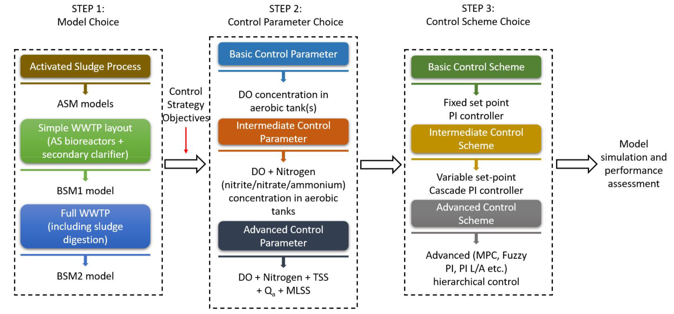

Proposed framework for control strategy design by Ballhysa et al. (2020).

In recent years, many publications presented an exciting way to demonstrate how machine learning-based model predictive control (MPC) can outperform the conventional PID controller in WWTPs using BSM. The researchers use Matlab-Simulink to simulate the treatment processes in WWTPs. At the same time, the block of PID controllers is replaced with machine learning models, and the effluent quality or treatment system performance can be differentiated via BSM simulated results. Wang et al. (2020) compared the stability of chlorinated water quality in the effluent of a DWTP with two control strategies, which are PID feedback controls and a predictive model-based support vector machine (SVM). The BSM simulated results showed that the SVM model required 21 minutes less to reach the residual chlorine setpoint than PID feedback controls. A proposed neuro-fuzzy PID controller (i.e., a hybrid machine learning model consisting of neural networks and fuzzy logic) also showed superior performance in optimizing the chlorine dosing rate to minimize the chance of errors (Hong et al., 2012). The significance of using BSM in Matlab-Simulink enables the performance of traditional and machine learning-based control strategies can be compared in objective and fair senarios, also providing the practicability of machine learning to the experts in the field. Matlab is a powerful and resourceful platform providing various machine learning functions, including point-and-click apps for training and evaluation, available classification and regression algorithms, Automatic machine learning (AutoML), etc (MathWorks, 2022a). The direct access to the abundant features and the integration of Simulink make Matlab an appealing option for many researchers in the wastewater treatment industry, especially in the research domain of machine learning and control strategy simulation. Despite the countless benefits of using Matlab, the Python programming language stands out differently.

Python is a high-level, interpreted, and object-oriented programming language and features simple and easy-to-learn syntax providing good readability (“What is Python? Executive Summary,” n.d.). The large developer community (e.g., GitHub and Stackoverflow) and open-source access (i.e., free of charge) have made Python an ideal tool for machine learning starters. The most cutting-edge research in the field of Artificial Intelligence is often led by Tech Giants like Google and Amazon, which conduct research via Python (e.g., machine learning frameworks of TensorFlow (Google)in Python), as well as the big research community using Python. All the latest updates and developments relating to machine learning architectures and techniques are usually accessible in the open-source Python community, including the example codes. Contrary to Python, users of commercial software Matlab need to wait for the software engineers working in Matlab to update the latest machine learning applications onto the Matlab platform, which is a time-consuming process and creates a delay of time and accessibilities to many resources (Castro, 2018). Machine learning developers in the wastewater treatment industry can freely choose between the programming methods based on the research need. Those looking for mature machine learning algorithms can simply use Matlab and be satisfied with the functionalities; on the other hand, those who intend to incorporate more new techniques and architectures in machine learning models can consider using Python as the programming language. Interestingly, MathWorks recently announced using Python functions in Simulink Model (MathWorks, 2022b); despite the update from Matlab, to the best of my knowledge, there are no research papers developing machine learning algorithms on Python and running on Matlab-Simulink.

### 2.3.2 Data pre-processing

The ubiquitous sensors installed in WWTPs for treatment automation generate a massive amount of data on a daily basis. Before being used for any purposes, the data must be understandable for explanation and relevant enough for water experts to extract valuable information (Kehrein et al., 2020). Without the help of Artificial Intelligence, data manipulation before training machine learning models can be time-consuming and challenging. The specifically designed algorithms can perform data evaluation and augmentation to improve data quality. Any statistical or machine learning algorithms which can complete these tasks are known as the data pre-processing techniques. The causes of sensors rendering undesired data with low quality are the limitations of the hardware sensors and the dynamics of the sampling locations. In general, the false data generated by sensors can be described in eight distinct states (Newhart et al., 2019; Rosen et al., 2008):

Operational: Sensor is working properly with normal measurement noise.

Excessive drift: When a sensor outputs a value progressively further from the truevalue.

Shift: When the output of the sensor is a constant amount away from its true value.

Fixed value: When the sensor is stuck and keeps repeating the same value.

Complete failure: Similar to a fixed value fault, but the sensors either give offthemaximum or minimum, value, zero or no value at all.

Wrong gain: When signals away from the calibration point are under- orover-amplified bythe sensor.

Calibration: The sharp change in sensor output directly following a calibration.

Isolated fault: When a single point in a series shows an incorrect value.

The researchers and experts have been proposing solutions for filling the data gaps created by sensor faults and maintenance operations. However, the number and length of missing values are mainly subject to the dynamics of the system being monitored and other factors. In their open-source wastewater data treatment toolkit,De Mulder et al. (2018) has recommended five data imputation strategies aimed at data generated from water resource recovery facilities:

Interpolate.

Use a correlation with other available measurement signals.

Replace with a corresponding value in an average daily profile.

Repeat the values obtained on the preceding day.

Replace with the output of a model.

The efficient monitoring of sensors and proper use of the data for developing control strategies in the wastewater treatment industry rely on careful data quality control. In recent years, automated data evaluation has drawn the attention of experts and researchers in this field as manual detection of sensor fouling is unrealistic because the tasks are labor-intensive and laborious. Alferes et al. (2013) presented three practical approaches for data quality validation, which are capable of automated calculating single abnormal values and collective faults over a long period. The author claimed that the significance of the research work is performing a data quality validation scheme on the multivariate dataset. The pitfall of the study is that despite the promising approaches proposed, the validity still depends on the thresholds or acceptability limits in the actual WWTPs. Similar to the data imputation strategies, the real situation differs tremendously across different WWTPs. That being said, instead of providing general guidance on how to manipulate data, the focus should be emphasized on how to use algorithms to help users understand, analyze, and process the fouling data.

### 2.3.3 Feature engineering

Feature engineering aims to enrich the raw dataset by selecting, manipulating, and transforming data, which forms a better dataset relating to the underlying targets to be learned by the machine learning model. Feature engineering and data pre-processing are easily confused with each other. The fundamental difference between the two is that the former creates essential features not included in the raw data; the latter is a data noise removal and cleaning process. In the study of Mamandipoor et al. (2020), feature engineering was performed to generate five extra features, which are the statistical metrics of mean, maximum, minimum, variance, and standard deviation of a specific input feature. However, in comparing the final results, the author only emphasized evaluating model accuracies across varied machine learning models (i.e, PCA-SVM and LSTM models). Another interesting technique used by Zaghloul et al. (2021) is to create the gradient values of an input variable to assist the model in better learning the trend of the historical removal rate of water parameters in aerobic granular sludge reactors. Similar to the results shown in the work of Mamandipoor et al. (2020), the influence of how engineered features affect the ultimate model accuracy is excluded in the results and discussion part. Thus, creating a lack of knowledge in how significant the feature engineered inputs are to the model accuracy and which techniques can be used in which senarios.

There is considerable ambiguity concerning the necessity of using feature-engineered inputs in training predictive models in WWTPs. In predicting total nitrogen (TN) in the effluent, Guo et al. (2015) input nine features and performed feature sensitivity analysis, which can capture the change of the output values attributed to the change input. The result showed that the top three most significant inputs, temperature, TN flow, and pH, are critical in predicting TN. The author claimed physical related cause-and-effect relationships between the effluent TN and those top three effective features could be elucidated by the machine learning model. In another work on predicting influent BOD concentration, the study clearly stated that using five inputs instead of three will cause model overfitting. Three inputs for model training were considered sufficient (Alsulaili and Refaie, 2021). Variables created from feature engineering have no physical properties, leading to extra unexplainable essence in addition to the black-box nature of machine learning models. Besides, extra model inputs from feature engineering can also cause overfitting if the data quality is not carefully evaluated. Said by Andrew Ng, "Coming up with features is difficult, time-consuming, requires expert knowledge. Applied machine learning is basically feature engineering". From the quote and the recent studies, we are uncertain how feature engineering techniques can practically help the development of machine learning models in the wastewater treatment industry. More research is required to elucidate further the effectiveness of performing feature engineering.

# 3 Methods and Materials

## 3.1 Wastewater treatment plant description

### 3.1.1 Process and data sources in SWHEPP

Shek Wu Hui Effluent Polish Plant (SWHEPP) is a secondary sewage treatment plant that treats the municipal wastewater from Sheung Shui/Fanling Districts and the treated leachate effluent from North East New Territories (NENT) leachate treatment plant. The plant was designed for 300,000 population equivalents (PE) in 2001, and in 2009, the daily treatment capacity was expanded from 80,000 m $​^{3}$/day to 93,000 m $​^{3}$/day. SHWEPP is operated and maintained by Drainage Services Department (DSD), and the plant will be upgraded to a tertiary treatment level to increase the treatment capacity of 190,000 m $​^{3}$/day by the end of 2025. As shown in Fig. 3.1, the treatment plant consists of primary sedimentation, secondary biological treatment, and final sedimentation, followed by a membrane bioreactor (MBR), which provides an advanced level of organic and suspended solids removal. A low volume of the MBR effluent is pumped to an effluent container n the MBR location to monitor the effluent quality in real-time. An ammoniacal nitrogen on-line sensor and a colour level on-line analyzer are installed in the effluent container, indicated as (a) and (b) in Fig. 3.1.

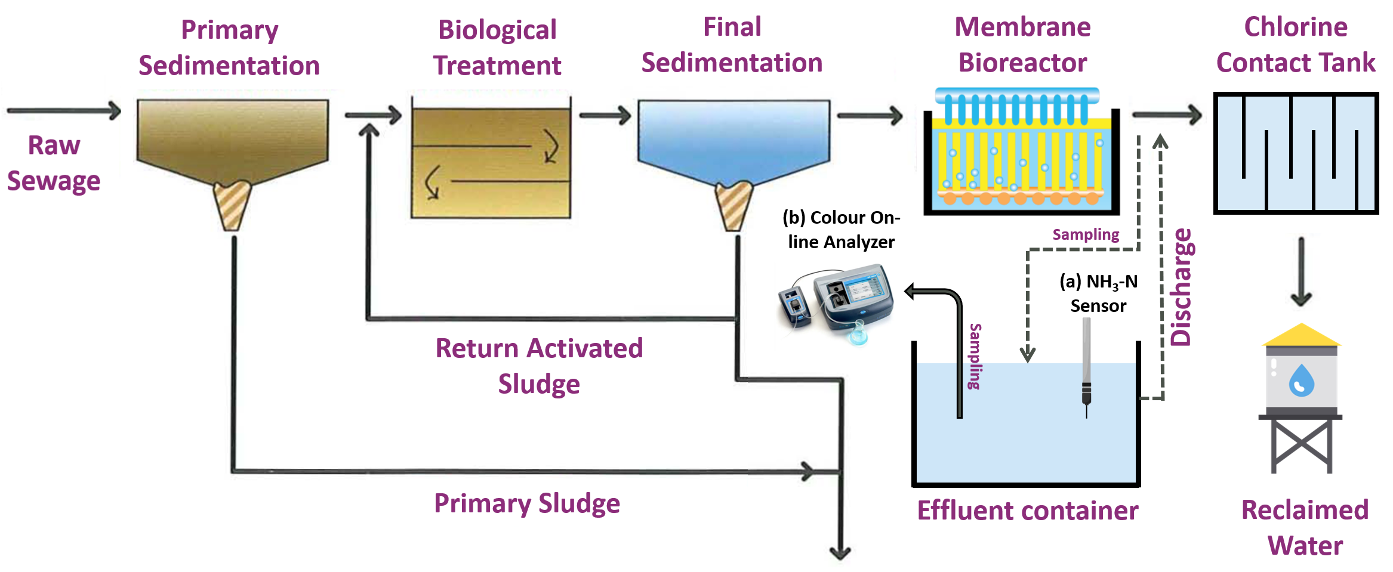

Sewage treatment process flowchart at SWHEPP (adapted from Drainage Services Department 2020)

## 3.2 Data collection and preparation

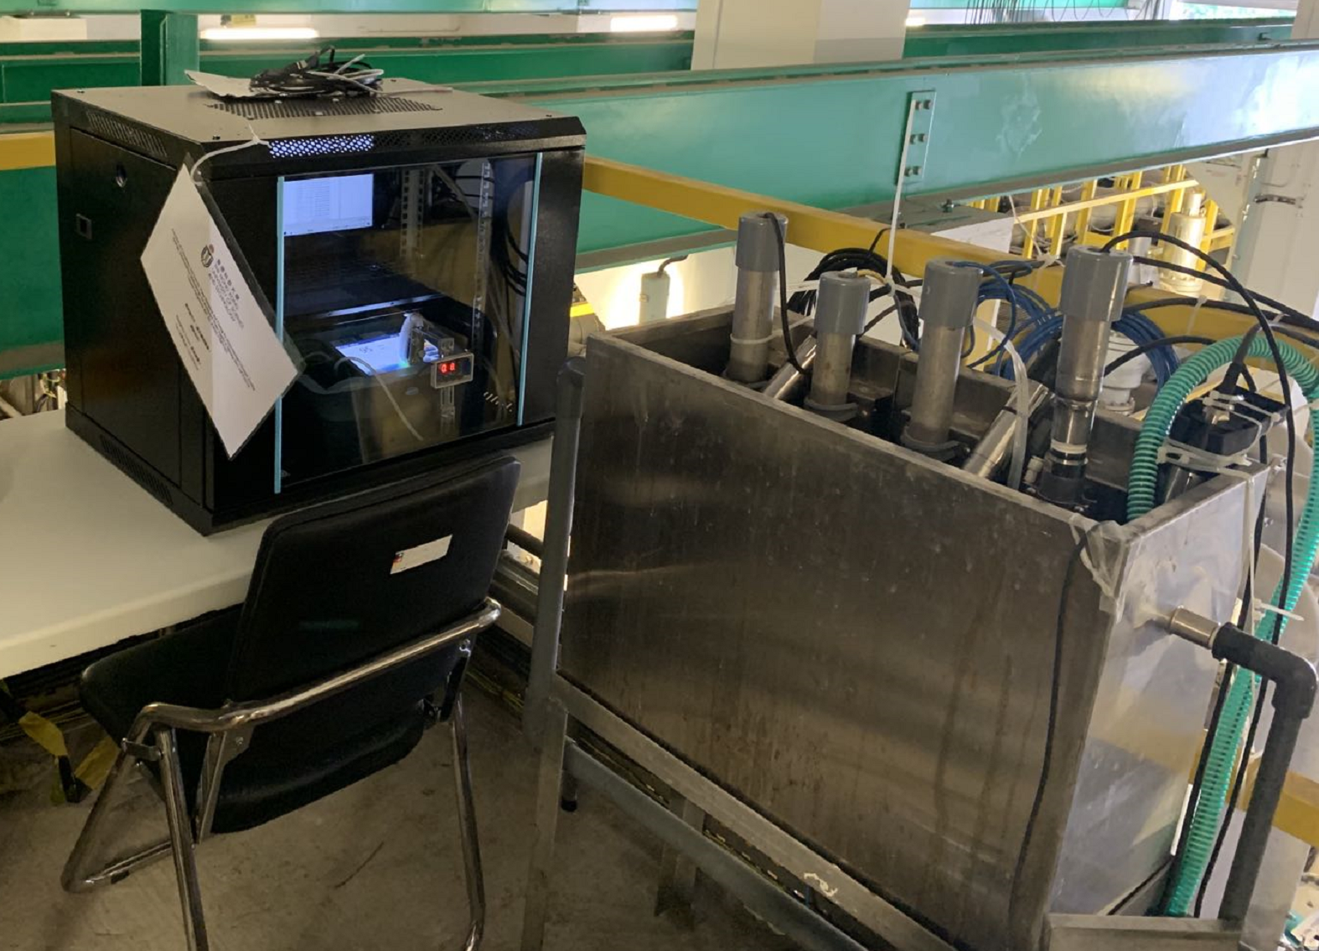

Colour levels and ammonia concentration are measure in the effluent container (i.e., on the right of the image.) A water pump transports MBR effluent to the effluent container continuously at real-time. The black vault on the left of the image contains a laptop and a colour spectrophotometer.

### 3.2.1 On-line data monitoring and collection

To enable us to perform on-line monitoring of ammonium concentration (NH $​_{3}$-N) in the MBR effluent, an Ammonium and Potassium Probe, AmmoLyt $​^{®}$ Plus 700 IQ (Xylem Company) is installed as Fig. 3.3 in the effluent container, as shown in Fig. 3.2. The operation was commenced on 27 April 2021 and completed on 27 March 2022. The ion-selective electrode (ISE) probe provides continuous and reagentless monitoring of ammonium and potassium at the configured interval of one measurement per minute. Due to the ISE probe cannot differentiate the potential difference caused by ammonium and potassium ions in the electrodes, the on-line monitoring of ammonium concentration requires continuous calibration using potassium concentration.

The instrument records ammonium concentration as NH $​_{4}$-N mg/L, a form to express the sum of nitrogen found in reduced nitrogen (III) form. Ammonia has a reported pKa of 9.25 (National Center for Biotechnology Information, 2022), meaning ammonium is a primary species under the pH of 9.25 in water. In WWTPs, the pH in water typically ranges from pH of 7–8, making the NH $​_{4}$-N concentration the dominant species. Both ammonia and ammonium contain one nitrogen atom; 1 mg/L NH $​_{3}$-N is the same as 1 mg/L NH $​_{4}$-N. Thus, to prevent confusion, in the following paragraph, the unit of NH $​_{4}$-N will be expressed by NH $​_{3}$-N, which is the unit used in the water quality standard. The collection of on-line ammonia data is achieved through downloading CSV files from the website connected to the IQ Sensor Controller (Xylem Company), as shown in Fig. 3.4.

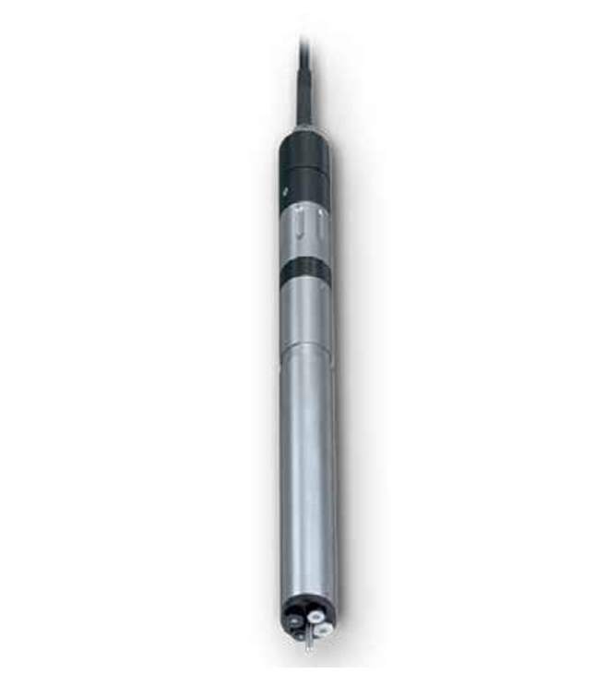

AmmoLyt $​^{®}$ Plus 700 IQ, Xylem.

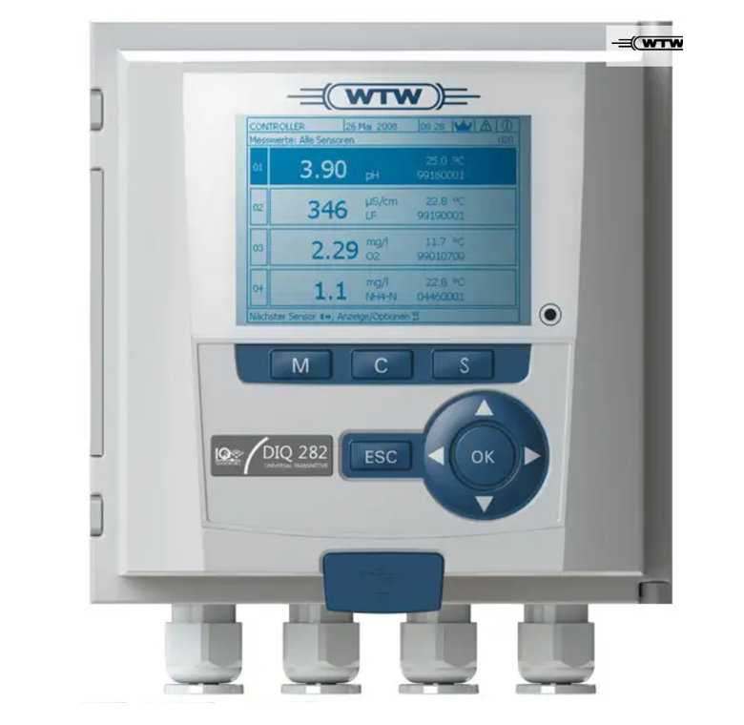

DIQ/S 284-EF controller, Xylem.

Hourly monitoring of the colour levels of MBR effluent was conducted from 5 October 2021 to 26 February 2022 by using a custom-made on-line colour analyzer. The default spectrophotometer as Fig. 3.5 and a peristaltic pump as Fig. 3.6 is only capable of initiating a single measurement of colour level by pressing the "READ" button on the DR3900 panel. To achieve continuous sampling and analyzing colour levels without human intervention, an actuator with a programmable time function was mounted on the panel of DR3900, as shown in Fig. 3.7.

The automatic sampling and analyzing of the colour level begins with the actuator clicking on the "READ" button to initiate the colour analysis at a fixed interval of 30 minutes. 3 mL of sample was collected from the effluent container and delivered to the spectrophotometer cell. After the spectrophotometer analyzed the sample, the data was transmitted to an automatic data acquisition and storage software pre-installed on the laptop. The DR3900 device is connected to a laptop, which receives the real-time data and stores it on data management software from Hach company. To access the real-time data from the laptop, Google Remote Desktop is used to operate the laptop via Internet cloud services using any devices having access to the Internet. The entire process is illustrated in Fig. 3.8. After the measurement, the sample will be discharged to the effluent container, and the on-line colour monitoring system is left idle until the subsequent measurement.

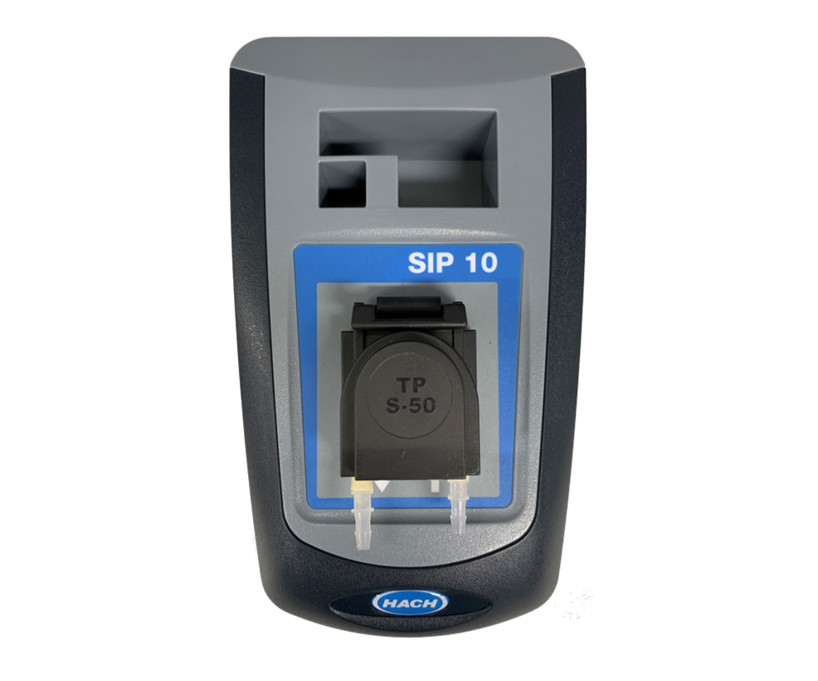

SIP10 peristaltic pump, Hach

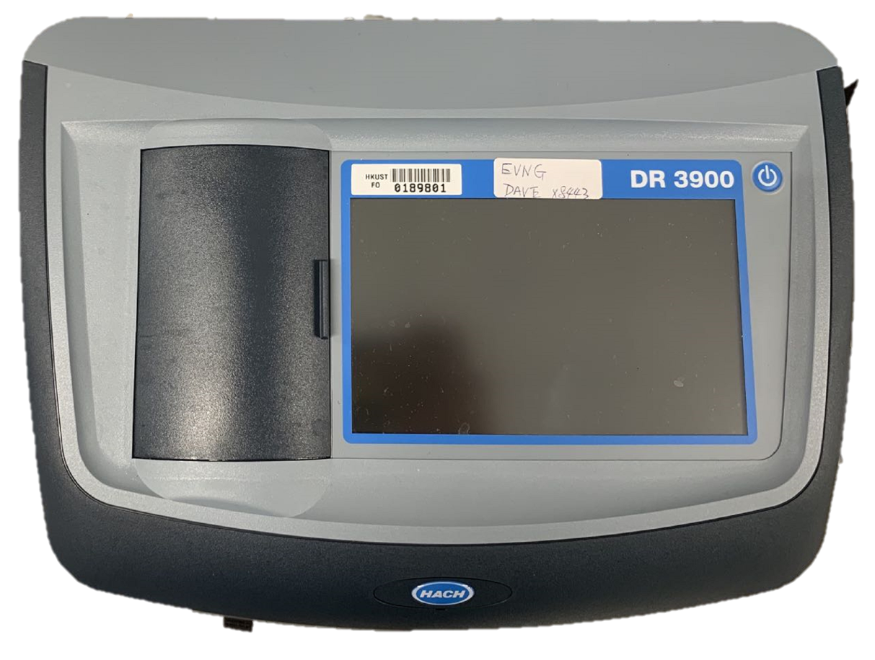

DR3900 spectrophotometer, Hach

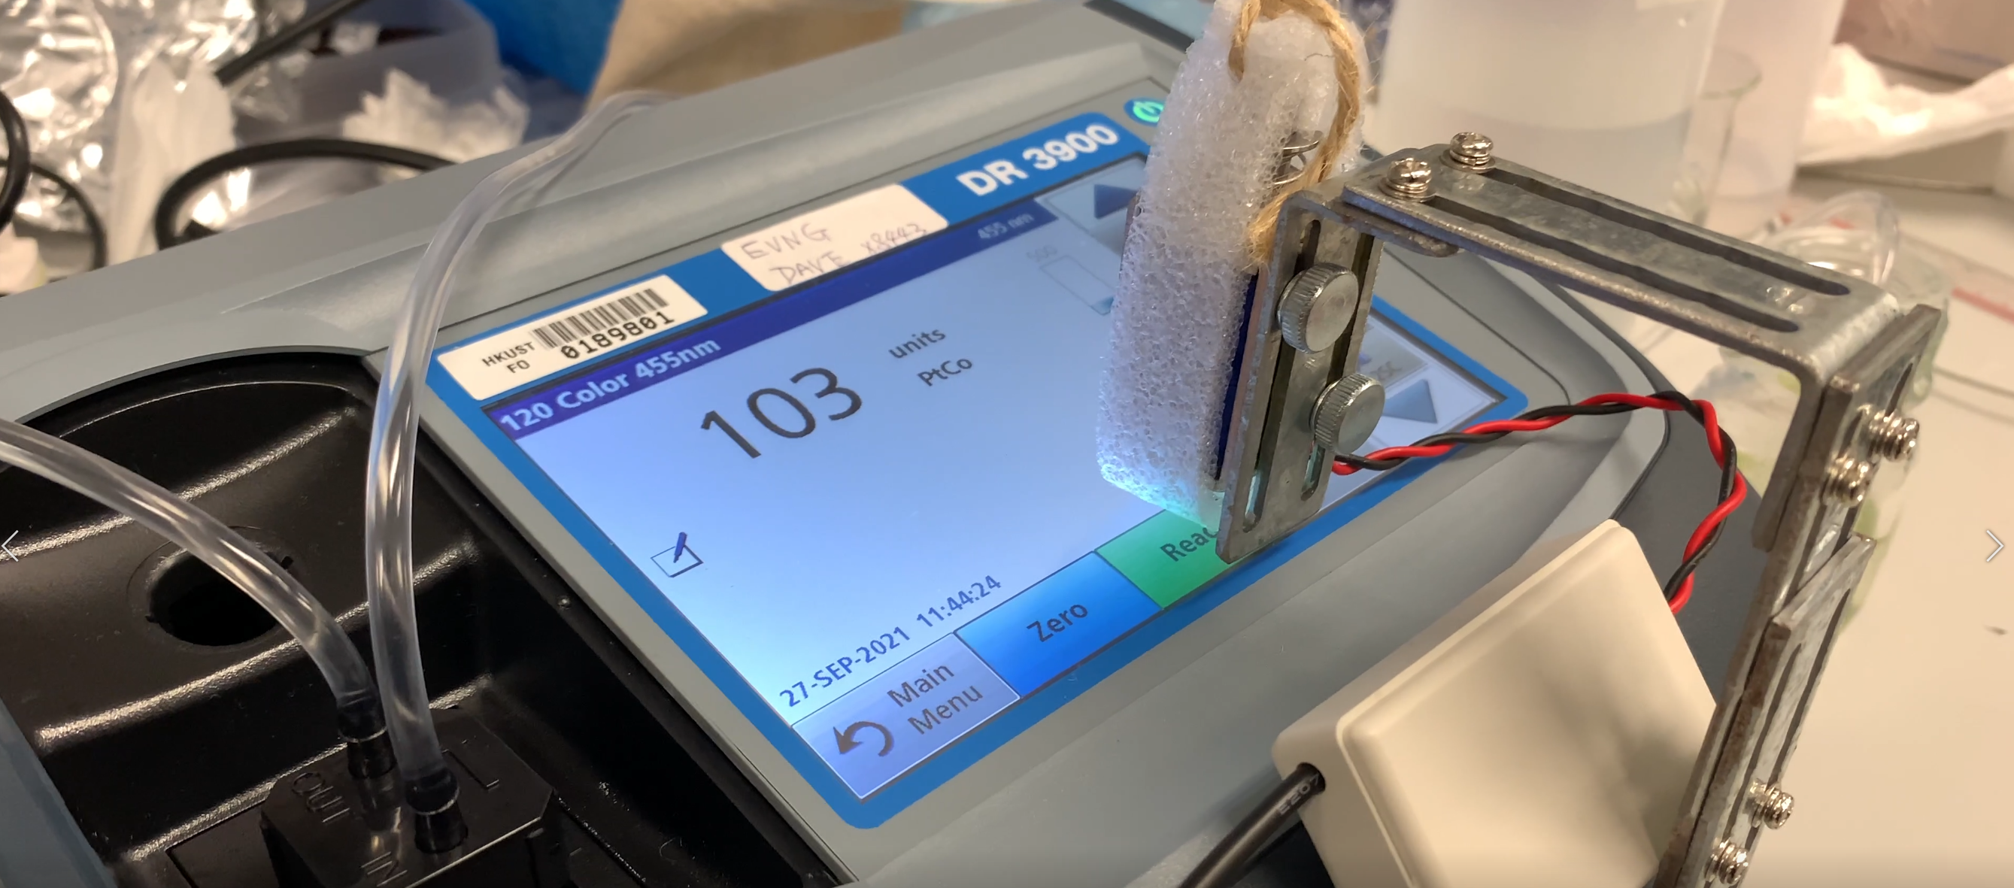

Customized clicker/actuator

The maintenance and calibration of the DR3900 spectrophotometer is performed on a weekly basis. During the maintenance, the DR3900 device was shut off, and 100 mg/L chlorine solution was pumped into the sampling tubes and the plastic cuvette for disinfection and cleansing. The cleansing of the tubes and cuvette were manually inspected with eyes to make sure no foreign objects were stuck inside. De-ionized water was brought to the site to perform the spectrophotometer calibration after the reboot of DR3900.

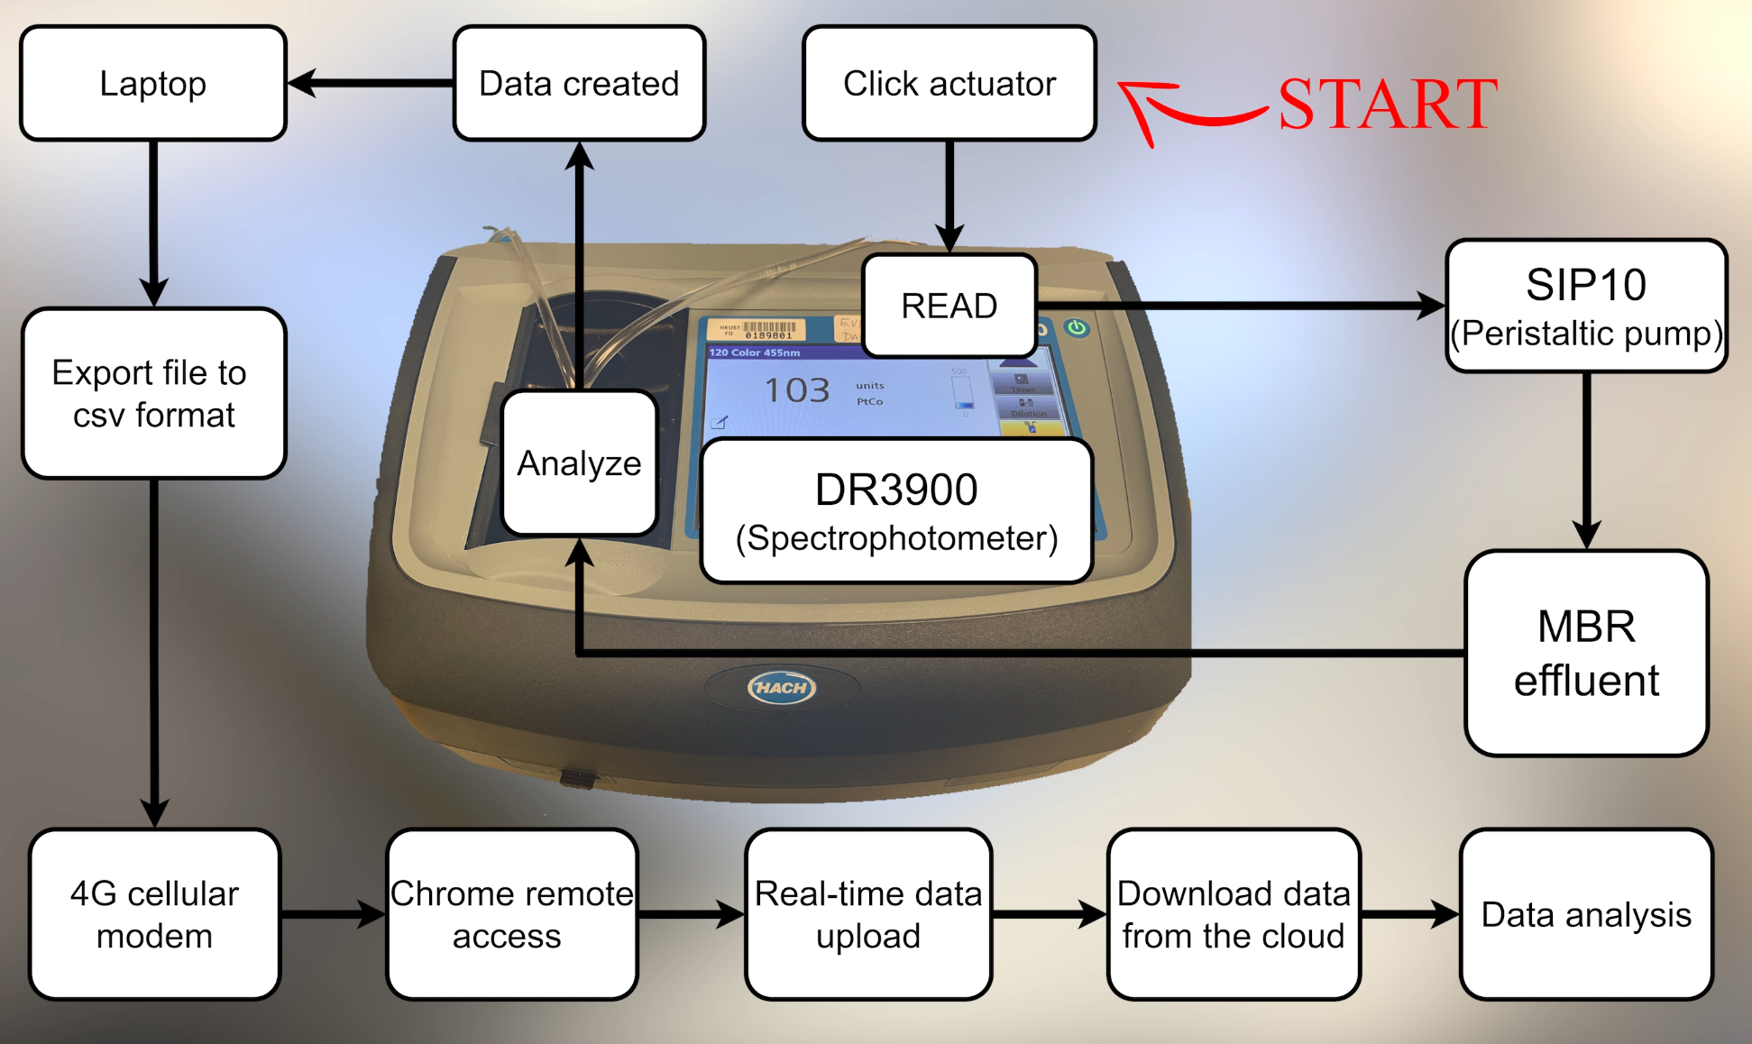

Schematic diagram of the custom-made on-line colour anlaysis system.

In the proposed model training methods, ammonia and colour data are input into the training forecasting models. Thus, the colour and ammonia data as features should be collected from the same period of time with the same dataset size. In addition, abnormal data caused by sensor downtime should also be excluded. Thus, we chose the ammonia and colour data from 23 December 2021 to 22 January, as shown in Fig. 3.9.

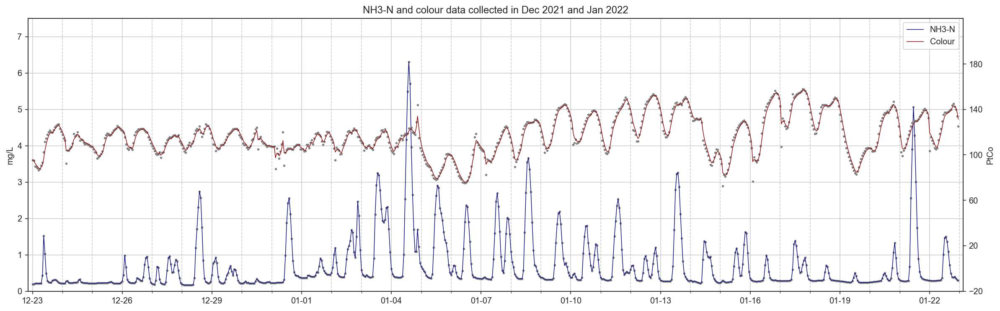

Ammonia and colour data collected from 23 December 2021 to 22 January 2022.

### 3.2.2 Loss function for model evaluation

Loss functions are used to determine the error between the model outputs (i.e., prediction or forecasting values) and the given target value (DeepAI, 2022). The bigger the difference between the ground truth $y$ and the model outputs $\hat{y}$, the higher the value of the loss function is, meaning the model performed poorer. A low value for the loss means the model performed well. The selection of the types of the loss function is essential for training the model to perform specific tasks. This study uses Mean Squared Error (MSE) to evaluate the regression models. The values of MSE will never be negative and are formally defined by the following equation:

$$MSE=\frac{∑{\left(y_{i}−\hat{y_{i}}\right)}^{2}}{n}$$

### 3.2.3 Data cleaning and pre-processing

In this study, ammonia concentrations and colour levels forecasting models will be trained, and the model training steps are shown in Fig. 3.10. The training processes are split into two sections; one is the baseline model training steps, and the other is the proposed model training steps. The training steps of the first section used cleaned data to train forecasting models and generated baseline model performance, which will be further compared with the model performance generated in the second section. The second section includes using pre-processed datasets (i.e., data smoothing) and feature engineering enhanced datasets to train the forecasting model.

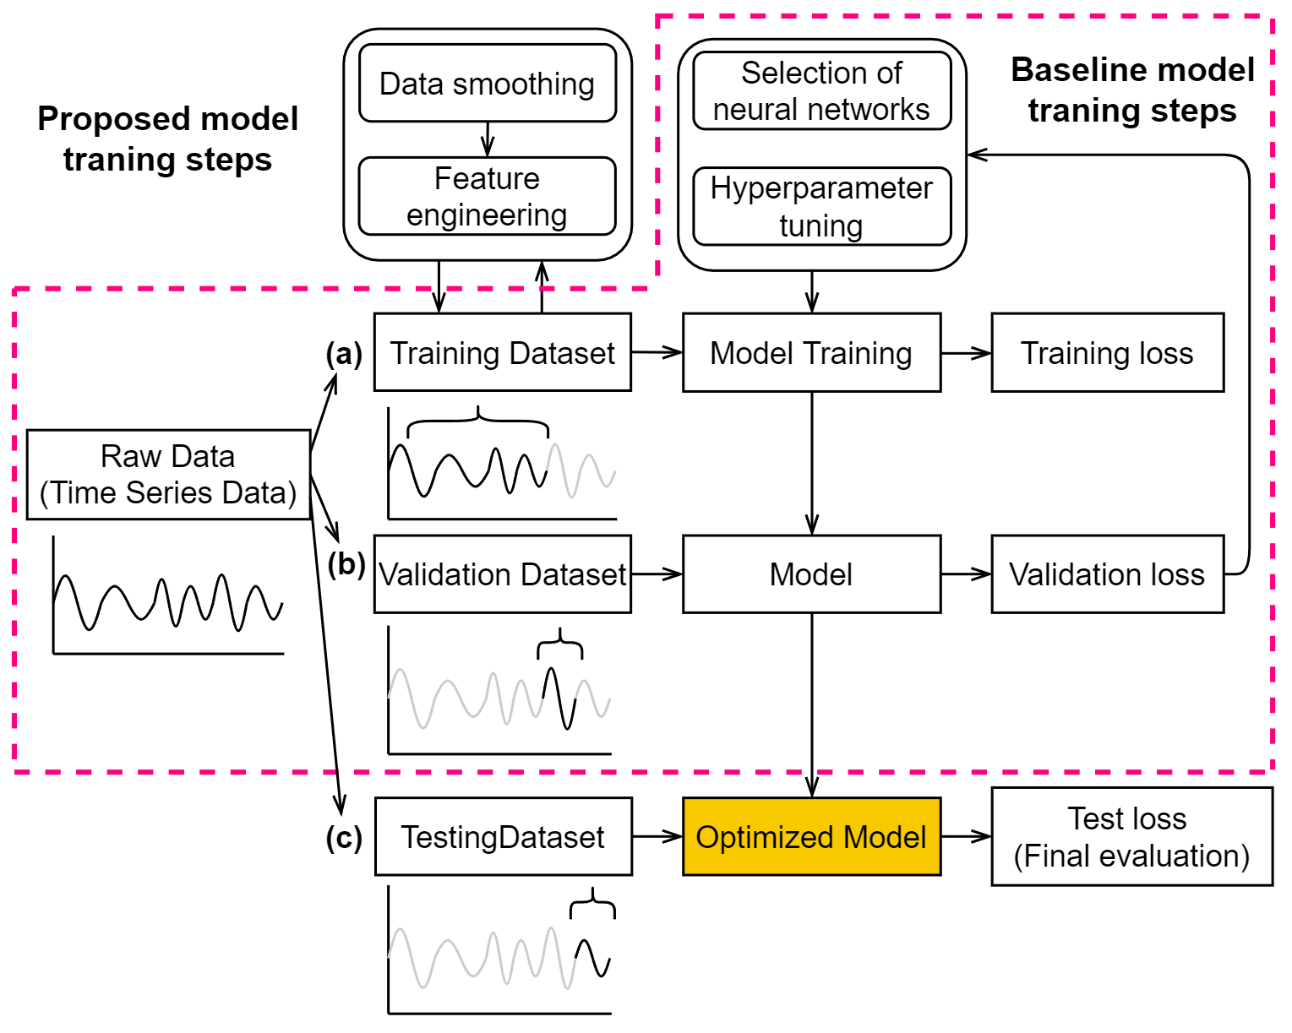

Machine learning model training steps.

The raw data embedded in the original CSV files has many problems, such as missing values, extreme low or high values, unreadable texts, etc. Thus, data cleaning and pre-processing are necessary for a more effective model training process. Python programming language and related libraries such as Numpy and Pandas were used to clean and pre-process the raw dataset for further usage. The raw ammonia dataset collected from the instrument contained 44,640 samples (data points) with eight variables, giving a matrix size of 44,640 x 8, and the samples were collected in time series at 1-minute intervals. The colour level raw dataset collected from the laptop contained 1488 samples with 34 variables, giving a matrix size of 1488 x 34, and the samples were collected in time series at 30-minute intervals.

Extreme values were manually removed before the colour and ammonia datasets were averaged into time-series data at 1-hour intervals. For the ammonia dataset, we replaced the values higher than 7.0 mg/L with NaN (i.e., Not a number), and further interpolation was used to fill up the NaN along with the missing values in the dataset. For colour dataset, we manually took out the relatively low data points on the days when the maintenance and calibration tasks were performed; extremely values higher than 300 Hazen Unit were also replaced by NaN. Same as the data cleaning method used for the ammonia dataset, the missing values and NaN were filled up with interpolation.

#### 3.2.3.1 Data smoothing with Savitzky-Golay and EWMA filter

Data smoothing was performed using the same method on ammonia and colour datasets. One of the effective ways to remove the noise from the dataset is to apply data smoothing filters. Two filters were applied in this study, Savitzky-Golay (SG) and Exponentially Weighted Moving Average (EWMA) filters.

A SG filter is a digital filter that can be applied to a set of digital data points for the purpose of smoothing the data without distorting the data tendency. This is achieved via convolution by fitting successive subsets of adjacent data points with a low-degree polynomial using linear least-squares (Wikipedia, 2022a). The illustration is shown in Fig. 3.11, and the procedures of how data points are smoothed are presented in the following steps:

Extract short-time window (i.e., blue dots in Fig.3.11)

Determine polynomial degree (e.g., different polynomial degree is compared in Fig. 3.11).

Find the smoothed data point (i.e., at center of the window).

Repeat for shifted window (e.g., similar to moving average).

The equation to describe the smoothed value of $Y_{j}$ can be expressed in Eq. [sg-eq]:

$$Y_{j}={\left(C⊗y\right)}_{j}=\sum_{i=\frac{1−m}{2}}^{\frac{m−1}{2}}{C_{i}}y_{j+i}, \frac{m+1}{2}≤j≤n−\frac{m−1}{2}$$

where $Y_{j}$ corresponds to the $j^{th}$ smoothed data point, $m$ to the window size (i.e., numer of data points intended to smooth out) and $C_{i}$ to the convolution coefficients (i.e., determined by Savitzky and Golay (1964)).

Exponentially weighted moving average (EWMA), also known as autoregressive (AR) filtering, is a technique that filters measurements. An EWMA filter smoothes a measured data point by exponentially averaging that particular point with all previous measurements. The EWMA equation can be expressed in Eq. [ewma-eq]:

$$\begin{matrix} & α=\frac{2}{span+1} \\ & y_{0}=x_{0} \\ & y_{t}=\left(1−α\right)y_{t−1}+αx_{t}\end{matrix}$$

where $α$ corresponds to the decay paratmeter, $x_{t}$ to the value at a time period, $y_{t}$ to the value of the EWMA at any time period t, span to the window size.

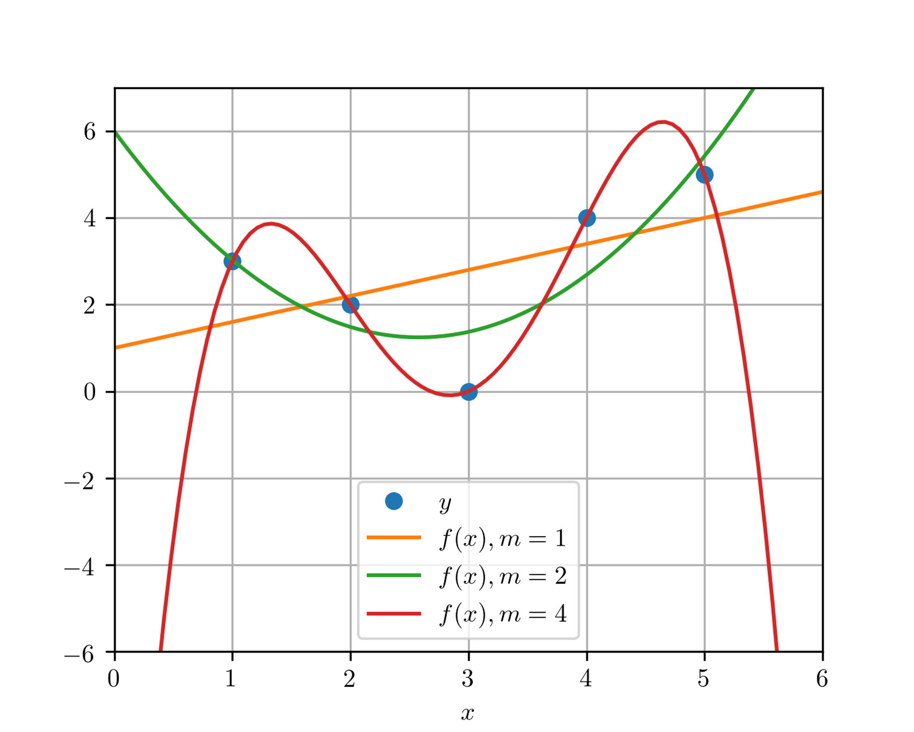

SG filter with different polynomial degree (Taal, 2017).

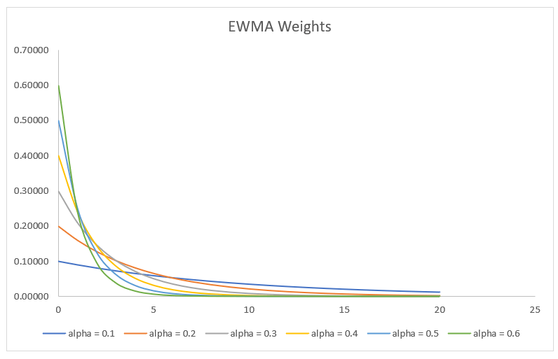

Examples of weights with exponential decay at varied alpha values (CFI, 2022).

Both SG and EWMA filters are required to select the hyperparamters, the selected values are presented in Table. [tab:filter-hyperparameters].

lcc Group Name & Window size & Polynomial degree  
SG-5 & 5 & 2  
SG-7 & 7 & 2  
SG-9 & 9 & 2  
EWMA-2 & 2 & -  
EWMA-3 & 3 & -  
EWMA-4 & 4 & -

Fig. [fig:smoothed] shows the influences of different windows sizes on SG filters as in Fig. 3.13 and on EWMA filters as in Fig. 3.14.

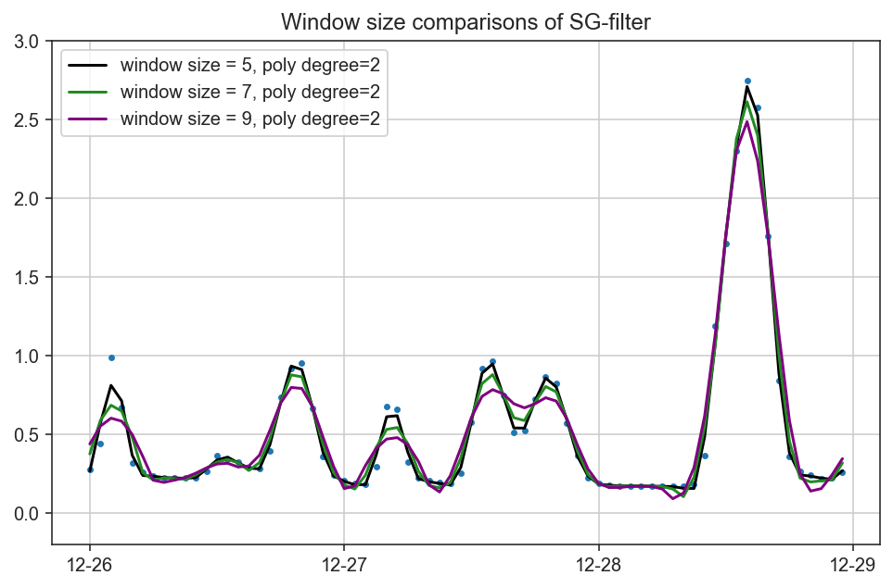

Ammonia data filtered by SG filters with different window sizes.

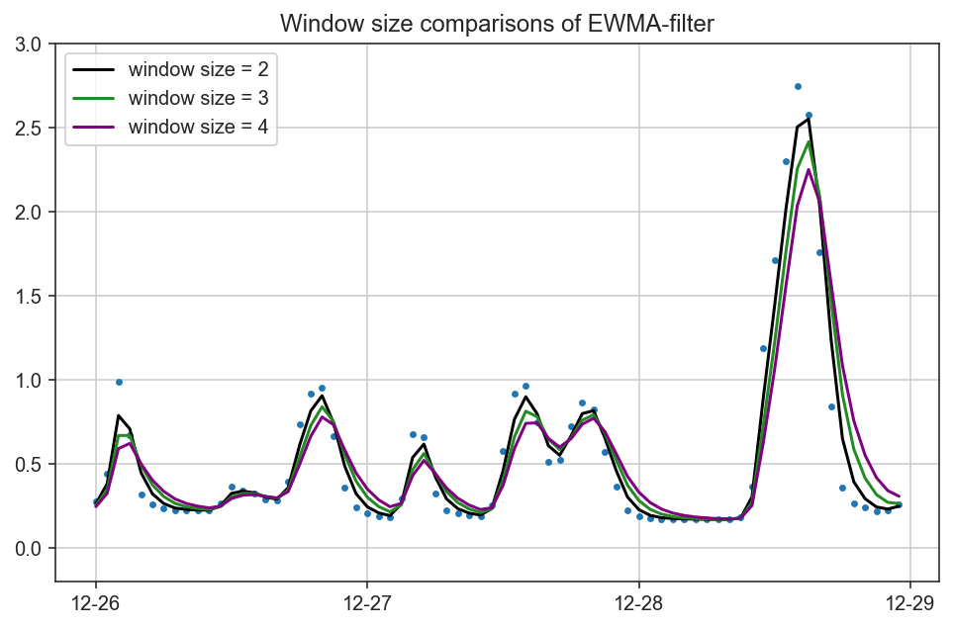

Ammonia data filtered by EWMA filters with different window sizes.

#### 3.2.3.2 Outlier Removal

Although the extreme values in the raw ammonia dataset were removed based on basic rules (i.e., concentration higher than 7.0 mg/L), the ammonia sensor can still collectively capture unideal data points. In the outlier removal process, we intended to identify the collective faults of ammonia data in the unit of an entire day. Two abnormal conditions are defined to determine whether the ammonia data on a specific day shows collective fault:

NH $​_{3}$-N fluctuation $≤$ 0.1 (i.e., lower than the sensor resolution).

No diurnal fluctuation (i.e., Fluctuation = peak value – bottom line value).

Peak analysis was performed on the daily ammonia data to automatically identify normal or abnormal signals. The analysis takes a one-dimension array (i.e., the data form of ammonia in a day) and finds all local maximum values by comparing neighboring values. This function will also provide information such as width and prominence, as in Fig. [[fig: prominence]](#fig: prominence) to help us identify whether the diurnal fluctuation exists.

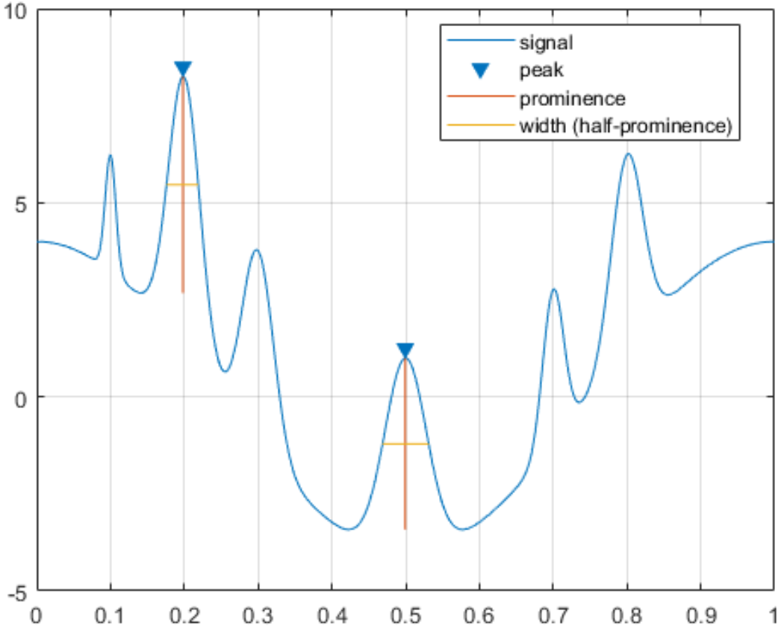

Illustration of peak analysis. Four important elements are automatic caculated by the function (MathWorks, 2022c).

#### 3.2.3.3 Feature Engineering

We have carefully observed and analyzed the SWHEPP influent to create new features from the raw datasets based on our domain knowledge. We discovered that the SWHEPP influent consists of treated landfill effluent from NENT landfill leachate site and municipal wastewater, as shown in Fig. 3.16. We observed that with a higher blending ratio, which is calculated from the daily volume of treated leachate effluent divided by the daily inflow volume of SHWEPP, the colours level are also higher, as shown in Fig 3.19. With the Pearson coefficient of 0.68, the increased volume of treated leachate effluent in the public sewage system is proportional to the increase of the colour levels in the SHWEPP influent, while the ammonia concentration is mainly from the municipal wastewater. During the mixing of both types of wastewater, as in Fig. 3.17, substances contributing to colour levels were diluted by the municipal wastewater; at the same time, the ammonia concentration was also diluted by the treated leachate effluent. In Fig. 3.20, we can observe that the time when the lowest colour level of the day occurred is close to when the highest ammonia concentration was observed. The changes in colour levels and ammonia concentration are interactive. Thus, in feature engineering, colour level data was selected for training the ammonia forecasting model; ammonia data was selected for the training colour forecasting model, as shown in Fig. 3.25.

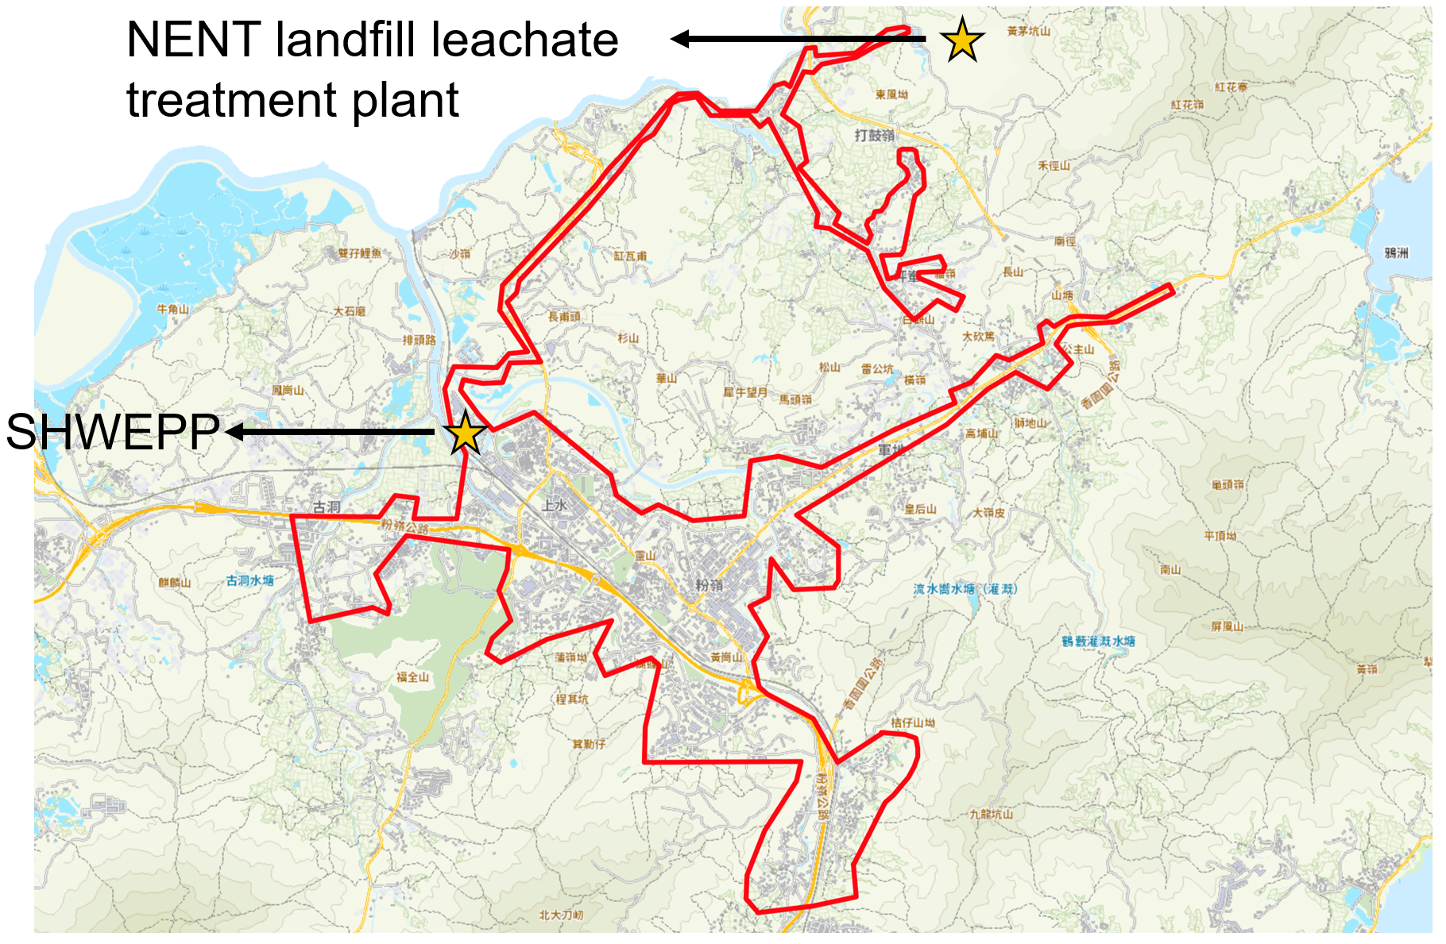

Sewer system coverage of SHWEPP. The covered areas (i.e., area circled in red boundary) include Fanling/Sheung-Shui new towns and NENT landfill leachate treament plant.

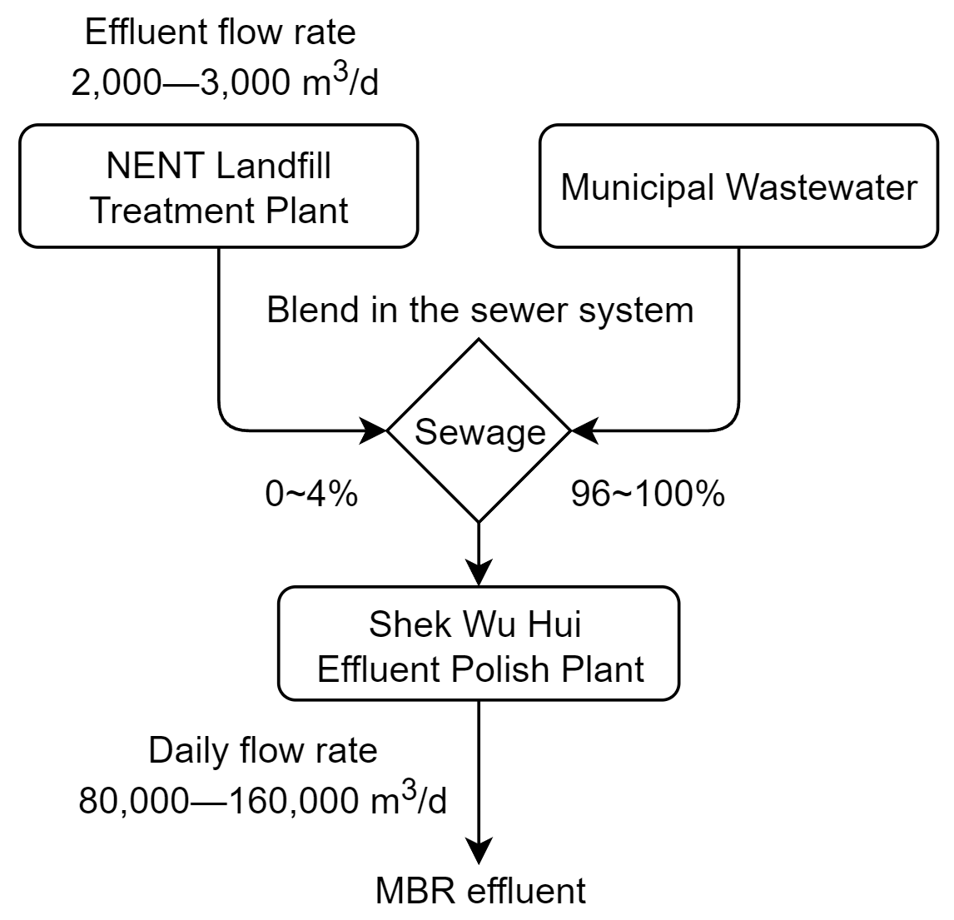

Flowchart showing the blending of treated leachate effluent with municipal wastewater.

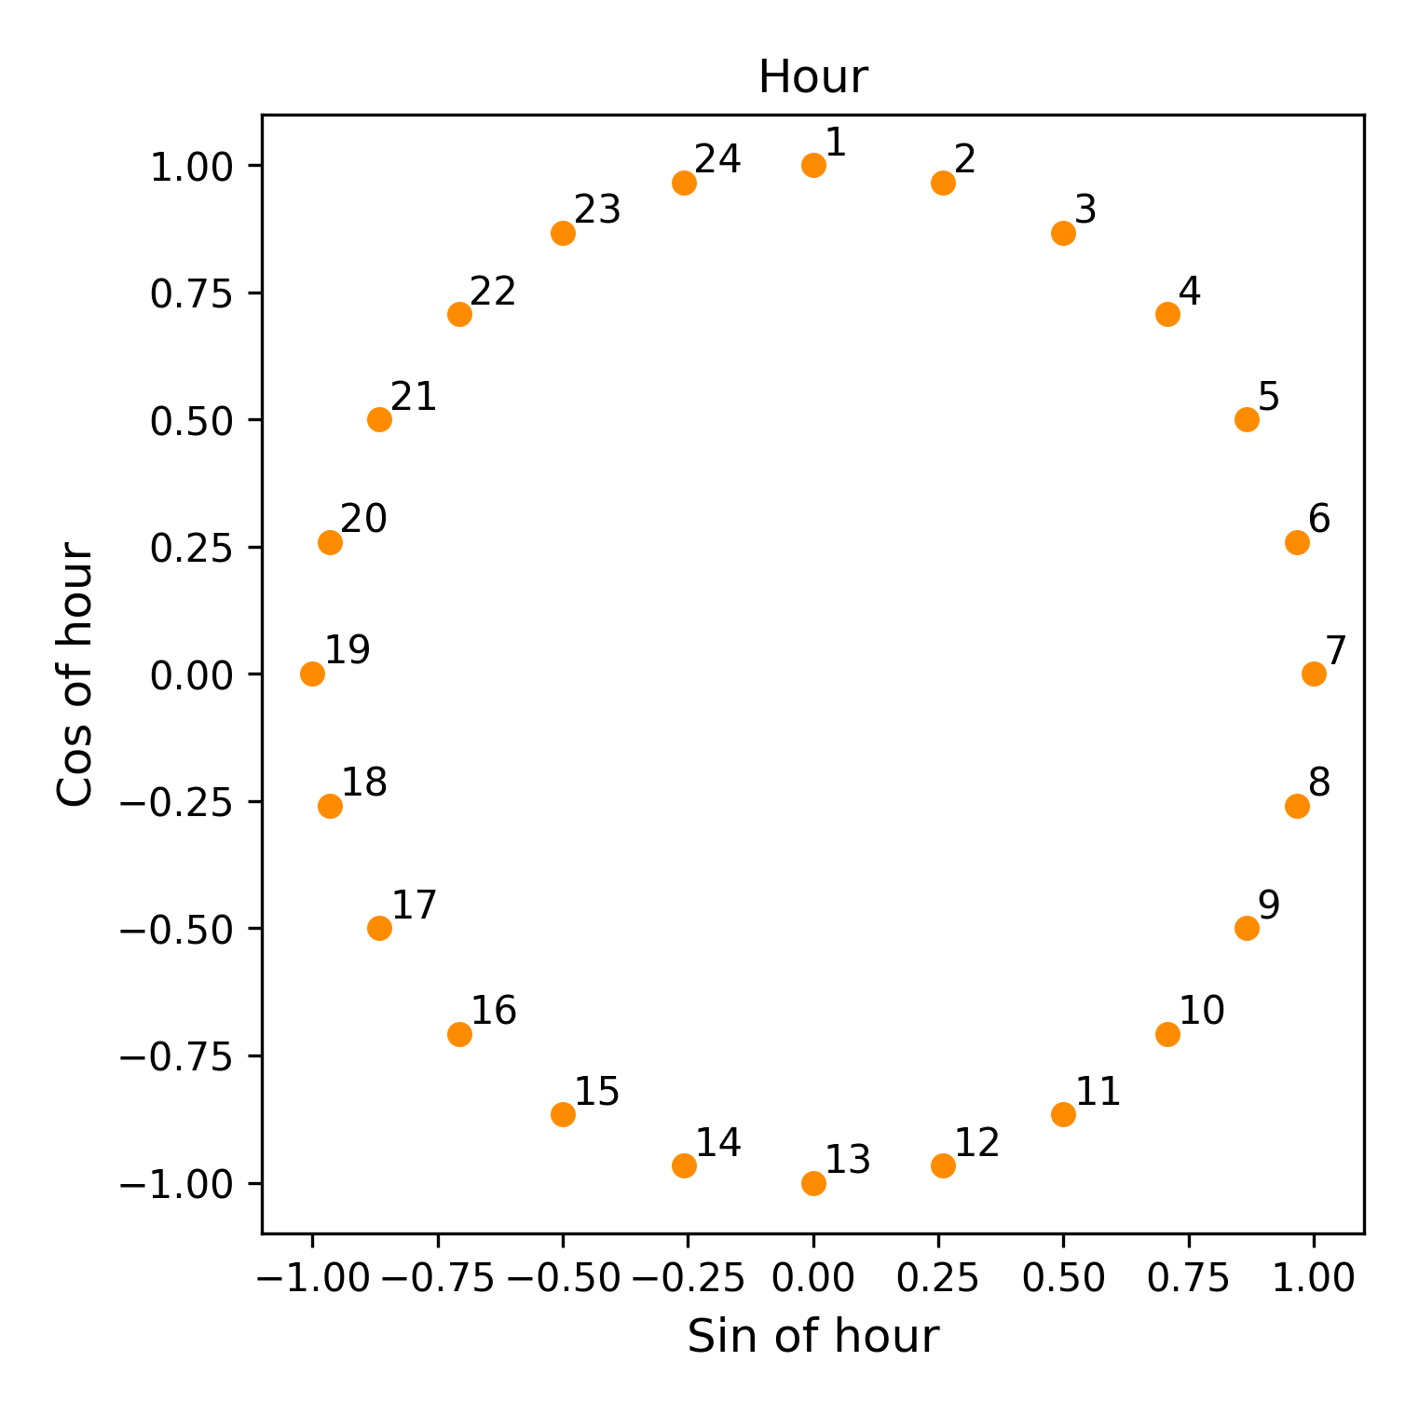

Positional encoding of hour components.

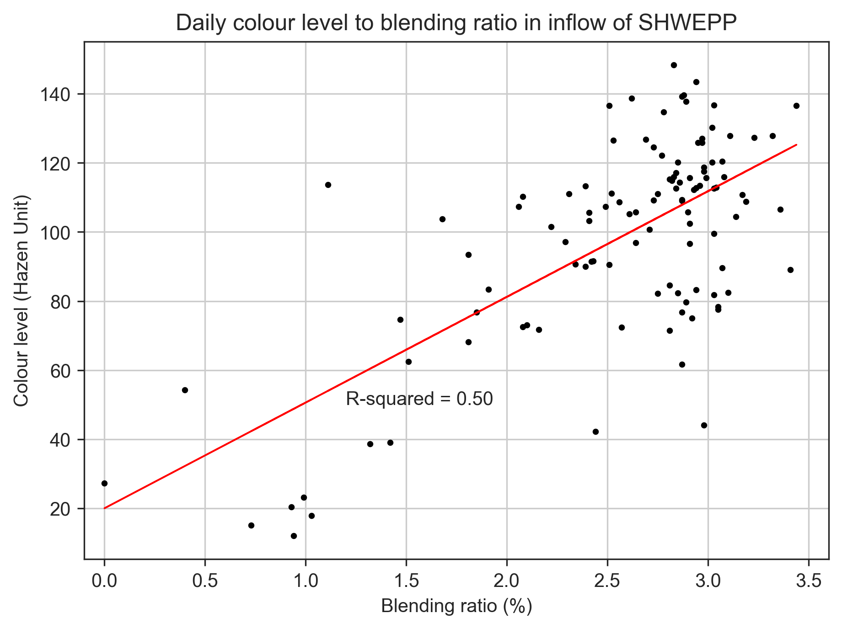

Coefficienct between blending ratio and colour levles.

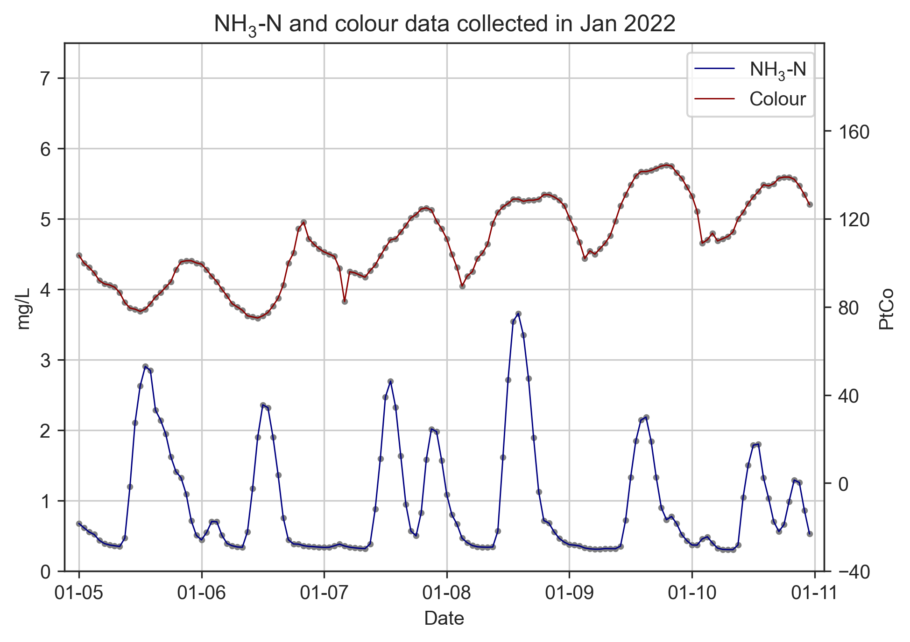

Trend comparison of ammonia concentration and colour levels.

The new features are inspired by the research work of Abu-Bakar et al. (2021). The author summarized the four types of hourly household water consumption patterns as in Fig. 3.21, which correlates the specific time of the day to the volume of water consumed in households. In other words, as fresh water is consumed, wastewater is generated simultaneously; the wastewater then enters the public sewage system and increases ammonia concentration. As shown in Fig. 3.22, the peak analysis tool helped us to identify the ammonia concentration’s peak hour, which occurred around 13:00 to 14:00, and 20:00 to 21:00. Thus, it is convinced that time features will help the machine learning models correlate better and predict the change of ammonia concentration in the wastewater. Time feature is created through a technique called positional encoding (POS). The positional encoded feature was achieved in the following steps:

The timestamp are represented as three elements—hour, day and month.

Each element will bed decomposed into sine and cosine components.

Last step is applied to hours and days to make all elements represented cyclically.

Due to the size of the datasets used in this study for training ammonia and colour forecasting model is 31 days, only hour element was transformed into sine and cosine components as in Fig. 3.18.

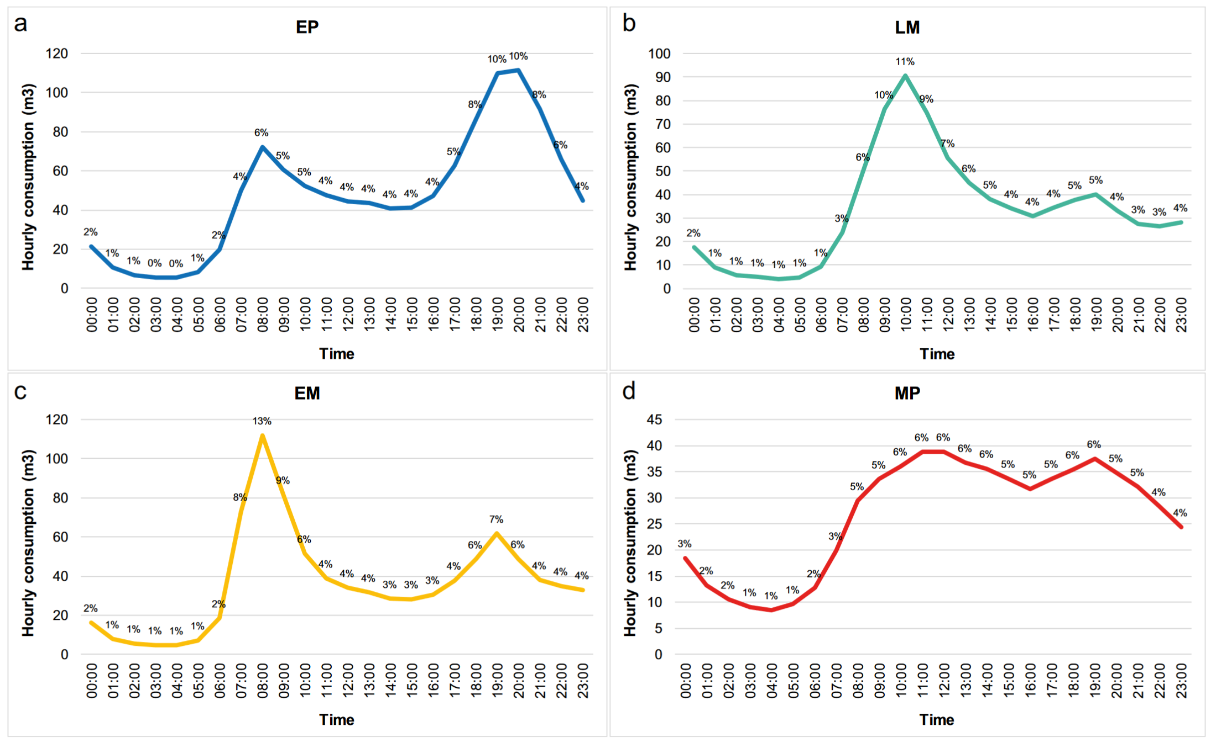

Hourly water consumption patterns in households (Abu-Bakar et al., 2021). (a) Cumulative pattern and percentage of hourly consumption for households in the “Evening Peak (EP)” cluster (b) Cumulative pattern and percentage of hourly consumption for households in the “Late Morning Peak Peak (LM)” cluster. (c) Cumulative pattern and percentage of hourly consumption for households in the “Early Morning Peak (EM)” cluster. (d) Cummulative pattern and percentage of hourly consumption for households in the “Multiple Peak (MP)” cluster. Consumption is in (m3).

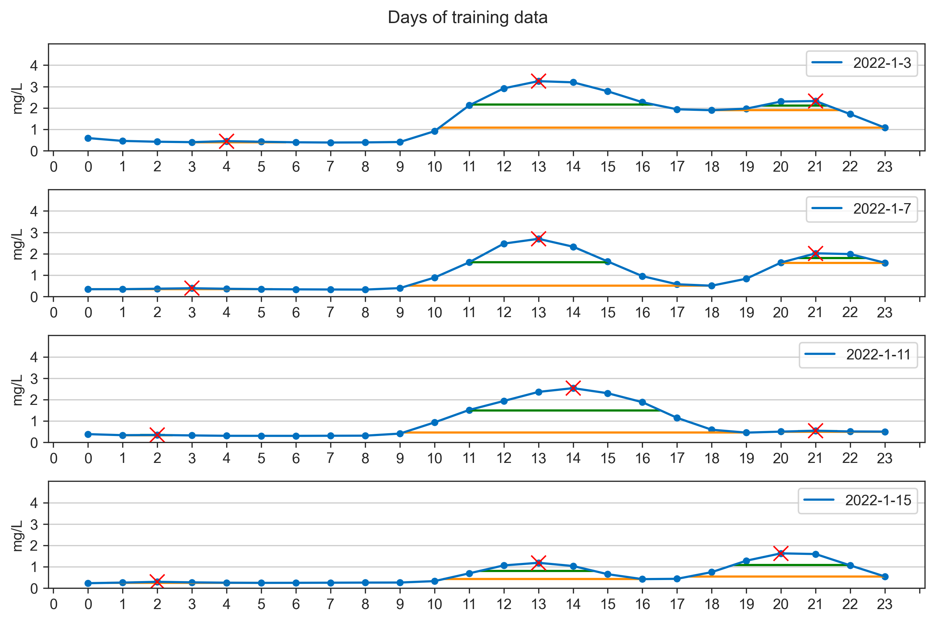

The daily patterns of ammonia concentration on 3, 7, 11, 15 Janurary 2022.

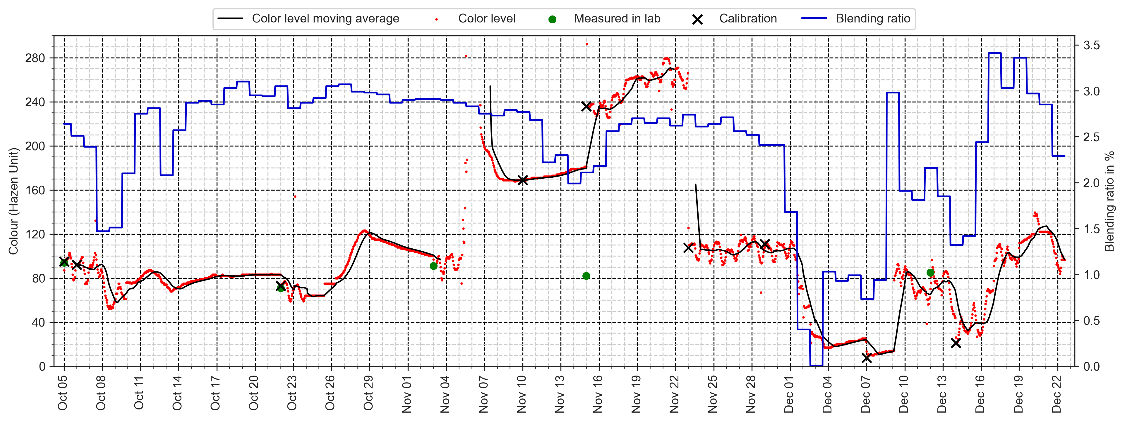

Data collected from 5 October 2021 to 22 December 2021.

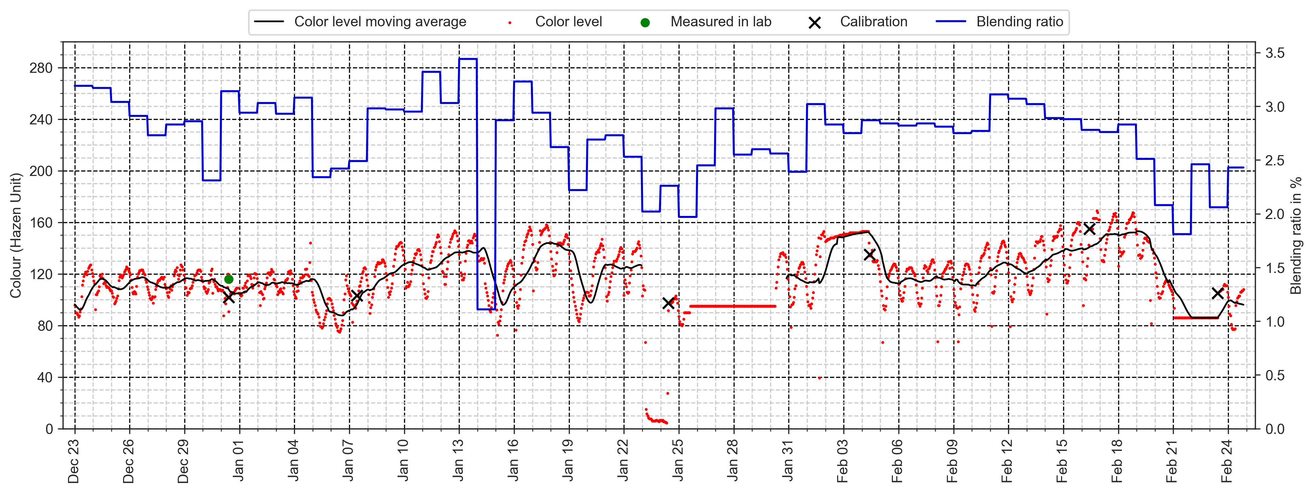

Data collected from 23 December 2021 to 24 February 2022.

### 3.2.4 Data transformation

Before the pre-processed data is fed into the models for training, we need to split the data into three clusters, which are training (60%), validation (20%), and testing dataset (20%). Among each cluster, the data will be further split into input variables $X$ and output variables $Y$ (i.e., training X/training Y, testing X/testing Y). During the training process, machine learning algorithms will learn a target function $f$ to best map $X$ to $Y$. A training dataset is a set of examples (e.g., historical data) for models to learn the hidden trends and information in the data, shown in (a) in Fig. 3.10. Training loss is calculated by taking the sum of loss for each pair of input and output in the training dataset after every training cycle (i.e., epoch).

In this study, the model is designed to forecast values three hours into the future using the values from the past 24 hours. Therefore, each training X will be assigned with time-series data of 24 hours, while each Y will be assigned with 3 hours. After the model successfully learns the hidden patterns between the training X and Y, it can forecast the values three hours into the future as testing X is input to the model.

The function of a validation dataset, as in (b) in Fig. 3.10, is used to assess the model performance until we obtain the optimized hyperparameter settings, including the number of neurons in machine learning models, epoch, etc. The hyperparameter settings for each model will be discussed in the next section. The validation loss plays a vital role during the model training. The adjustments of the hyperparameters will directly reflect on the change of the validation loss; the lower the values, the better the model performance is. As the optimized model is obtained, a testing dataset is used to evaluate the performance of the forecasting model, as shown in (c) in Fig. 3.10. The testing datasets will only be input into the models when the models are tuned to the optimized settings and ready for the final evaluation. The testing datasets are also known as the unseen datasets, which can fairly evaluate the model performance. If the model tuning process was performed on the testing dataset, the model performance would be biased since the hyperparameters are adjusted in favor of the evaluation of the testing dataset.

In Fig. 3.10, the hyperparameters will remain the same once the optimized values are found, thus generating a baseline model performance from different machine learning algorithms. The baseline results will be further compared with the results from the model trained by the proposed model training steps, which include datasets that have been performed data smoothing and feature engineering techniques.

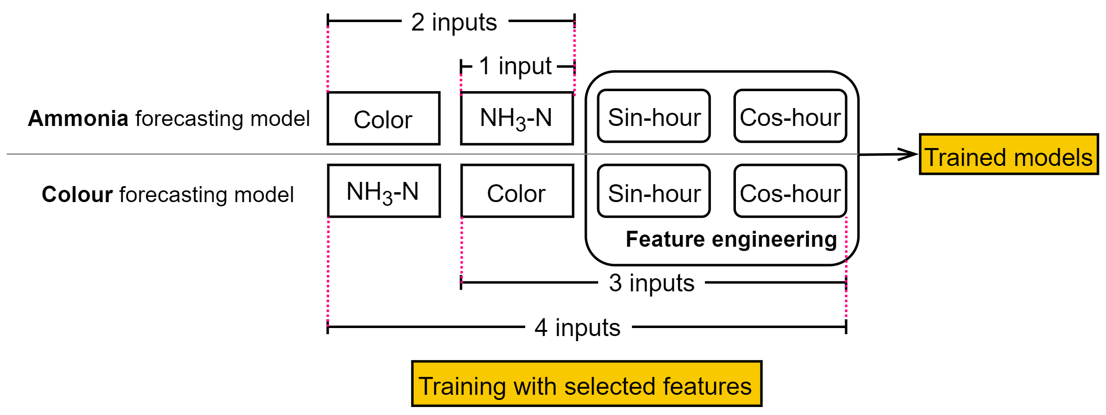

Illustration of feature selections for model training.

### 3.2.5 Feature selection

Fig. 3.25 illustrates which features are selected during the model training processes. In baseline model training steps, for both ammonia and colour forecasting models, only one feature is used for training for each model, which is ammonia and colour data, respectively. Following the baseline model training steps, the model trained by a single feature will generate baseline models. The results from the final evaluation will be defined as the baseline model performance, which will be compared with the model evaluated results from the proposed model training steps. Once the baseline model performance is obtained, more features will be input to the model training processes in the order of two features, three features, and four features.

## 3.3 Machine learning models

### 3.3.1 Random Forest

The machine learning model used in this study (i.e., not deep learning models) is random forest (RF). It is an ensemble method in which the final output is obtained by averaging the results from multiple tree learners (Wang et al., 2021), as shown in Fig. 3.26. The training algorithm applies the general technique of bootstrap aggregating, also known as bagging, to tree learners. Given a training set $X=x_{1},...,x_{n}$ with targets $Y=y_{1},...,y_{n}$, bagging repeatedly (B times) selects a random sample with replacement (i.e., not putting the samples back to the population) of the training set and fits trees to these samples (Wikipedia, 2022b), RF generate outputs through the following steps:

For $b=1,...,B:$

Sample (with replacement) n training examples from $X$, $Y$, call these $X_{b},Y_{b}$.

Train a regression tree $f_{b}$ on $X_{b},Y_{b}$.

Predict unseen samples $x^{′}$ by averaging the predicdtions from all the regression tree learners on $x^{′}$ as in Eq. [eq-rf]:

$$\hat{f}=\frac{1}{B}\sum_{b=1}^{B}{f_{b}}\left(x^{′}\right)$$

### 3.3.2 Deep Neural Networks

Artificial Neural Network (ANN) is a broad term that encompasses any form of Deep Learning model. A typical ANN consists of input, hidden, and output layers, and each layer comprises multiple neurons (i.e., nodes). The connected neurons simulate the human brain by processing and transmitting input signals to the next nodes (Mohseni-Dargah et al., 2022). What sets it apart from an ANN model and a DNN model is that the former contains only one hidden layer while the latter has more than one, as shown in Fig. 3.27. The DNN models are nonlinear, which finds the correct mathematical manipulation to turn the input into the output (Bangaloreai, 2018).

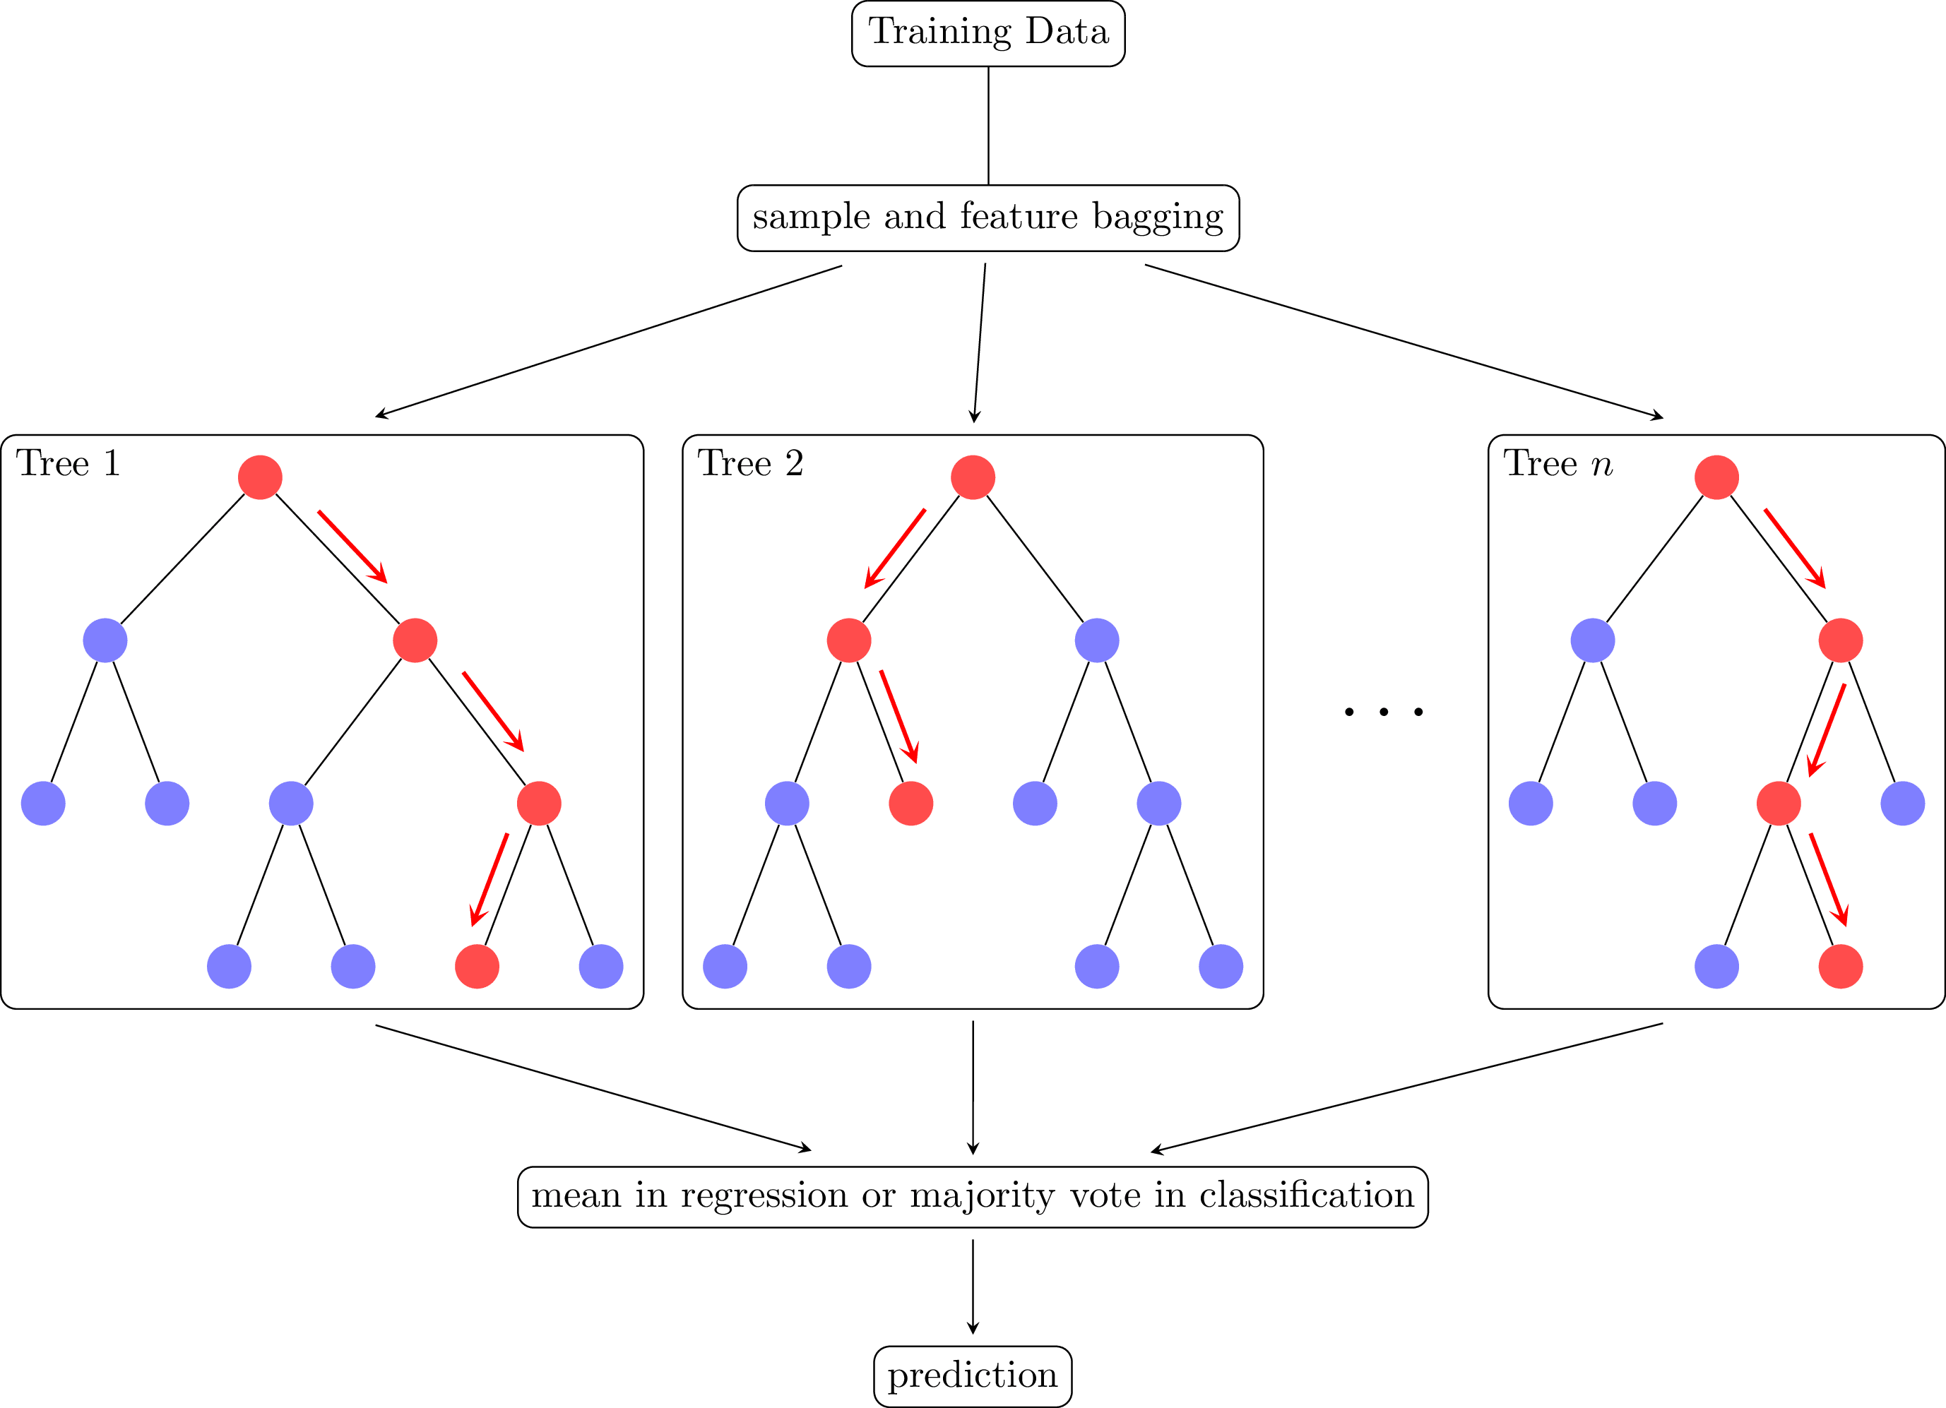

Random Forest (RF) (Riebesell, 2022).

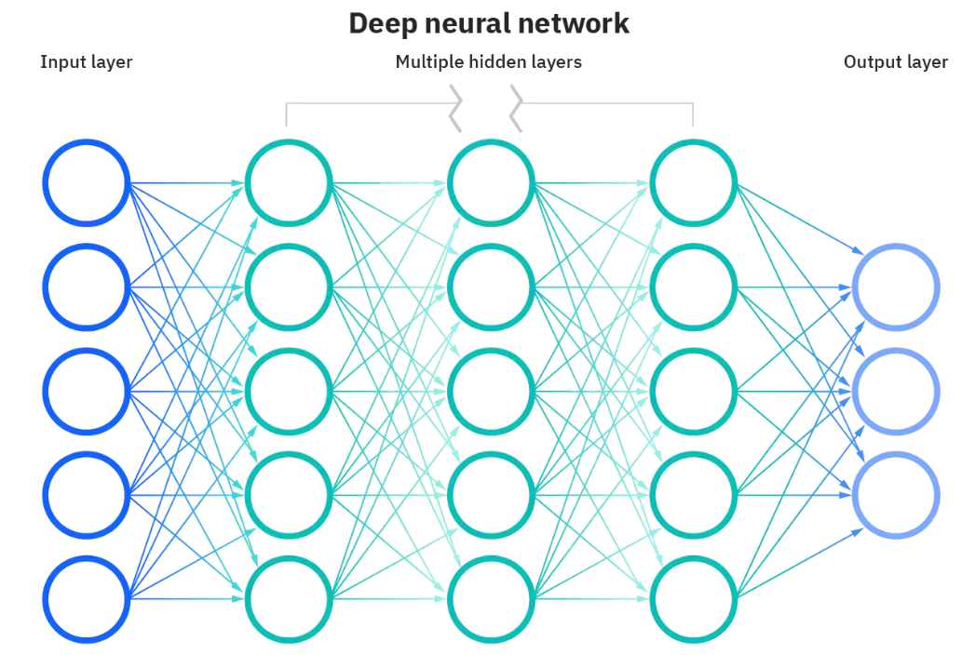

Deep Neural Network (DNN) (IBM, 2022).

### 3.3.3 Recurrent Neural Network

A recurrent neural network (RNN) is a type of Artificial Neural Network designed to work with sequence data. For instance, sequence data are time series, DNA, language, speech, sequences of user actions data, etc. The ammonia concentration and colour level data are time-series data, a series of data points listed in minute orders (Donges, 2021). A distinguishing characteristic of RNN is that they share parameters across each layer of the network by allowing information to be passed from the last step of the network to the next. Unlike RNN, feedforward networks like DNN have different weights across each node. The reuse of previous information for making the decision on RNN makes it capable of "learning" from the previous inputs. The realization of the memorizing function is through a memory unit called hidden state (i.e., a vector contains weights) in RNN architecture, which enables RNN to persist data, thus capturing short-term dependencies. The RNN architecture is presented in Fig. 3.28. The general formulation of a RNN is expressed in Eq. [eq-rnn] (Mamandipoor et al., 2020):

$$h_{t}=σ\left(W^{h}h_{t−1}+W^{x}x_{t}+b\right)$$

where $x_{t}$ is the current input, $h_{t}$ is the current hidden state (output), $h_{t−1}$ is the previous output, $W^{x}$ is the weights of the hidden state, $W^{h}$ is the weight of the input, $b$ is the bias, $σ$ is the sigmoid activation function.

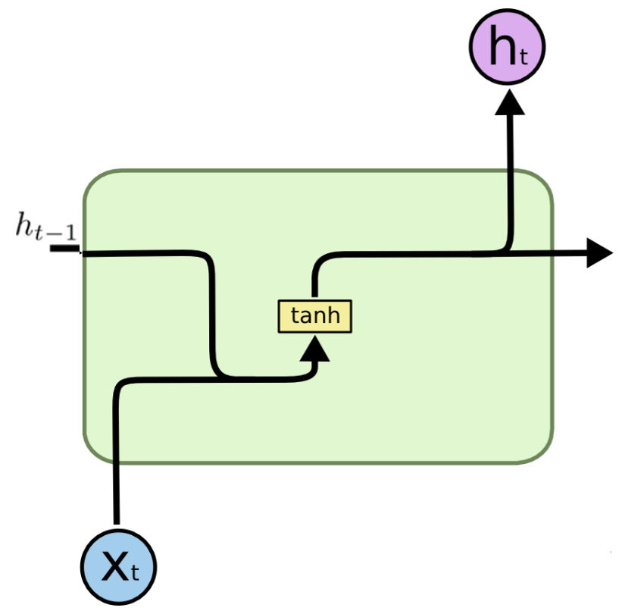

Recurrent Neural Network (RNN).

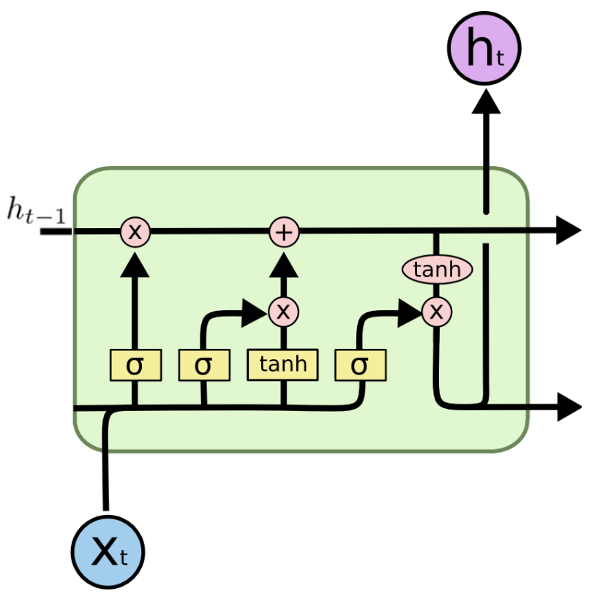

Long Short-term Memory (LSTM).

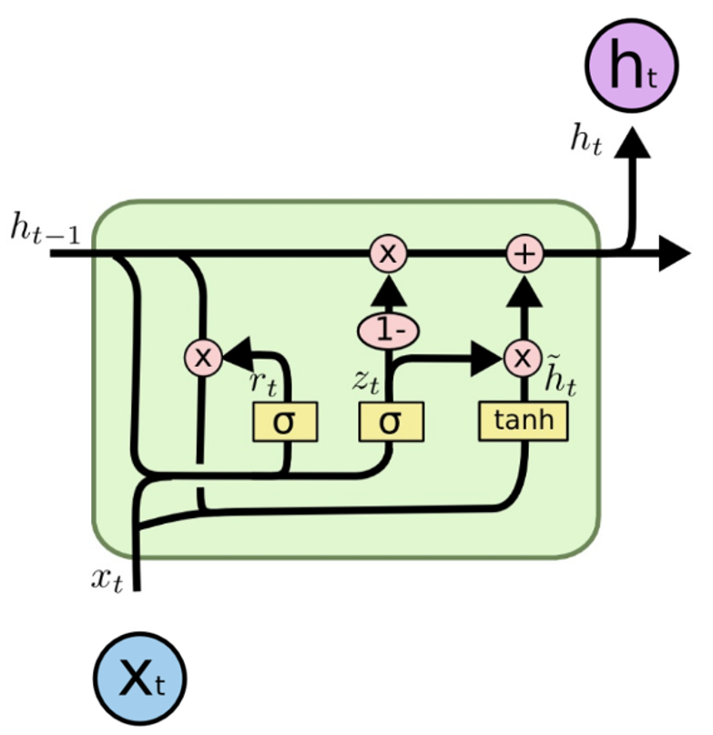

Gate Recurrent Unit (GRU).

### 3.3.4 Long Short-term Memory

Long Short-term Memory (LSTM) is a deep recurrent neural network (RNN), an advanced and improved version of RNN. The advent of LSTM solves problems requiring long-term temporal dependencies that RNN cannot learn due to the simple model architecture. The fundamental LSTM network is built on memory blocks called "cells", which are responsible for transferring and receiving the states (i.e., vectors) recording the information from the previous cells. In a cell block, there is an input gate, a forget gate, and an output gate. The function of these three gates is to control the movement of the information into and out of the cell via the sigmoid function. The inputs of the cell will first go through a forget gate ($f_{t}$) as Eq. [[lstm-(1)]](#lstm-(1)), where the function will multiply each element in the input states by values ranging from 0 to 1 to realize the effect of "forget." Next, an input gate ($i_{t}$) as in Eq. [[lstm-(2)]](#lstm-(2)) will decide whether the new information should be updated or ignored by the sigmoid function (i.e., 0 or 1), followed by a tangent function giving the weight of importance (i.e., -1 to 1) to the values which passed by as in Eq. [[lstm-(3)]](#lstm-(3)). New memory then is appended to the previous memory $C_{t−1}$ resulting a new $C_{t}$. Lastly, output values ($h_{t}$) is obtained based on output cell state ($O_{t}$) as in Eq. [[lstm-(5)]](#lstm-(5)) and Eq. [[lstm-(6)]](#lstm-(6)) (Le et al., 2019). The equations for LSTM structure are shown in Eq. [eq-lstm]:

$$\begin{matrix} & f_{t}=σ\left(W_{f}\left[h_{t−1},X_{t}\right]+b_{f}\right) \\ & i_{t}=σ\left(W_{i}\left[h_{t−1},X_{t}\right]+b_{i}\right) \\ & \tilde{C_{t}}=tanh\left(W_{n}\left[h_{t−1},X_{t}\right]+b_{n}\right) \\ & C_{t}=C_{t−1}f_{t}+\tilde{C_{t}}i_{t} \\ & O_{t}=σ\left(W_{o}\left[h_{t−1},X_{t}\right]+b_{o}\right) \\ & h_{t}=O_{t}tanh\left(C_{t}\right)\end{matrix}$$

where $f_{t}$ corresponds to the forget gate, $i_{t}$ to the input gate, $\tilde{C_{t}}$ to the candidate cell state, $C_{t}$ to the current cell state, $O_{t}$ to the output cell state, $h_{t}$ to the output values, $σ$ to the sigmoid function, $X_{t}$ to the current input, tanh to the tangent function, $W$ and $b$ are the weight matrices and bias of the corresponding output gate, respectively.

### 3.3.5 Gate Recurrent Unit

Gated Recurrent Unit (GRU) model is a variant of the LSTM model; by combining the forget gate and input gate into an update gate as in Fig. 3.30, GRU has fewer parameters compared to LSTM. The advantage of GRU over LSTM is less computing power required while maintaining a similar model performance compared to LSTM. The inputs of the GRU model first enter the update gate ($z_{t}$) as in Eq. [[gru-(1)]](#gru-(1)), where the function will help the model determine how much of the past information needs to be passed along to the future via sigmoid functions, and then followed by the reset gate ($r_{t}$) as in Eq. [[gru-(2)]](#gru-(2)), which is used to decide how much of the past information to forget. Although Eq. [[gru-(1)]](#gru-(1)) and Eq. [[gru-(2)]](#gru-(2)) have the same inputs of $X_{t}$ and $h_{t−1}$, the usages of the gates are different. The outputs of the reset gate will be used to determine the candidate hidden state ($]tildeh$) as in Eq. [[gru-(3)]](#gru-(3)), where the tangent function will determine the importance of the current input ($X_{t}$), reset gate output, and previous hidden state ($h_{t}$). At the last step, the output values ($h_{t}$) is calculated from the candidate hidden state ($\tilde{h_{t}}$), previous hidden state ($h_{t−1}$), and the outputs of update gate as in Eq. [[gru-(4)]](#gru-(4)). The equations of GRU structures are presented in Eq. [eq-gru] (Cheng et al., 2020):

$$\begin{matrix} & z_{t}=σ\left(X_{t}W_{xz}+h_{t−1}W_{hz}+b_{z}\right) \\ & r_{t}=σ\left(X_{t}W_{xr}+h_{t−1}W_{hr}+b_{r}\right) \\ & \tilde{h_{t}}=tanh\left(X_{t}W_{xh}+\left(r_{t}∘h_{t−1}\right)W_{hh}+b_{h}\right) \\ & h_{t}=z_{t}∘h_{t−1}+\left(1−z_{t}\right)∘\tilde{h_{t}}\end{matrix}$$

where $z_{t}$ corresponds to the update gate, $r_{t}$ to the reset gate, $\tilde{h_{t}}$ to the candidate hidden state, $h_{t}$ to the output values, $σ$ to the sigmoid function, tanh to the tangent function, $X_{t}$ to the current input, $W$ and the $b$ are the weight matrices and bias of the corresponding output gate, respectively.

### 3.3.6 Configuration of models

Hyperparameters are variables that we need to set before applying a learning algorithm to a dataset (Agrawal, 2019). For different tasks and datasets, the optimized hyperparameters vary, which makes the seeking of hyperparameters challenging. For RF models, only one hyperparameter needs to be selected—the number of estimators. As shown in Fig. 3.26, each estimator, known as the tree in the forest, makes a decision. Therefore, we need to set the number of estimators for making a forecast. In this study, we tried different numbers of estimators and selected 500 estimators ultimately.

For training neural networks (NNs), the selection of hyperparameters is much more. The hyperparameters in NNs can be split into two categories, as shown in the followings:

**Optimizer hyperparameters**

Learning rate

Number of epochs

Mini batch size

**Model-specific hyperparameters**

Number of hidden units (neurons)

Number of layers

The learning rate is a tuning parameter in an optimization algorithm that determines the step size at each iteration while moving toward a minimum of a loss function. An iteration describes the number of times a batch of data passed through the algorithm. In our study, the training data has a length of 432, with a batch size of one; the model will iterate 432 times to complete one epoch. To determine an optimal learning rate, there is a trade-off between the rate of convergence and overshooting. A too high learning rate leads to a learning step jump over minima as in Fig. 3.33, yet a too low learning rate will either be too slow to converge or get stuck in a local minimum loss as in Fig 3.31. A good size of learning rate should reach the minimum loss at a reasonable time, as in Fig. 3.32. However, searching for the most optimal learning rate can be time-consuming and a waste of computing power. In this study, we used a learning rate scheduler to achieve the same effect of using a decent learning rate. The scheduler can be set to reduce the learning rate as the epoch increases. When the algorithm detects the test loss is not reducing during the training within a designated epoch time, the learning rate will be multiplied by a customized factor. A factor of 0.5 and patience of 10 were used in this study. The effect of using a learning rate scheduler is shown in Fig. 3.34.

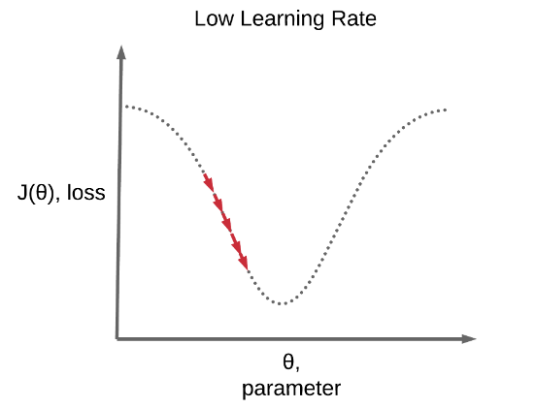

Recurrent Neural Network (RNN).

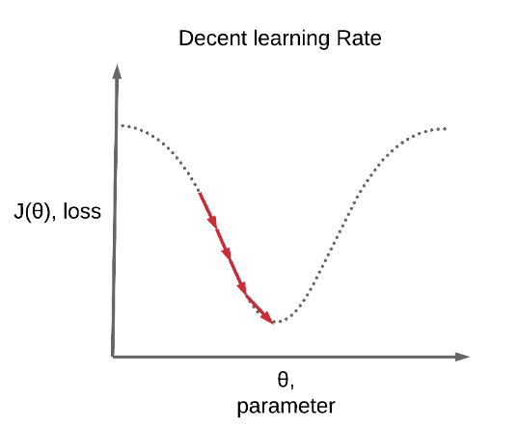

Long Short-term Memory (LSTM).

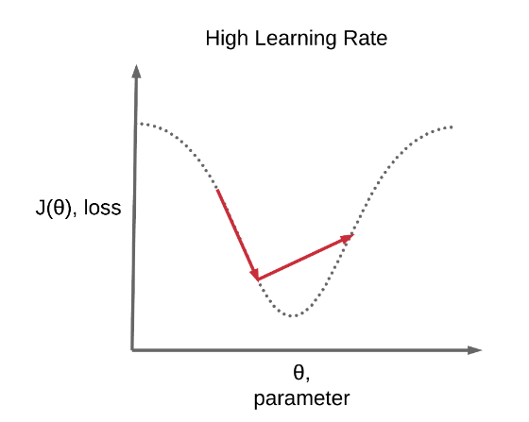

Gate Recurrent Unit (GRU).

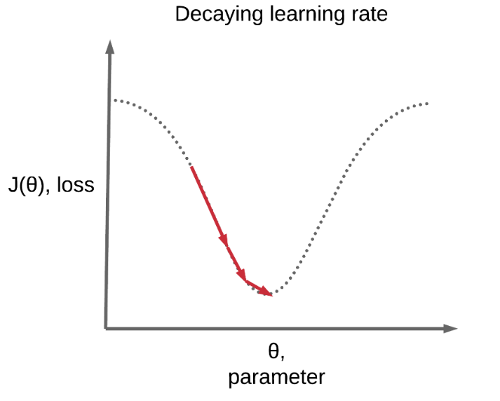

Gate Recurrent Unit (GRU).

In model-specific hyperparameter tuning, the number of neurons and the number of layers need to be determined based on the complexity of our training dataset. The ammonia and colour datasets are considered simple and small datasets. In the hyperparameter tunings of the deep learning models, we simplified the model structure by lowering the number of layers to 1 except for the DNN model. If the number of hidden layers decreased to one, the DNN models would be called the ANN models according to the definition. The number of neurons was set to 10 to maintain simple deep learning models to prevent overfitting.

lccccl Model & Input & h.d & Output & Num. of Exp & Comments  
RF & 24 & - & 3 & 3 & Estimators = 500  
DNN & 24 & 2 & 1 & 3 & h.d = 10 neurons  
RNN & 24 & 1 & 1 & 3 & h.d = 10 neurons  
GRU & 24 & 1 & 1 & 3 & h.d = 10 neurons  
LSTM & 24 & 1 & 1 & 3 & h.d = 10 neurons

The settings of the optimzer hyperparameters are listed in the followings:

**Optimizer hyperparameters**

Learning rate: 5e-05

Number of epochs: 100

Mini batch size: 1

# 4 Results and Discussion

## 4.1 Baseline performance of the forecasting models

In this study, five machine learning algorithms were trained with univariate datasets to predict the ammonia concentrations and colour levels in the reclaimed water system. The forecasting model performance is presented in Fig. [fig:baseline-performance]. As shown in Fig. 4.1, the test loss values of RF, DNN, RNN, GRU, and LSTM models are 0.1158, 0.0561, 0.0440, 0.0414, and 0.0405, respectively. The test loss of the RF model is significantly higher than all the other four deep learning models. The baseline model performance is based on the hyperparameter tunings, and for RF models, only one hyperparameter—estimators (i.e., the number of trees for making decisions in the forest), can be adjusted. For deep learning models, the adjustable hyperparameters are much more, such as, the number of hidden layers, the numbers of neurons, learning rate, etc. The customizable hyperparameters in the deep learning models provide the researchers to fully explore the possibilities of training better models.

GRU and LSTM models learn the data in similar ways compared to RNN but contain more "gates" in the model architectures to control the flow of information. The number of gates in RNN, GRU, and LSTM are one, three, and four; theoretically, GRU and LSTM are capable of learning more information from the data. The results in Fig. 4.1 showed good agreement with our understanding that LSTM performed better than GRU, followed by RNN models. For DNN models, the lack of memorizing cells in the model architecture relates to the poorer capability of learning information hidden in a time-series dataset. The DNN test loss of 0.0440, higher than the 0.0414 of the RNN models, fully justifies the inferior performance for training ammonia forecasting models.

In Fig. 4.2, the test loss from colour forecasting models are 78.5296, 0.0186, 0.0160, 0.0149, and 0.0148 for RF, DNN, RNN, GRU and LSTM models respectively. We first noticed the extremely high test loss value of 78.5296 in the RF model compared to the other four. This could be caused by the colour levels in the range between 80 to 160 Hazen Units, resulting in the amplified MSE values for models poorly forecasting the colour levels. As shown in Fig. 4.5, on 20 January 2022, the errors between the ground truth and forecasted values are up to around 30 Hazen Units, which can contribute to a large increase of MSE values in the test loss. RF model is regarded as an inferior model for forecasting colour levels using the data collected in SWHEPP.

The performance of DNN, RNN, GRU, and LSTM models, from the best to the least, are identical to what we observed in the results of ammonia forecasting models. LSTM model has the lowest test loss of 0.0148, followed by the GRU, RNN, and DNN models. In colour forecasting models, the model performance of LSTM is very close to GRU, with a difference of less than 0.0001 (i.e., less than 1%). However, the lowest test loss generated from the LSTM model in all the experiment runs (i.e., three runs) is 0.0143, which is lower than 0.0146 from the GRU model. Indicating LSTM model has more potential in forecasting time-series data.

The significantly higher test loss of RF models compared to other models can be visualized by plotting the forecasted values with the ground truths (i.e., observed values). In Fig. [fig:baseline-plot], one-step-ahead forecast horizon of ammonia concentration and colour level is plotted by RF as in Fig. 4.3 and Fig. 4.5 and LSTM models as in Fig. 4.4 and Fig. 4.6. It is easier to observe that the RF models are less capable of predicting the water quality parameters.

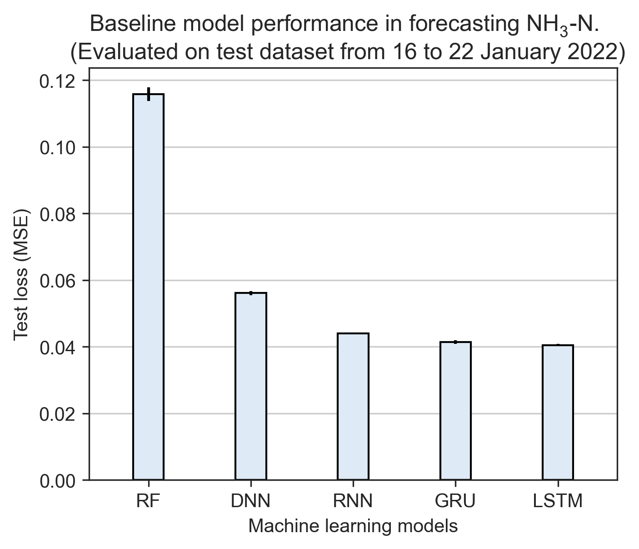

Test loss values from five ammonia forecasting models.

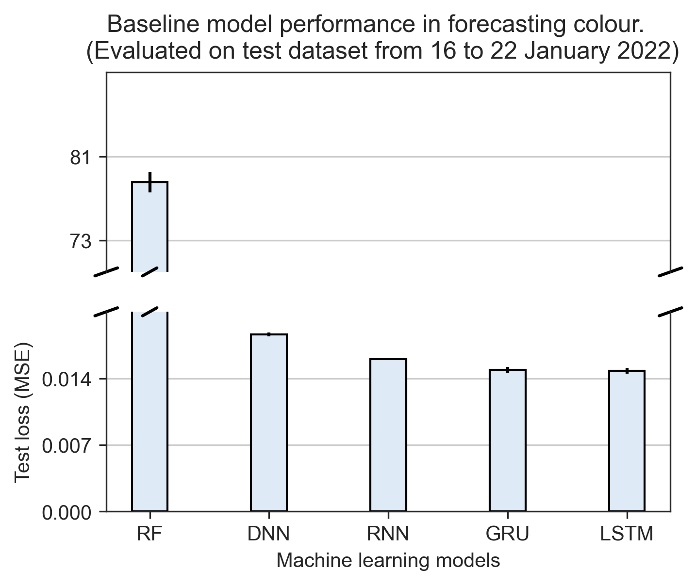

Test loss values from five colour forecasting models.

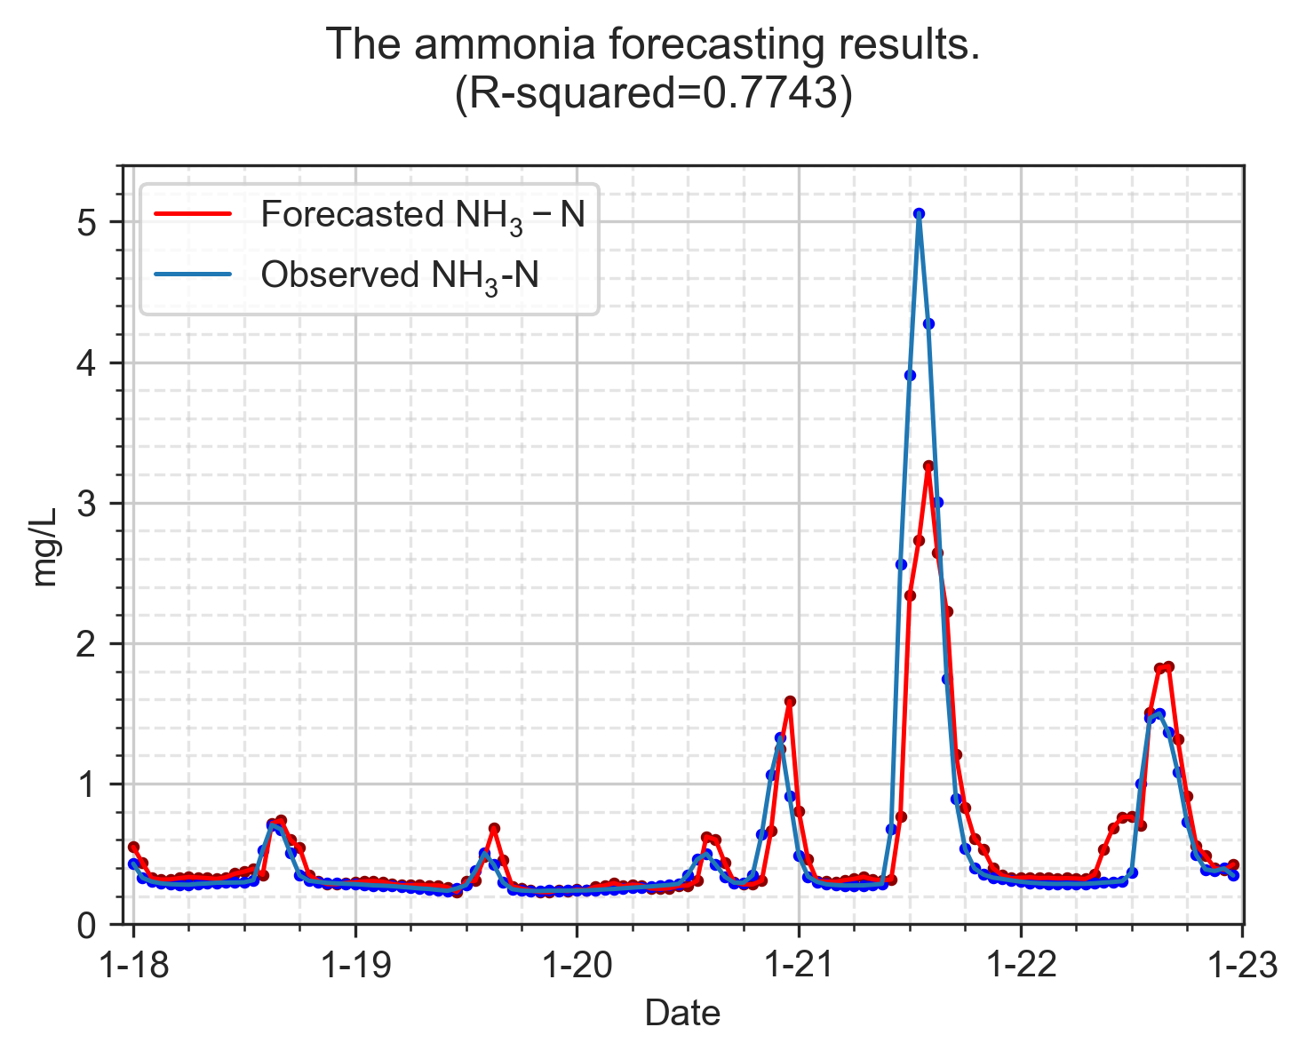

Baseline RF model forecasting ammonia concentration.

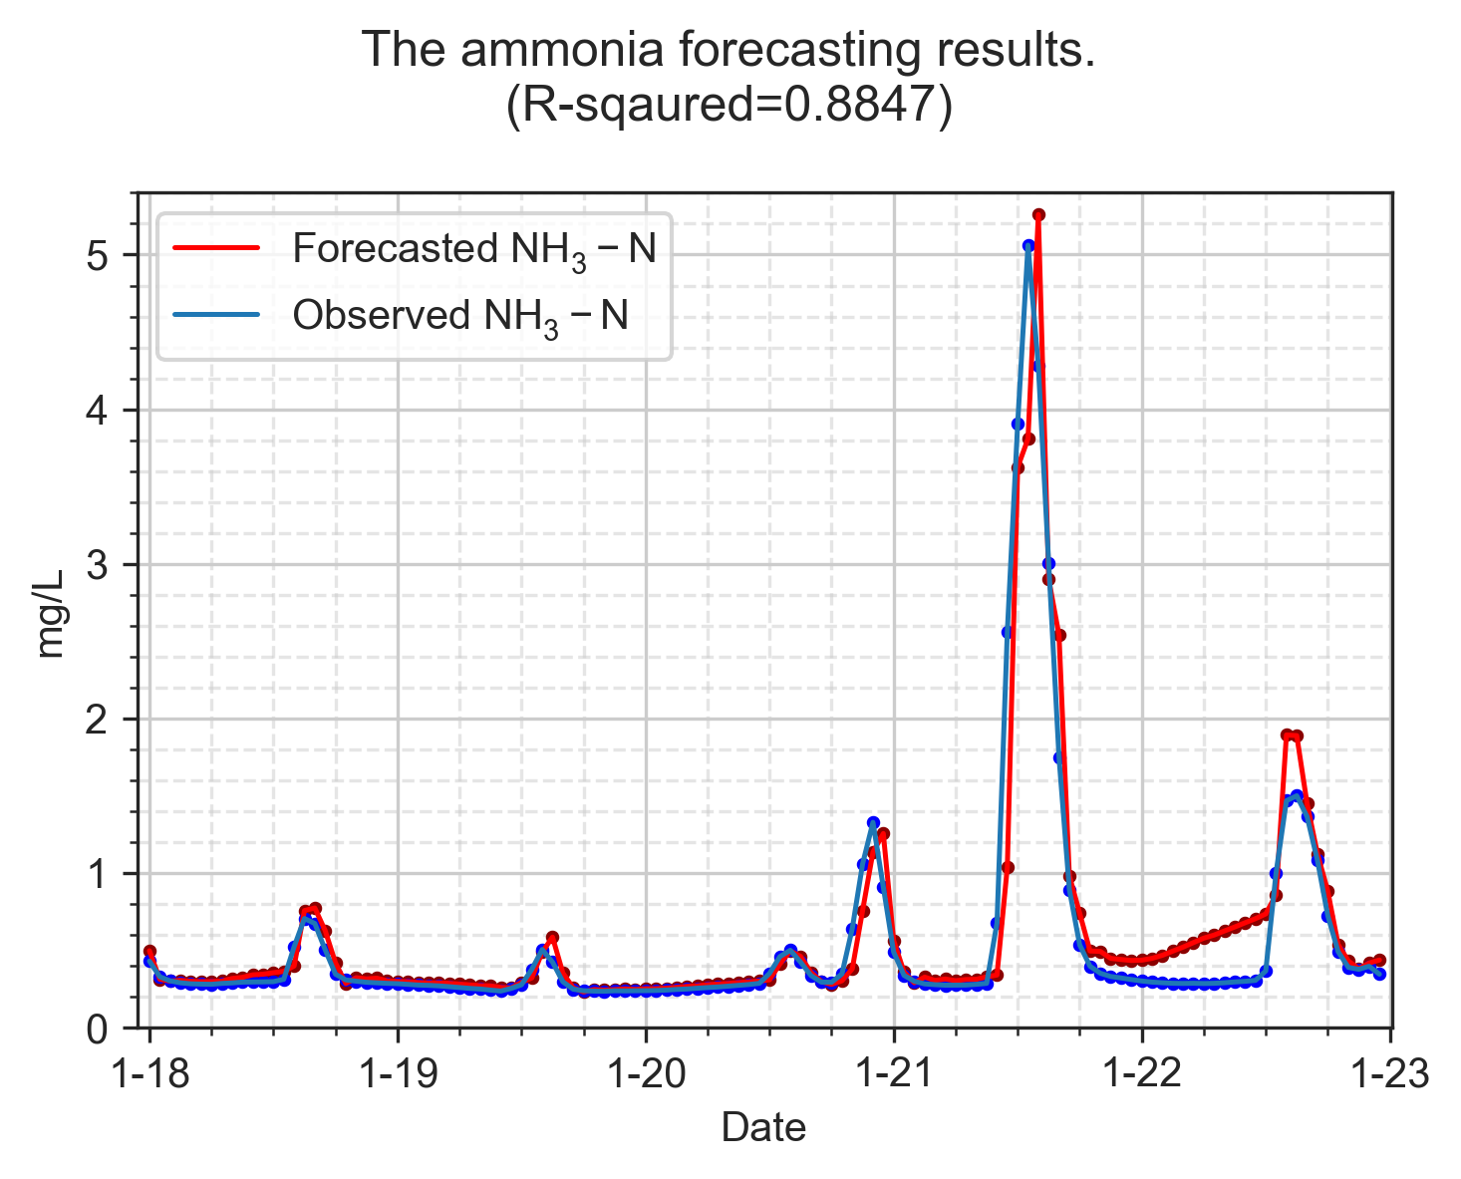

Baseline LSTM model forecasting ammonia concentration.

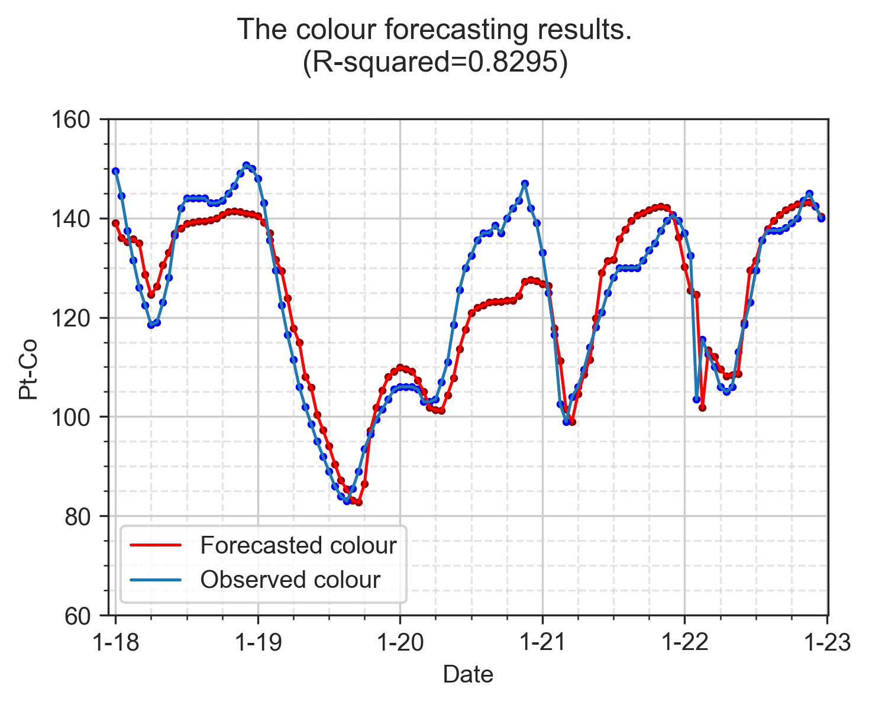

Baseline RF model forecasting colour levels.

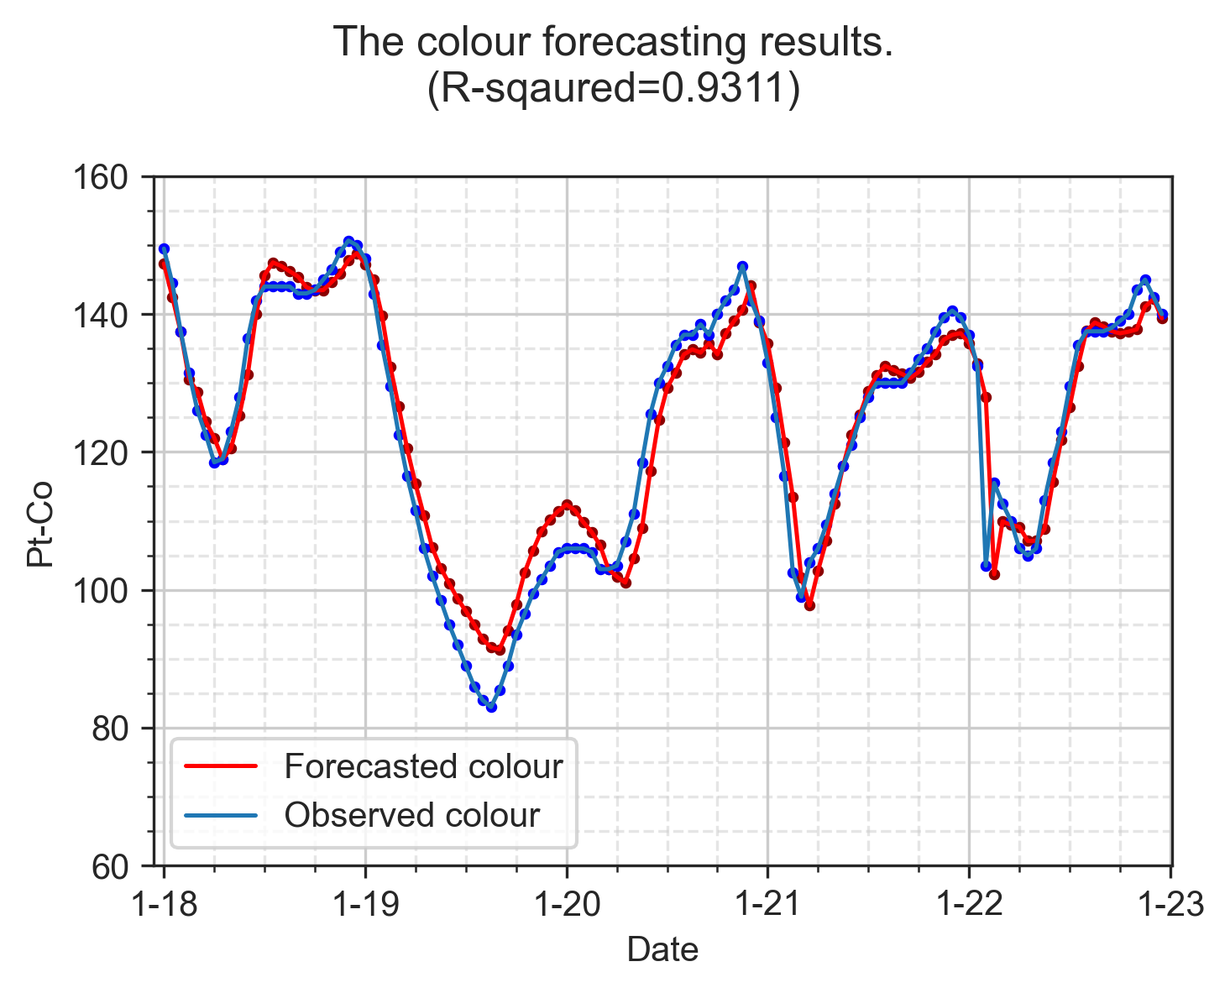

Baseline LSTM model forecasting colour levels.

## 4.2 Improved performance on forecasting models using data pre-processing techniques

### 4.2.1 Models trained by pre-processed datasets

In this study, we investigate whether the datasets treated by the proposed data pre-processing methods can improve the baseline model performance using the same hyperparameter settings. As shown in Table. [tab:baseline-result-jan-nh3] and Table. [tab:baseline-result-jan-colour], we listed all the test loss values of five machine learning algorithms trained with each proposed pre-processed method for ammonia concentrations and colour levels forecasting. The machine learning algorithm trained by datasets that were applied with SG filters at different window sizes is denoted as model-sg5, model-sg7, and model-sg9. The naming rule applies the same to EWMA filtered dataset; the method of outlier removal for ammonia data is denoted as model-or; models trained with the raw datasets are denoted as model-obs (i.e., observed dataset).

lcclcc Model-Dataset & Test loss & Valid loss & Model-Dataset & Test loss & Valid loss  
GRU-sg7 & 0.0383 &1.2508&RNN-or & 0.0432&1.6345  
GRU-sg5 & 0.0385 &1.2644&RNN-ew3 & 0.0434&1.6041  
LSTM-ew3 & 0.0388 &1.0796&RNN-obs & 0.0440&1.6734  
LSTM-sg5 & 0.0388 &1.2346&RNN-sg9 & 0.0442&1.7046  
LSTM-sg7 & 0.0388 &1.1804&DNN-obs & 0.0561&3.2383  
GRU-ew2 & 0.0389 &1.1891&DNN-sg5 & 0.0562&3.2170  
GRU-ew4 & 0.0391 &1.2390&DNN-ew2 & 0.0563&3.1677  
GRU-ew3 & 0.0392 &1.2199&DNN-ew3 & 0.0569&3.2317  
LSTM-ew2 & 0.0392 &1.0969&DNN-sg7 & 0.0570&3.2014  
LSTM-ew4 & 0.0395 &1.1219&DNN-ew4 & 0.0571&3.2188  
GRU-sg9 & 0.0396 &1.3097&DNN-or & 0.0572&3.1972  
LSTM-or & 0.0398 &1.2612&DNN-sg9 & 0.0574&3.2484  
LSTM-obs & 0.0405 &1.3993&RF-obs & 0.1158&-  
GRU-or & 0.0405 &1.2366&RF-sg9 & 0.1196&-  
LSTM-sg9 & 0.0410 &1.3076&RF-ew2 & 0.1286&-  
GRU-obs & 0.0414 &1.3638&RF-or & 0.1294&-  
RNN-sg5 & 0.0415 &1.5088&RF-sg5 & 0.1298&-  
RNN-ew2 & 0.0421 &1.5425&RF-ew3 & 0.1313&-  
RNN-sg7 & 0.0423 &1.6267&RF-sg7 & 0.1409&-  
RNN-ew4 & 0.0432 &1.5992&RF-ew4 & 0.1441&-

The improvements in the performance of ammonia forecasting models are most significant with SG filters. Training GRU models with an sg7 filtered dataset reduced the test loss of GRU-obs from 0.0414 to 0.0383, respectively. LSTM-sg7 also successfully decreased the test loss value of LSTM-obs from 0.0405 to 0.0388, while RNN-sg5 reduced the test loss value of RNN-obs from 0.0440 to 0.0415. The use of SG filters on the training datasets is proven to improve the performance of LSTM, GRU, and RNN models. However, the DNN and RF models trained by sg filtered datasets did not show a superior model performance compared to the test loss values of 0.0561 and 0.1158 of DNN-obs and RF-obs, respectively. DNN and RF models perceive the data points as clusters of individuals, which might be why data smoothing using SG filter did not help improve their model performance. SG filter can smooth the data by convoluting with both previous and the following data points, making a series of data points correlated. Such data property is believed to be captured by recurrent neural networks, such as RNN, GRU, and LSTM. From the results in Table. [tab:baseline-result-jan-nh3], all the recurrent neural networks-based models outperformed all the DNN and RF models. It can be concluded that DNN and RF models are poor options for training time-series models.

The RNN-or, GRU-or, and LSTM-or models, which were trained with datasets applied with outlier removal methods, showed lower test loss values of 0.0432, 0.0405, and 0.0398 compared to test loss values of 0.0440, 0.0414, and 0.0405 from RNN-obs, GRU-obs, and LSTM-obs, respectively. Noticed that the improvements of RNN-or, GRU-or, and LSTM-or are minor compared with the models trained by SG and EWMA filtered datasets. Although removing three days of abnormal data from an 18-days training dataset accounts for around 15% of the data, it is suggested that the deep learning models are smart enough to neglect the noise in the training datasets.

RNN, GRU, and LSTM models trained by EWMA filtered datasets also showed good improvements in the model performance. RNN-ew2, GRU-ew2, and LSTM-ew3 showed lower test loss of 0.0421, 0.0389, and 0.0388 compared to RNN-obs, GRU-obs, and LSTM-obs of 0.0440, 0.0414, and 0.0405, respectively. EWMA filters modified the data points by averaging the value of the current data point with previous ones, making the data property almost identical to the SG filtered data. The performance of models trained by EWMA filtered datasets is consistent to the models trained by SG filtered datasets. However, we noticed something abnormal in the validation loss of models with the top lowest test loss values.

Empirically, the best Model-Dataset combination should have the lowest test and validation loss values when using the same testing dataset to evaluate different models. For instance, the GRU-sg7 model in forecasting ammonia has the lowest test loss of 0.0383, yet the validation loss of 1.2508 only ranks tenth among the smallest validation loss values. The top three lowest validation loss models are LSTM-ew3, LSTM-ew2 and LSTM-ew4. This finding points to the potential of heterogeneity between the training and testing datasets. Further tests were carried out using a testing dataset from October to examine how the Model-Dataset ranks of test and validation loss values will change. To the best of my understanding, the comparisons between testing and validation loss are not discussed in the currently available research papers in the modeling of the wastewater treatment industry.

As shown in Table. [tab:baseline-result-oct-nh3], the models with the lowest test loss values are 0.0158, 0.0161, 0.0163 for LSTM-ew3, LSTM-ew2, and LSTM-ew4, which match the top three lowest validation loss values of 1.0796, 1.0969, and 0.1219. This is in good agreement with how the heterogeneity of the datasets can impact the model performance. The evaluations of the ammonia forecasting models in October 2021 showed completely different outcomes compared to the one in January 2022. Instead of GRU, LSTM becomes the best model for training the ammonia forecasting model. The most remarkable result in Table. [tab:baseline-result-oct-nh3] is that the EWMA filter seems to be an ideal pre-processing method for training deep learning model.

lcclcc Model-Dataset & Test loss & Valid loss & Model-Dataset & Test loss & Valid loss  
LSTM-ew3 & 0.0158 & 1.0796 & RNN-or & 0.0197 & 1.6345  
LSTM-ew2 & 0.0161 & 1.0969 & RNN-sg7 & 0.0201 & 1.6267  
LSTM-ew4 & 0.0163 & 1.1219 & RNN-sg9 & 0.0205 & 1.7046  
LSTM-sg5 & 0.0166 & 1.2346 & RNN-obs & 0.0206 & 1.6734  
GRU-ew3 & 0.0167 & 1.2199 & DNN-ew3 & 0.0316 & 3.2317  
GRU-ew4 & 0.0169 & 1.2390 & DNN-or & 0.0316 & 3.1972  
GRU-ew2 & 0.0170 & 1.1891 & DNN-sg7 & 0.0316 & 3.2014  
GRU-sg9 & 0.0174 & 1.3097 & DNN-ew2 & 0.0318 & 3.1677  
LSTM-obs & 0.0175 & 1.2366 & DNN-ew4 & 0.0319 & 3.2188  
LSTM-or & 0.0177 & 1.2612 & DNN-obs & 0.0319 & 3.2383  
GRU-sg5 & 0.0178 & 1.2644 & DNN-sg5 & 0.0319 & 3.2170  
GRU-sg7 & 0.0180 & 1.2508 & DNN-sg9 & 0.0319 & 3.2484  
LSTM-sg7 & 0.0180 & 1.1804 & RF-sg9 & 0.1307 & -  
GRU-or & 0.0187 & 1.3993 & RF-sg7 & 0.1311 & -  
LSTM-sg9 & 0.0188 & 1.3076 & RF-sg5 & 0.1343 & -  
GRU-obs & 0.0189 & 1.3638 & RF-ew2 & 0.1346 & -  
RNN-ew4 & 0.0190 & 1.5992 & RF-ew3 & 0.1368 & -  
RNN-ew2 & 0.0191 & 1.5425 & RF-obs & 0.1443 & -  
RNN-ew3 & 0.0193 & 1.6041 & RF-ew4 & 0.1451 & -  
RNN-sg5 & 0.0195 & 1.5088 & RF-or & 0.1477 & -

The test loss values of the colour forecasting models are presented in Table. [tab:baseline-result-jan-colour]. The top six lowest test loss models are LSTM-ew4, LSTM-ew2, LSTM-ew3, GRU-ew3, GRU-ew2, and GRU ew4 with the values of 0.0136, 0.0138, 0.0138, 0.0140, 0.0142, and 0.0143, respectively. Notice that all the top models are trained by EWMA filtered datasets. Interestingly, LSTM models trained by EWMA filtered dataset also showed superior performance in ammonia forecasting models, as shown in Table. [tab:baseline-result-oct-nh3]. The top three ranks of Model-Dataset in the lowest validation loss ranks the $6^{th}$, ${20}^{th}$, and $1^{st}$ from the lowest test loss values. Despite the fact that we would like to use the same models to predict colour levels from other periods of time, we do not have extra testing datasets for re-evaluating the colour forecasting models. Compromises have to be made during the analysis of colour forecasting models.

lcclcc Model-Dataset & Test loss & Valid loss & Model-Dataset & Test loss & Valid loss  
LSTM-ew4 & 0.0136 &0.7515&RNN-obs & 0.0160 &1.0623  
LSTM-ew2 & 0.0138 &0.8011&LSTM-sg7 & 0.0161 &0.7439  
LSTM-ew3 & 0.0138 &0.7547&LSTM-sg5 & 0.0168 &0.8355  
GRU-ew3 & 0.0140 &0.8068&DNN-sg5 & 0.0180 &1.4702  
GRU-ew2 & 0.0142 &0.8330&DNN-sg7 & 0.0180 &1.4823  
GRU-ew4 & 0.0143 &0.7694&DNN-sg9 & 0.0180 &1.4574  
LSTM-sg9 & 0.0143 &0.7137&DNN-ew4 & 0.0181 &1.4632  
RNN-ew3 & 0.0144 &0.8492&DNN-ew3 & 0.0182 &1.4716  
RNN-ew4 & 0.0147 &0.8476&DNN-ew2 & 0.0183 &1.4946  
RNN-sg9 & 0.0147 &0.8363&DNN-obs & 0.0186 &1.5397  
LSTM-obs & 0.0148 &0.9744&RF-sg9 & 63.6847&  
GRU-obs & 0.0149 &0.9927&RF-sg7 & 73.8263&  
RNN-ew2 & 0.0150 &0.9083&RF-ew3 & 75.1974&-  
GRU-sg9 & 0.0151 &0.7575&RF-ew4 & 77.8829&-  
RNN-sg5 & 0.0158 &0.8846&RF-obs & 78.5296&-  
RNN-sg7 & 0.0158 &0.8755&RF-ew2 & 78.8753&-  
GRU-sg7 & 0.0159 &0.7791&RF-sg5 & 81.0696&-  
GRU-sg5 & 0.0160 &0.8080& - & - &-

By comparing the baseline performance and the influences of data pre-processing techniques on machine learning models, our findings appear to be well substantiated by using LSTM models for training ammonia and colour forecasting models due to their outstanding model performance evaluated by test loss values. Although EWMA filters showed surprising effects on improving the performance of most models, the influence of pre-processing methods is still not consistent across different models and training datasets. Thus, the testings of the proposed model training processes will include all the pre-processing techniques for model training, and LSTM will be used as the only machine learning model.

### 4.2.2 The effect of window size of data smoothing filters

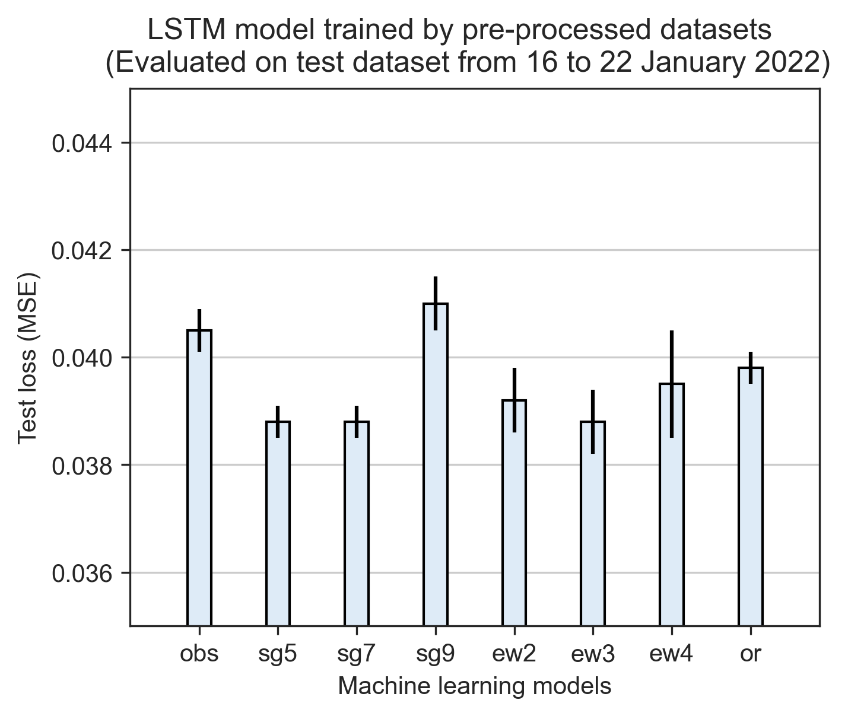

Baseline performance of ammonia forecasting models trained by LSTM.

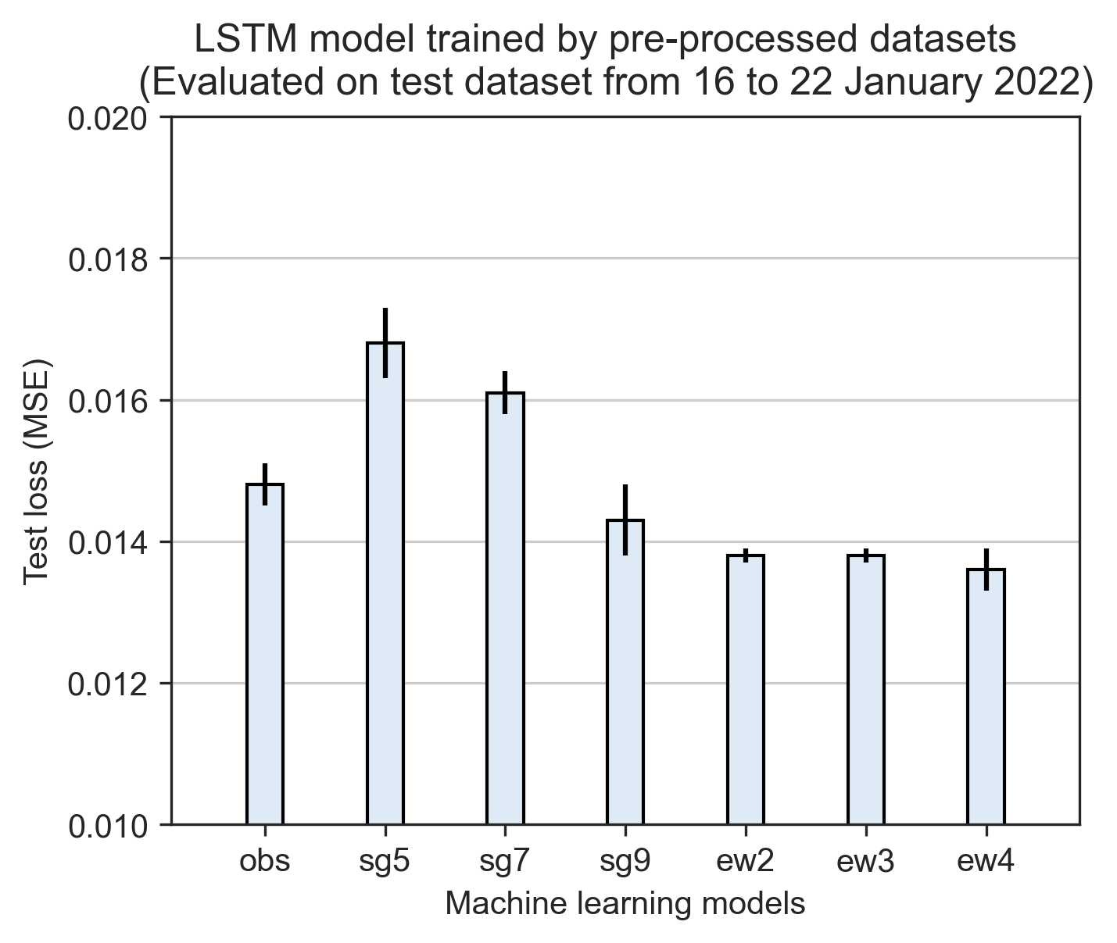

Baseline performance of colour forecasting models trained by LSTM.

The influences of window sizes in the data smoothing process are investigated using LSTM models and illustrated in Fig. [fig:preprocessing-comparison]. SG window sizes of higher and lower have different impacts on ammonia and colour forecasting models. In ammonia forecasting models, as shown in Fig. 4.7, LSTM models trained with SG filtered datasets with window sizes of 5, 7, and 9 have the test loss values of 0.0388, 0.0388, and 0.0410. The results suggested that modifying data points at higher degrees may negatively affect the model training process. The results from models trained by EWMA filtered datasets showed good agreement with this finding. The model trained with EWMA filtered datasets with the windows size of 2, 3, and 4 have the test loss values of 0.0392, 0.0388, and 0.0395. The higher test loss value is observed in LSTM-ew4.

For colour forecasting models as shown in Fig. 4.8, LSTM models trained by SG filtered datasets with window sizes of 5, 7, and 9 have test loss values of 0.0168, 0.0161, and 0.0143. LSTM models trained by EWMA filtered datasets with window sizes of 2, 3, and 4 showed test loss values of 0.0138, 0.0138, and 0.0136. From this result, we observed that larger window sizes helped the models achieve lower test loss for color forecasting models, which does not support what we have concluded for the ammonia forecasting models. One possible explanation for the contradictory results is that ammonia and colour data have different sensitivity toward the data smoothing filters. For instance, ammonia concentrations change between the values of 7.0 to 1.0 mg/L, while colour levels change from 160 to 80 Hazen Units, making the values of filtered data points less significant in colour data. In other words, if ammonia data points are deviated from the original values after applying data smoothing techniques, the value might be biased. By far, we can not conclude how to select the window sizes of the data smoothing filters. The unpredictable influences of applying data smoothing filters on forecasting models impede the determination of the optimal data smoothing method in the subsequent experiments. All the pre-processing techniques will be applied to the LSTM models for further studies.

## 4.3 Exploit hidden patterns in MBR effluent water quality to enhance model performance

### 4.3.1 Ammonia forecasting models

In the section of feature engineering, we have introduced the selection and creation of the extra input features for training forecasting models, as shown in Fig. 3.25. In this study, a forecasting model trained by one feature is called an univariate model and denoted as LSTM-1; a forecasting model trained by two features is called a multivariate model and denoted as LSTM-2. For models trained by three and four features are denoted as LSTM-3 and LSTM-4. In Fig. 4.9, the performance of ammonia forecasting models trained by two to four inputs (i.e., LSTM-2, LSTM-3, LSTM-4) is compared with the baseline performance (i.e., LSTM-1-obs) to demonstrate how the feature engineered features influenced on the model outputs.

As shown in Fig. 4.9, LSTM-4-obs, LSTM-3-obs, LSTM-2-obs, and LSTM-1-obs have the test loss values of 0.0432, 0.0426, 0.0411, and 0.0405, respectively. This result indicates that LSTM models trained with more features resulted in poorer model performance. Based on our understanding to the extra features such as color levels and sine/cosine features, models trained with more features are expected lower test values. The model performance from LSTM-sg7 and LSTM-sg9 fits well with what we hypothesized. The test loss values of LSTM-4-sg7, LSTM-3-sg7, LSTM-2-sg7, LSTM-1-sg7 are 0.0369, 0.0373, 0.0379, 0.0388, respectively. For LSTM-4-sg9, LSTM-3-sg9, LSTM-2-sg9, and LSTM-1-sg9, the test loss values are 0.0384, 0.0391, 0.0409, 0.0410, respectively. These findings showed that the test loss values of the LSTM models trained by sg7 and sg9 filtered datasets followed the trends of LSTM-4 $<$ LSTM-3 $<$ LSTM-2 $<$ LSTM-1. The most remarkable results are from LSTM models trained by SG filtered dataset at a window size of 7. Comparing to the baseline model performance (i.e., LSTM-1-obs), the test loss values of LSTM-1-sg7, LSTM-2-sg7, LSTM-3-sg7 and LSTM-4-sg7 reduced by 4.2%, 6.4%, 7.9%, and 8.9%, respectively.

Our findings in the ammonia forecasting models suggest that colour level is an indispensable input for improving the model performance. LSTM-2 models trained by datasets applied with any pre-processing techniques showed lower test loss compared to LSTM-1, except LSTM-2 trained by dataset without applying any methods. Strong evidence leads us to believe that the fluctuation of ammonia concentration is highly correlated with the colour level in SHWEPP influent even without direct evidence.

The methods of training LSTM models on pre-processed datasets have proved their benefits in improving baseline model performance. Yet, the test loss values were only reduced slightly for those models trained with EWMA filtered datasets. As shown in Fig. 4.9, LSTM-3-ew2, LSTM-4-ew2, LSTM-3-ew4, and LSTM-4-ew4 shared very similar test loss values to LSTM-1-obs, indicating the advantages of enhanced training datasets were not fully reflected on the model performance when LSTM models were trained with EWMA filtered datasets.

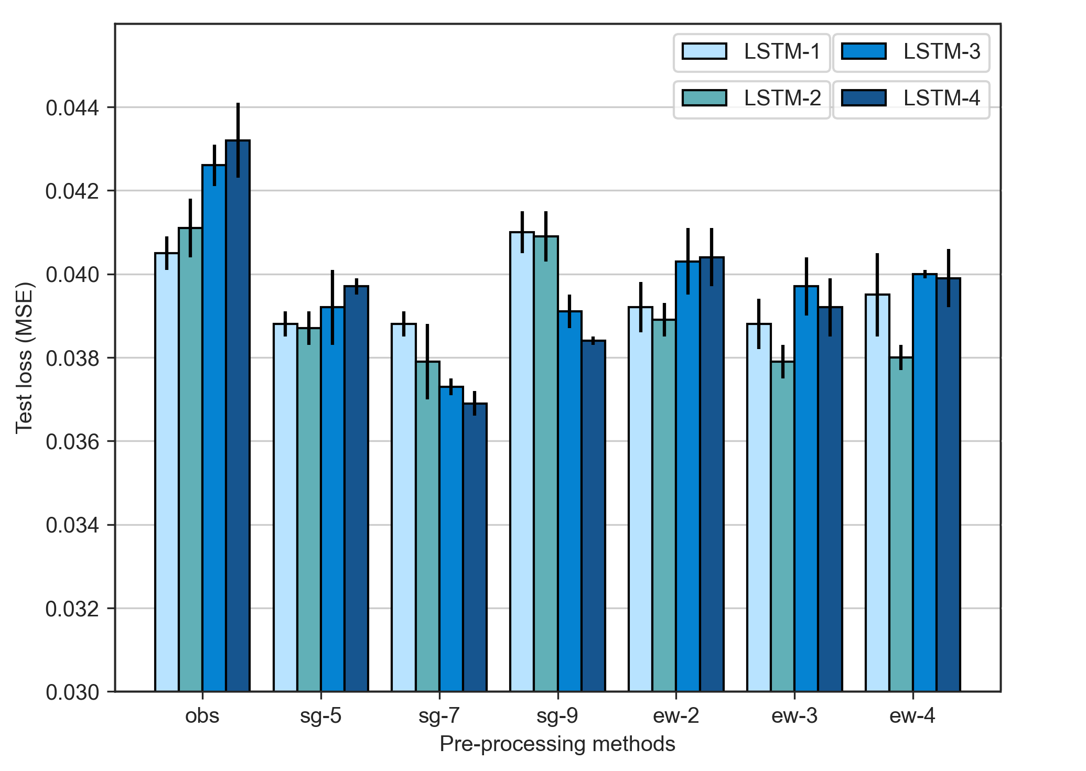

Comparisons of the model performance in forecasitng ammonia concentrations.

### 4.3.2 Colour forecasting models

As shown in Fig. 4.10, the baseline performance is LSTM-1-obs with test loss value of 0.0148, and many models trained by both SG and EWMA filtered datasets show lower test loss values. The performance of models trained by SG filtered datasets was rather disappointing. In the results of models trained by sg-5 and sg7 filtered datasets, only LSTM-3-sg5, LSTM-3-sg7, and LSTM-4 sg-7 showed lower test loss values of 0.0144, 0.0143, and 0.0136, respectively, compared to LSTM-1-obs. Models trained by sg9 and all the EWMA filtered datasets showed improvement over LSTM-1-obs. In LSTm-3-sg9, we observed the lowest test loss value of 0.0129, which is 28.6% lower than the test loss values of 0.0148 from LSTM-1-obs.

The test loss values of LSTM-4-sg9, LSTM-4-ew2, LSTM-4-ew3, and LSTM-4-ew4 are higher than LSTM-3-sg9, LSTM-3-ew2, LSTM-3-ew3, and LSTM-3-ew4, by 0.0009, 0.0009, 0.0002, and 0.0002, respectively. This finding indicates that training with ammonia and the sine/cosine features deteriorate the model performance for color forecasting models. From what we found in the results of ammonia forecasting models, we concluded that the test loss values increase more when more features were input to the training datasets. In the colour forecasting results, the finding contrasts what we have found previously. The interpretation for the higher test loss in LSTM-4 models in sg9, ew2, ew3, and ew4 filtered datasets compared to LSTM-3 and LSTM-2 models are that ammonia and sine/cosine features are irrelevant to the development of colour forecasting models. In the process of generating feature engineering, we observed that colour substances are mixed with municipal wastewater at the volume to volume ratio of 1 to 50. Hence, we can infer that the model outputs of forecasted colour levels are highly subject to the input of ammonia concentration. In the training process of the machine learning model, it treats each input feature with equivalent importance; however, when the model is trained and input with unseen data, the model cannot differentiate which input feature actually influences on the model output the most. The results suggest that it is better to train with colour data and sin/cosine features for training color forecasting models.

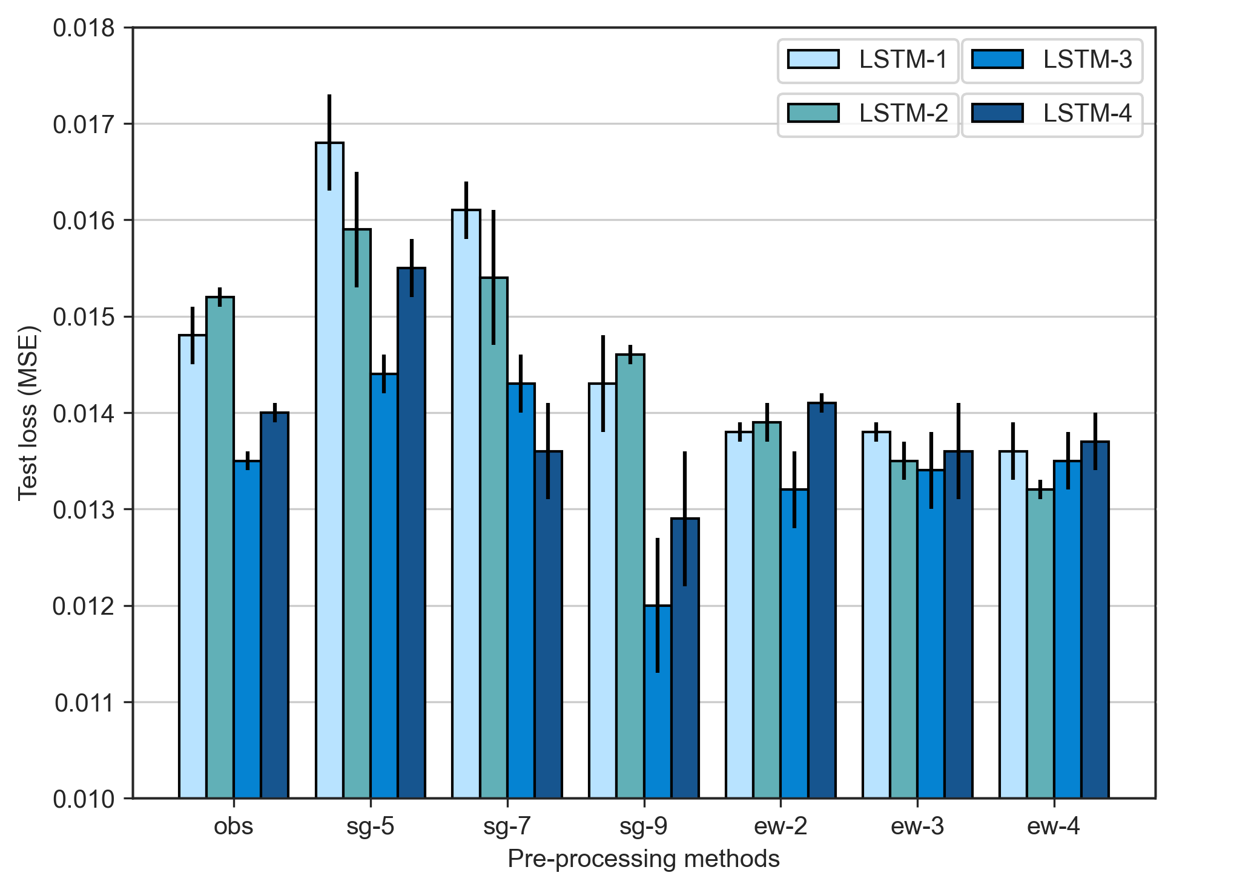

Comparisons of model performance in forecasting colour levels.

### 4.3.3 Model forecasting results on different forecast horizon

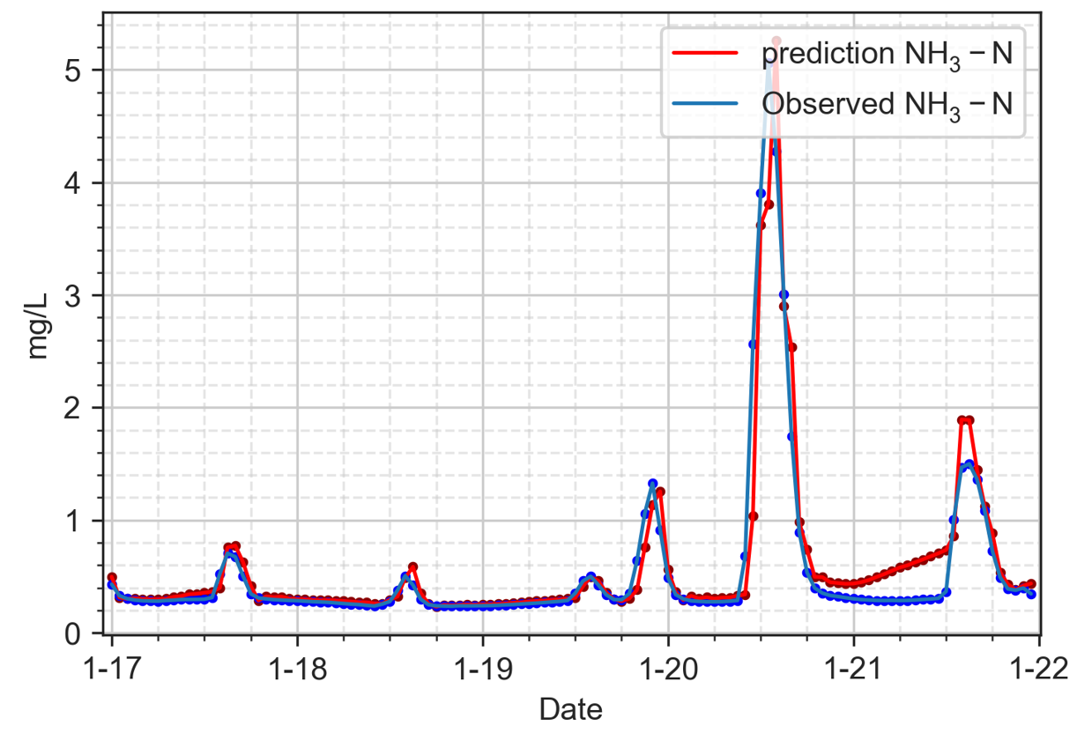

FC1, LSTM-1-obs, MSE = 0.0647

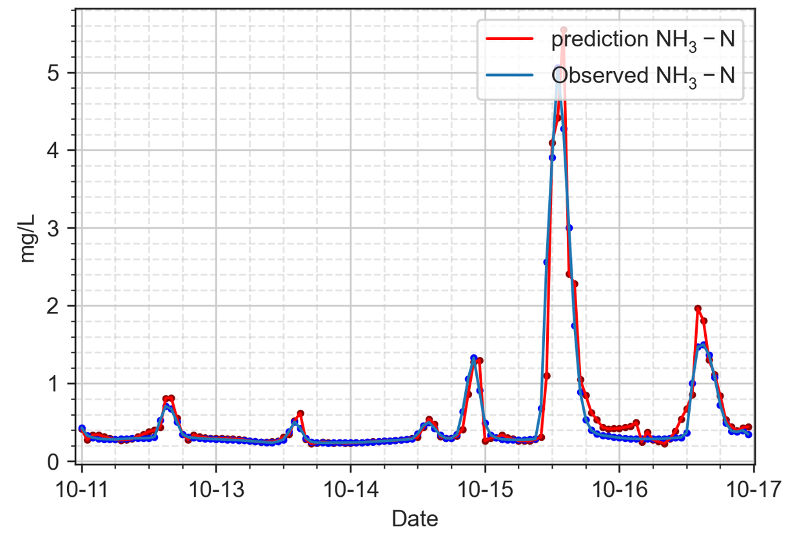

FC1, LSTM-3-sg9, MSE = 0.0529

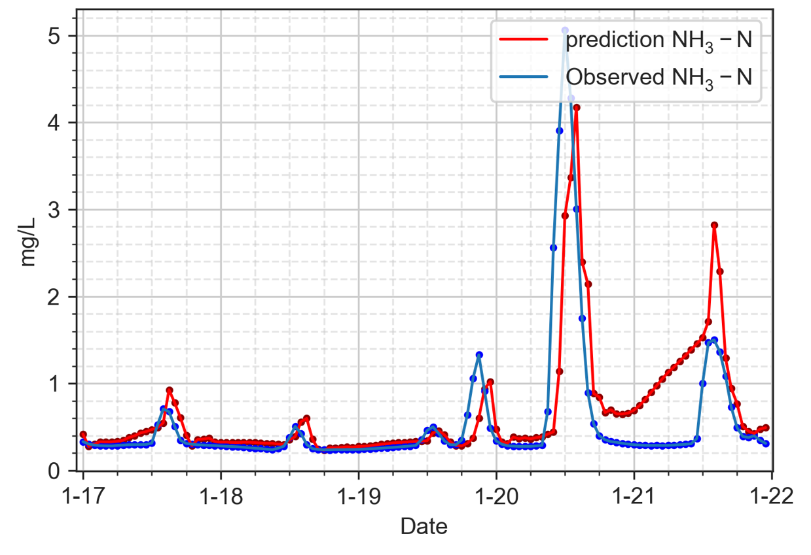

FC2, LSTM-3-sg9, MSE = 0.2916

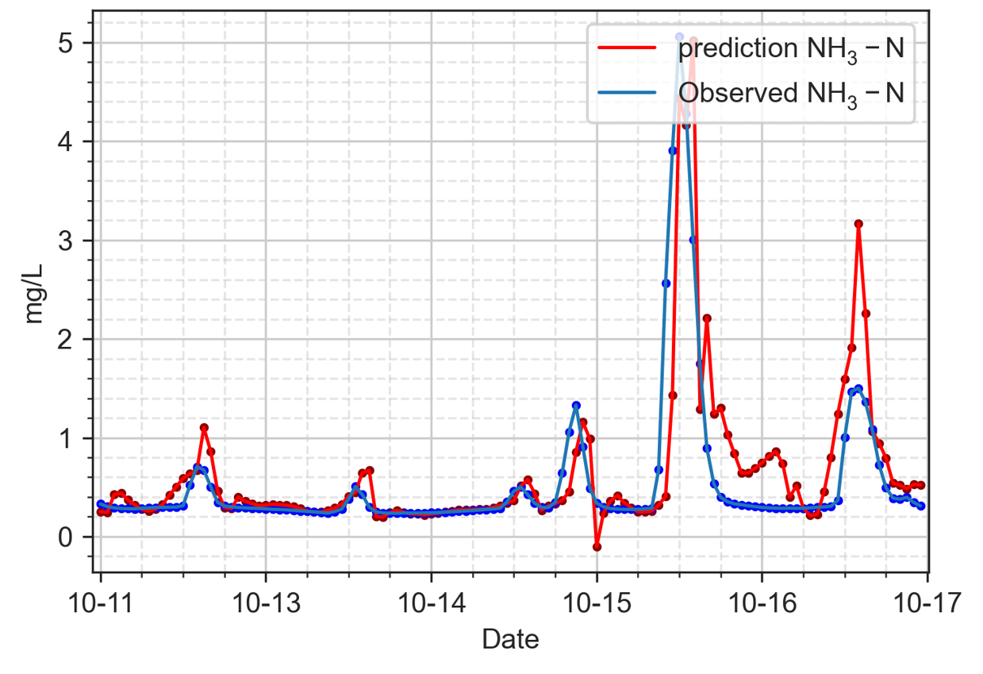

FC2, LSTM-3-sg9, MSE = 0.2351

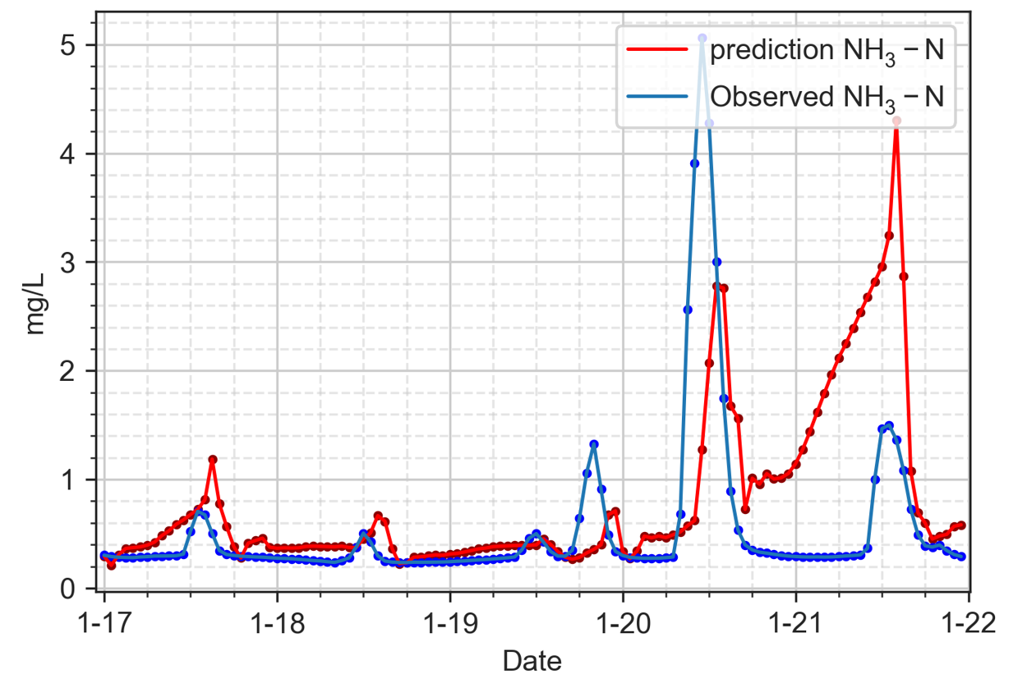

FC3, LSTM-3-sg9, MSE = 0.8025

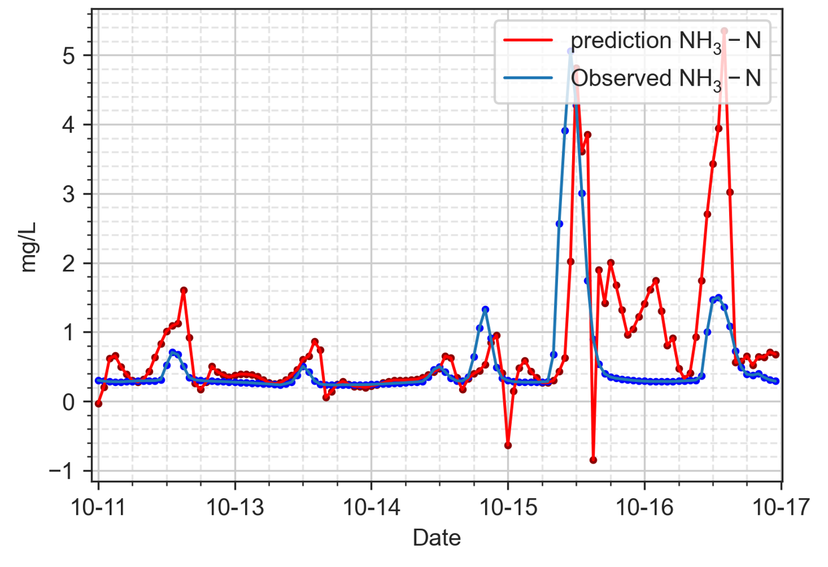

FC3, LSTM-3-sg9, MSE = 0.7637

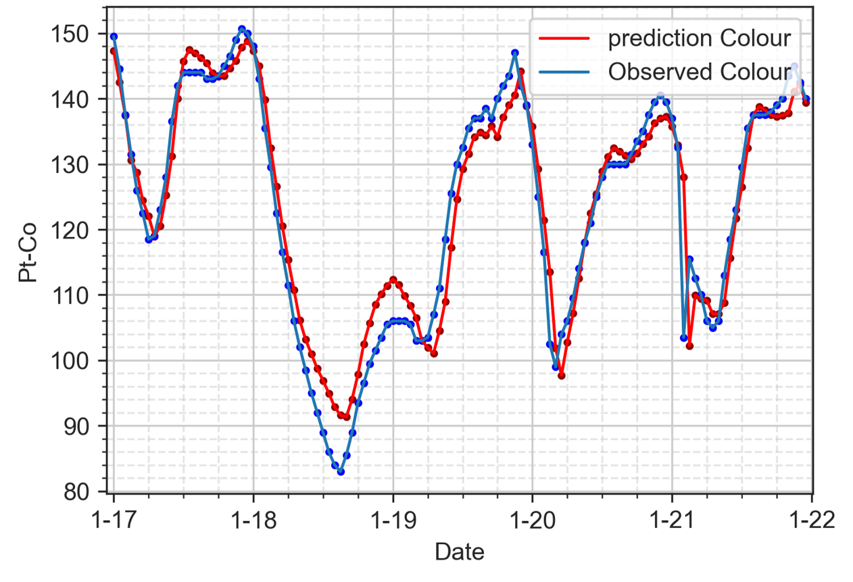

FC1, LSTM-1-obs, MSE = 22.4922

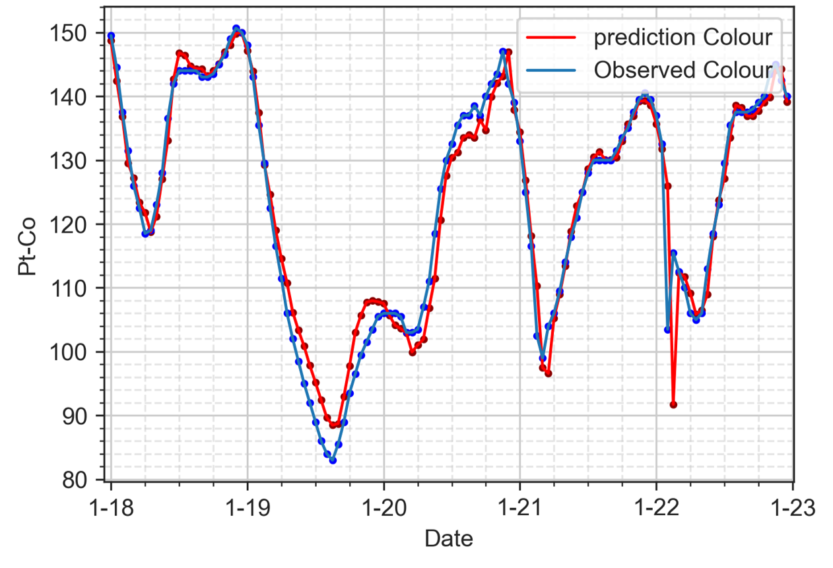

FC1, LSTM-3-sg9, MSE = 17.5955

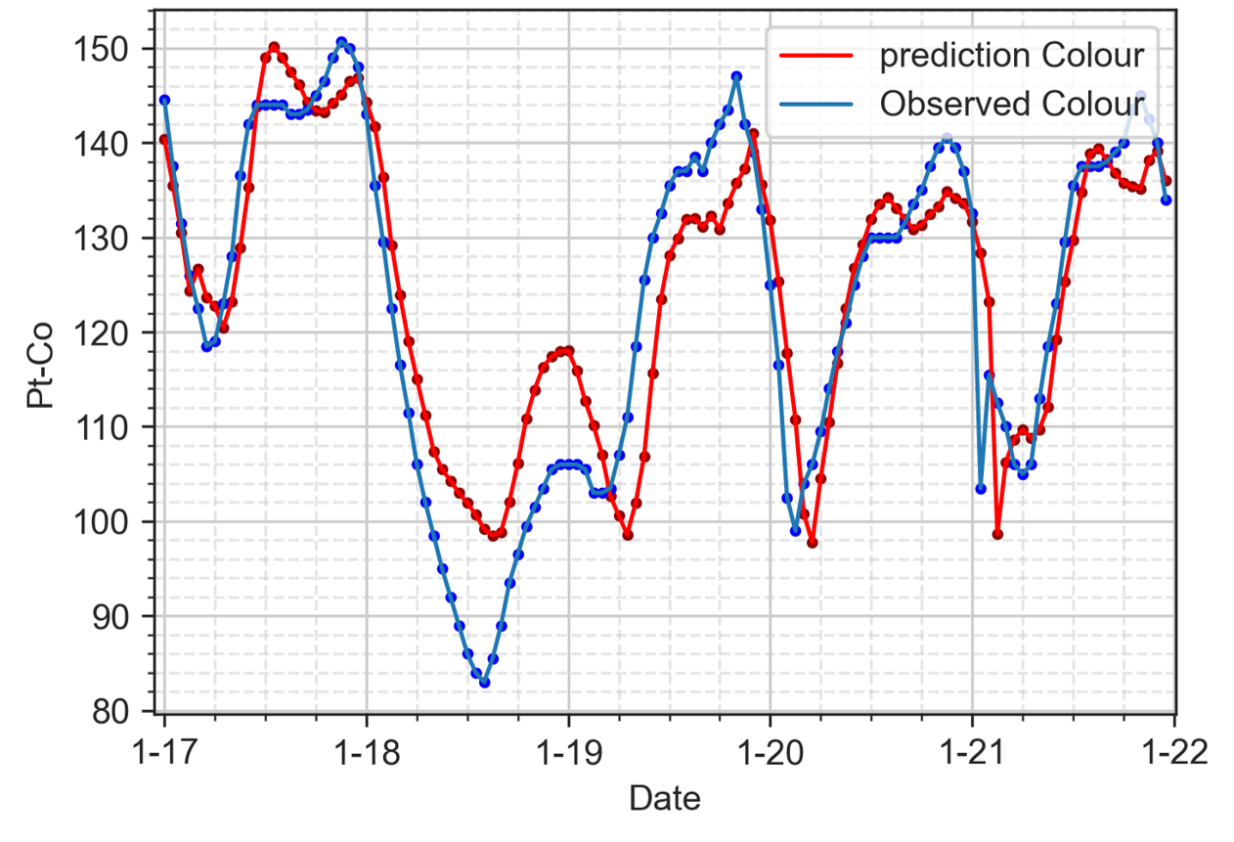

FC2, LSTM-3-sg9, MSE = 62.6678

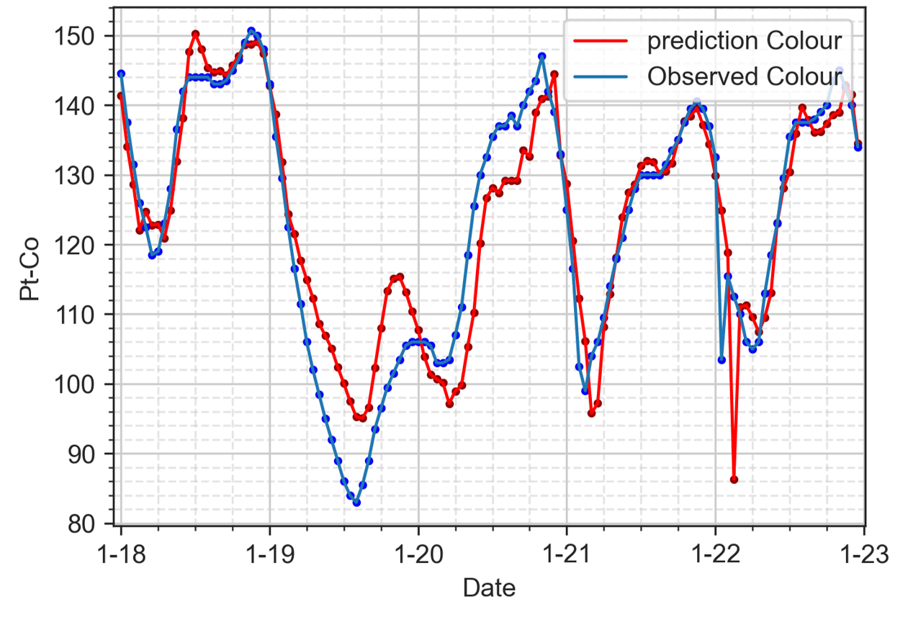

FC2, LSTM-3-sg9, MSE = 47.4252

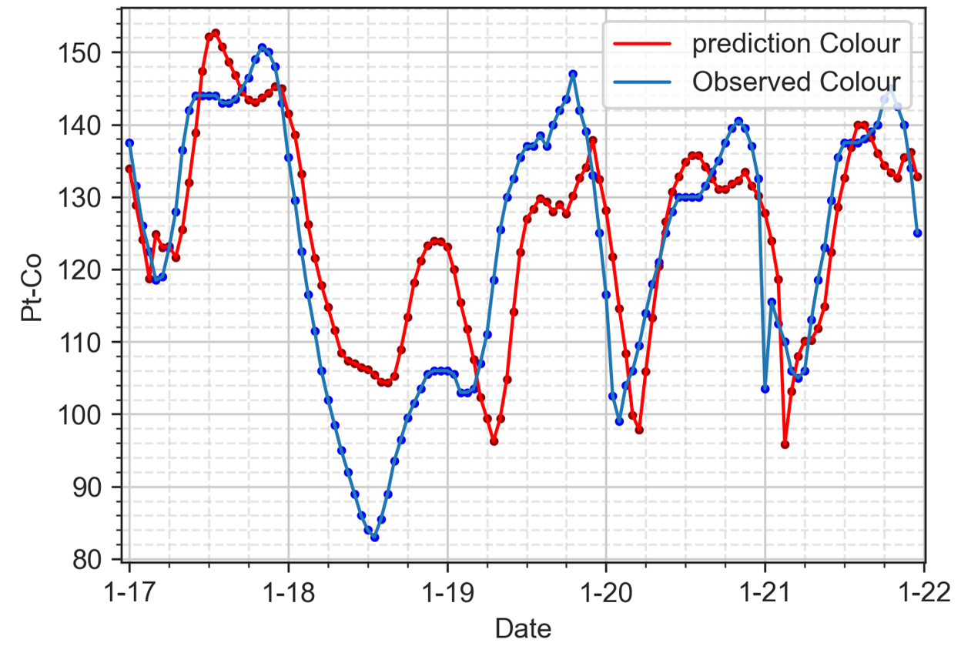

FC3, LSTM-3-sg9, MSE = 116.8928

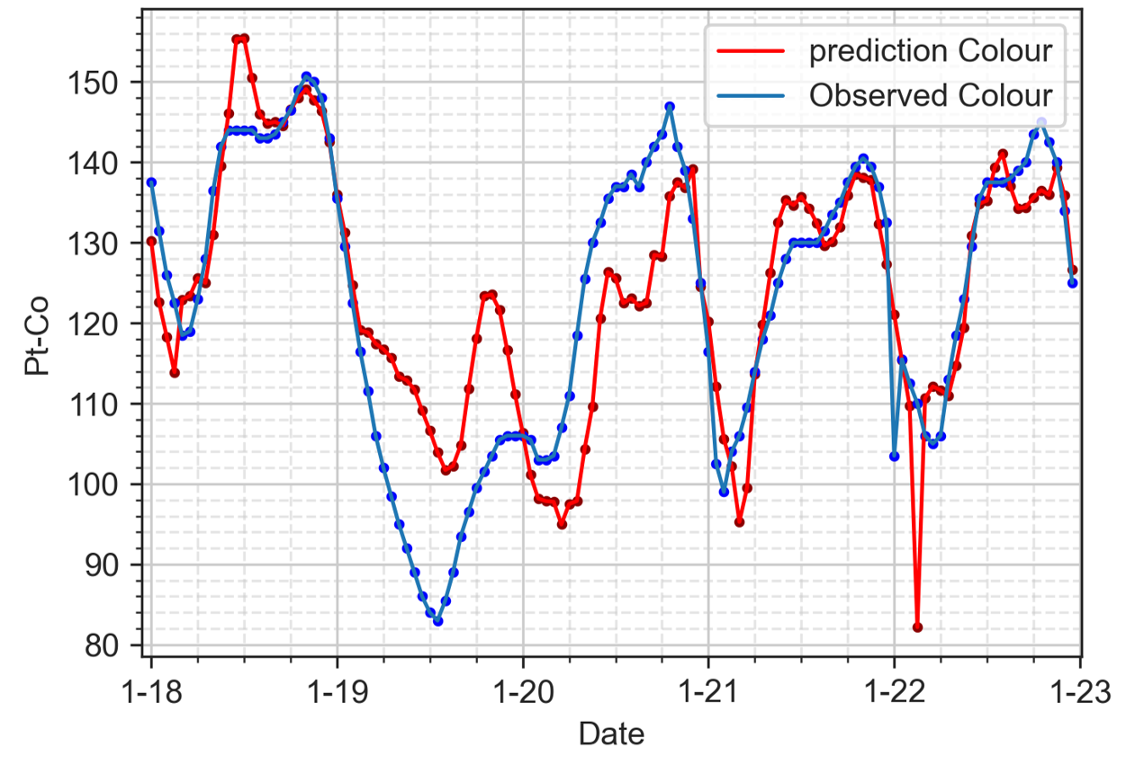

FC3, LSTM-3-sg9, MSE = 103.4329

# 5 Conclusions and Recommendation

## 5.1 Conclusions

### 5.1.1 Machine learning models vs deep learning models

The selection of using which machine learning and deep learning models was not widely discussed to the best of our knowledge in the modeling of the wastewater treatment industry. This study has investigated the model performance of the machine learning model of RF and four other deep learning models of DNN, RNN, GRU, and LSTM on forecasting ammonia concentrations and colour levels in the reclaimed water system for assisting treatment operation and management. The evidence from this study suggests deep learning models are much capable of learning from historical data and generating more accurate forecasting results. In both ammonia and colour forecasting models, the test loss values of RF are much higher than those of the least-performance deep learning model of DNN. Among all the deep learning models, the results indicate that LSTM and GRU models have the lowest test loss of 0.0405 and 0.0414, respectively. However, further research works suggest that LSTM models trained with pre-processing methods generate the lowest test loss compared to GRU, making the LSTM model the most promising recurrent neural network model for training forecasting models.

### 5.1.2 Data pre-processing techniques

Our research also highlighted how the model performance could be improved by applying data pre-processing and feature engineering techniques. Generally speaking, all the proposed data smoothing and outlier removal methods reduced the test loss values compared to the baseline model performance (i.e., the window sizes of the filters need to be carefully selected), as shown in Fig. [fig:preprocessing-comparison]. It is believed that the convoluted data points generated from data smoothing filters enable the recurrent neural networks to predict future values more easily.

### 5.1.3 Feature engineering

This study is the first step towards enhancing our understanding of the potential benefits of using created features for model training. The thorough examinations of the Geomap near the SHWEPP and the investigation of water composition in the public sewage system helped us hypothesize that the change of ammonia concentrations and colour levels depend on each other. With the help of additional colour/ammonia data for the ammonia/colour forecasting models, the test loss was reduced by 6.4% (i.e., LSTM-2-sg7 compared to LSTM-1-obs) and 10.8% (i.e., LSTM-2-ew4 compared to LSTM-1-obs), respectively.

Moreover, the similarity between the household consumption patterns and the daily fluctuation of ammonia concentrations have unexpectedly helped us to formulate the time features via positional encoding. The influence of the sine and cosine hour features on the model performance showed tremendous improvements in both ammonia and colour forecasting models. In the former, test loss dropped by 8.9% (i.e., LSTM-1-obs compared with LSTM-4-sg7) while the latter reduced by 28.6% (i.e., LSTM-1-obs compared with LSTM-3-sg9). The remarkable use of positional encoding features is that they are not limited to ammonia and colour forecasting models. Any time-series data characterized by daily fluctuation patterns can adopt the use of the features of sine and cosine hour as long as the patterns are based on actual events. In addition, the positional encoding features are not limited to the hour component, we can encode time component features from seconds to weeks and even years, the application of it is infinite. However, the feature engineering method has some limitations. In the results of ammonia forecasting models, LSTM-2-obs, LSTM-3-obs, and LSTM-4-obs showed higher test loss compared to LSTM-1-obs, indicating that when the models were trained by any features other than ammonia, the model performance worsened. Another scenario from the colour forecasting results is that the test loss increases when the models are input with more than one feature and trained with EWMA filtered datasets. Our results suggest that feature engineering needs to be carefully evaluated and experimented with before its real application. Despite the limitations, the combination use of feature engineering in building ammonia and colour forecasting models in this study has fully proved its advantages.

## 5.2 Recommendations for future research

Due to the insufficient amount of ammonia and colour data, we cannot differentiate whether the undesired model performance was caused by the heterogeneity of the training and testing datasets or caused by the pre-processing and feature engineering techniquess we applied to the datasets. It is recommended a larger dataset (e.g., a dataset with the size of more than two months) should be used in the future study when evaluating the proposed methods in this study. The insufficient data could also lead to the unstable performance of different models trained by the same data smoothing technques. For instance, LSTM-4-sg7 and LSTM-3-sg7 have the lowest test loss among LSTM-4 and LSTM-3 models; however, LSTM-2-ew4 has a lower test loss than LSTM-4-sg7. We failed to explain what has caused such an outcome.

All the forecasting models in this study only focus on predicting ammonia concentration and colour levels, and in futher study, more water quality parameters should be included. In a reclaimed water system, the concentration of water quality parameters such as turbidity and E. coli are also regulated by Water Supply Department. Violating any water quality parameter will directly lead to the disqualification of being used as reclaimed water. Moreover, The hidden correlations that reside between each water quality parameter will most likely help build any water quality, forecasting models.

# Reference

Abu-Bakar, H., Williams, L., Hallett, S.H., 2021. Quantifying the impact of the COVID-19 lockdown on household water consumption patterns in England. npj Clean Water 4, 13. <https://doi.org/10.1038/s41545-021-00103-8>

Adewumi, J.R., Ilemobade, A.A., Van Zyl, J.E., 2010. Treated wastewater reuse in South Africa: Overview, potential and challenges. Resources, Conservation and Recycling 55, 221–231. <https://doi.org/10.1016/j.resconrec.2010.09.012>

Agrawal, S., 2019. Hyperparameters in Deep Learning.

Alferes, J., Lynggaard-Jensen, A., Munk-Nielsen, T., Tik, S., Vezzaro, L., Sharma, A.K., Mikkelsen, P.S., Vanrolleghem, P.A., 2013. Validating data quality during wet weather monitoring of wastewater treatment plant influents. Proceedings of the Water Environment Federation 2013, 4507–4520. <https://doi.org/10.2175/193864713813686060>

Al-Ghazawi, Z., Alawneh, R., 2021. Use of artificial neural network for predicting effluent quality parameters and enabling wastewater reuse for climate change resilience A case from Jordan. Journal of Water Process Engineering 44, 102423. <https://doi.org/10.1016/j.jwpe.2021.102423>

Alsulaili, A., Refaie, A., 2021. Artificial neural network modeling approach for the prediction of five-day biological oxygen demand and wastewater treatment plant performance. Water Supply 21, 1861–1877. <https://doi.org/10.2166/ws.2020.199>

Andhare, S.L., Palkar, P.J., 2014. SCADA a tool to increase efficiency of water treatment plant. Asian Journal of Engineering and Technology Innovation 8.

Bachis, G., Maruéjouls, T., Tik, S., Amerlinck, Y., Melcer, H., Nopens, I., Lessard, P., Vanrolleghem, P.A., 2015. Modelling and characterization of primary settlers in view of whole plant and resource recovery modelling. Water Science and Technology 72, 2251–2261. <https://doi.org/10.2166/wst.2015.455>

Bados, J.S.F., Morejon, I.Y.P., 2020. Design of a PID Control System for a Wastewater Treatment Plant, in: 2020 3rd International Conference on Robotics, Control and Automation Engineering (RCAE). IEEE, Chongqing, China, pp. 31–35. <https://doi.org/10.1109/RCAE51546.2020.9294199>

Ballhysa, N., Kim, S., Byeon, S., 2020. Wastewater Treatment Plant Control Strategies. International journal of advanced smart convergence 9, 16–25. <https://doi.org/10.7236/IJASC.2020.9.4.16>

Bangaloreai, 2018. Deep neural network (DNN) is an artificial neural network (ANN).

Castro, S., 2018. Why should I choose matlab deep learning toolbox over other opensource frameworks like caffe, onnx, pytorch, torch etc?

Cecconi, F., Rosso, D., 2021. Soft Sensing for On-Line Fault Detection of Ammonium Sensors in Water Resource Recovery Facilities. Environmental Science: Water Research and Technology. <https://doi.org/10.1021/acs.est.0c06111>

CFI, 2022. Exponentially Weighted Moving Average (EWMA).

Chandola, V., n.d. Anomaly Detection : A Survey 72.

Chen, J.C., Chang, N.B., Shieh, W.K., 2003. Assessing wastewater reclamation potential by neural network model. Engineering Applications of Artificial Intelligence 16, 149–157. <https://doi.org/10.1016/S0952-1976(03)00056-3>

Cheng, T., Harrou, F., Kadri, F., Sun, Y., Leiknes, T., 2020. Forecasting of wastewater treatment plant key features using deep learning-based models: A case study. IEEE Access 8, 184475–184485. <https://doi.org/10.1109/ACCESS.2020.3030820>

Chojnacka, K., Witek-Krowiak, A., Moustakas, K., Skrzypczak, D., Mikula, K., Loizidou, M., 2020. A transition from conventional irrigation to fertigation with reclaimed wastewater: Prospects and challenges. Renewable and Sustainable Energy Reviews 130, 109959. <https://doi.org/10.1016/j.rser.2020.109959>

Colella, M., Ripa, M., Cocozza, A., Panfilo, C., Ulgiati, S., 2021. Challenges and opportunities for more efficient water use and circular wastewater management. The case of Campania Region, Italy. Journal of Environmental Management 297, 113171. <https://doi.org/10.1016/j.jenvman.2021.113171>

De Mulder, C., Flameling, T., Weijers, S., Amerlinck, Y., Nopens, I., 2018. An open software package for data reconciliation and gap filling in preparation of Water and Resource Recovery Facility Modeling. Environmental Modelling & Software 107, 186–198. <https://doi.org/10.1016/j.envsoft.2018.05.015>

DeepAI, 2022. Loss Function.

Demir, F., Woo, W.W., 2014. Feedback control over the chlorine disinfection process at a wastewater treatment plant using a Smith predictor, a method of characteristics and odometric transformation. Journal of Environmental Chemical Engineering 2, 1088–1097. <https://doi.org/10.1016/j.jece.2014.04.006>

Donges, N., 2021. A Guide to RNN: Understanding Recurrent Neural Networks and LSTM Networks.

Gamiz, J., Vilanova, R., Martinez-Garcia, H., Bolea, Y., Grau, A., 2020. Fuzzy Gain Scheduling and Feed-Forward Control for Drinking Water Treatment Plants (DWTP) Chlorination Process. IEEE Access 8, 110018–110032. <https://doi.org/10.1109/ACCESS.2020.3002156>

Gani, P., Mohamed Sunar, N., Matias-Peralta, H., Abdul Latiff, A.A., 2017. Effect of pH and alum dosage on the efficiency of microalgae harvesting via flocculation technique. International Journal of Green Energy 14, 395–399. <https://doi.org/10.1080/15435075.2016.1261707>

Godo-Pla, L., Rodríguez, J.J., Suquet, J., Emiliano, P., Valero, F., Poch, M., Monclús, H., 2021. Control of primary disinfection in a drinking water treatment plant based on a fuzzy inference system. Process Safety and Environmental Protection 145, 63–70. <https://doi.org/10.1016/j.psep.2020.07.037>

Guo, H., Jeong, K., Lim, J., Jo, J., Kim, Y.M., Park, J. pyo, Kim, J.H., Cho, K.H., 2015. Prediction of effluent concentration in a wastewater treatment plant using machine learning models. Journal of Environmental Sciences (China) 32, 90–101. <https://doi.org/10.1016/j.jes.2015.01.007>

Haimi, H., Corona, F., Mulas, M., Sundell, L., Heinonen, M., Vahala, R., 2015. Shall we use hardware sensor measurements or soft-sensor estimates? Case study in a full-scale WWTP. Environmental Modelling and Software 72, 215–229. <https://doi.org/10.1016/j.envsoft.2015.07.013>

Hong, S.-T., Lee, A.-K., Lee, H.-H., Park, N.-S., Lee, S.-H., 2012. Application of neuro-fuzzy PID controller for effective post-chlorination in water treatment plant. Desalination and Water Treatment 47, 211–220. <https://doi.org/10.1080/19443994.2012.696810>

IBM, 2022. Neural Networks.

Kehrein, P., van Loosdrecht, M., Osseweijer, P., Garfí, M., Dewulf, J., Posada, J., 2020. A critical review of resource recovery from municipal wastewater treatment plants market supply potentials, technologies and bottlenecks. Environmental Science: Water Research & Technology 6, 877–910. <https://doi.org/10.1039/C9EW00905A>

Kobylinski, E.A., Hunter, G.L., Shaw, A.R., 2006. On Line Control Strategies for Disinfection Systems: Success and Failure. Proceedings of the Water Environment Federation 2006, 6371–6394. <https://doi.org/10.2175/193864706783761716>

Le, Ho, Lee, Jung, 2019. Application of Long Short-Term Memory (LSTM) Neural Network for Flood Forecasting. Water 11, 1387. <https://doi.org/10.3390/w11071387>

Li, L., Rong, S., Wang, R., Yu, S., 2021. Recent advances in artificial intelligence and machine learning for nonlinear relationship analysis and process control in drinking water treatment: A review. Chemical Engineering Journal 405, 126673. <https://doi.org/10.1016/j.cej.2020.126673>

Li, P., Zhang, J., Krebs, P., 2022. Prediction of Flow Based on a CNN-LSTM Combined Deep Learning Approach. Water 14, 993. <https://doi.org/10.3390/w14060993>

Li, Z., Ding, C., Wang, S., Wen, W., Zhuo, Y., Liu, C., Qiu, Q., Xu, W., Lin, X., Qian, X., Wang, Y., 2018. [E-RNN: Design Optimization for Efficient Recurrent Neural Networks in FPGAs](https://arxiv.org/abs/1812.07106).

Librantz, A.F., Santos, F.C.R. dos, Dias, C.G., 2018. Artificial neural networks to control chlorine dosing in a water treatment plant. Acta Scientiarum. Technology 40, 37275. <https://doi.org/10.4025/actascitechnol.v40i1.37275>

Lyu, S., Chen, W., Zhang, W., Fan, Y., Jiao, W., 2016. Wastewater reclamation and reuse in China: Opportunities and challenges. Journal of Environmental Sciences 39, 86–96. <https://doi.org/10.1016/j.jes.2015.11.012>

Mamandipoor, B., Majd, M., Sheikhalishahi, S., Modena, C., Osmani, V., 2020. Monitoring and detecting faults in wastewater treatment plants using deep learning. Environmental Monitoring and Assessment 192. <https://doi.org/10.1007/s10661-020-8064-1>

Mannina, G., Rebouças, T.F., Cosenza, A., Sànchez-Marrè, M., Gibert, K., 2019. Decision support systems (DSS) for wastewater treatment plants A review of the state of the art. Bioresource Technology 290, 121814. <https://doi.org/10.1016/j.biortech.2019.121814>

Maryam, B., Büyükgüngör, H., 2019. Wastewater reclamation and reuse trends in Turkey: Opportunities and challenges. Journal of Water Process Engineering 30, 100501. <https://doi.org/10.1016/j.jwpe.2017.10.001>

MathWorks, 2022b. Call Python Function Using MATLAB Function and MATLAB System Block.

MathWorks, 2022c. Documentation-Findpeaks.

MathWorks, 2022a. MATLAB for Machine Learning.

Mohseni-Dargah, M., Falahati, Z., Dabirmanesh, B., Nasrollahi, P., Khajeh, K., 2022. Chapter 12 - Machine learning in surface plasmon resonance for environmental monitoring, in: Asadnia, M., Razmjou, A., Beheshti, A. (Eds.), Artificial Intelligence and Data Science in Environmental Sensing, Cognitive Data Science in Sustainable Computing. Academic Press, pp. 269–298. <https://doi.org/10.1016/B978-0-323-90508-4.00012-5>

National Center for Biotechnology Information, 2022. "PubChem Compound Summary for CID 222, Ammonia" PubChem.

Newhart, K.B., Holloway, R.W., Hering, A.S., Cath, T.Y., 2019. Data-driven performance analyses of wastewater treatment plants: A review. Water Research 157, 498–513. <https://doi.org/10.1016/j.watres.2019.03.030>

Norton-Brandão, D., Scherrenberg, S.M., van Lier, J.B., 2013. Reclamation of used urban waters for irrigation purposes A review of treatment technologies. Journal of Environmental Management 122, 85–98. <https://doi.org/10.1016/j.jenvman.2013.03.012>

Pattnaik, B.S., Pattanayak, A.S., Udgata, S.K., Panda, A.K., 2021. Machine learning based soft sensor model for BOD estimation using intelligence at edge. Complex & Intelligent Systems 7, 961–976. <https://doi.org/10.1007/s40747-020-00259-9>

Pisa, I., Santin, I., Morell, A., Vicario, J.L., Vilanova, R., 2019. LSTM-Based Wastewater Treatment Plants Operation Strategies for Effluent Quality Improvement. IEEE Access 7, 159773–159786. <https://doi.org/10.1109/ACCESS.2019.2950852>

Riebesell, J., 2022. Random Forest.

Rosen, C., Rieger, L., Jeppsson, U., Vanrolleghem, P.A., 2008. Adding realism to simulated sensors and actuators. Water Science and Technology 57, 337–344. <https://doi.org/10.2166/wst.2008.130>

Santín, I., Pedret, C., Vilanova, R., 2015. Fuzzy Control and Model Predictive Control Configurations for Effluent Violations Removal in Wastewater Treatment Plants. Industrial & Engineering Chemistry Research 54, 2763–2775. <https://doi.org/10.1021/ie504079q>

Savitzky, Abraham., Golay, M.J.E., 1964. Smoothing and Differentiation of Data by Simplified Least Squares Procedures. Analytical Chemistry 36, 1627–1639. <https://doi.org/10.1021/ac60214a047>

Stevenson, M., Bravo, C., 2019. Advanced turbidity prediction for operational water supply planning. Decision Support Systems 119, 72–84. <https://doi.org/10.1016/j.dss.2019.02.009>

Taal, C., 2017. Smoothing your data with polynomial fitting: A signal processing perspective.

Talib, A.H. bin, 2011. Modeling and Control of Wastewater Treatment Process (PhD thesis). Universiti Teknologi Petronas.

TheWorldBank, 2021. Circular Economy: An Opportunity to Transform Urban Water Services.

UNICEF, 2021. URBAN WATER SCARCITY GUIDANCE NOTE: PREVENTING DAY ZERO.

Viet, N.D., Jang, D., Yoon, Y., Jang, A., 2021. Enhancement of membrane system performance using artificial intelligence technologies for sustainable water and wastewater treatment: A critical review. Critical Reviews in Environmental Science and Technology 1–31. <https://doi.org/10.1080/10643389.2021.1940031>

Wang, D., Shen, J., Zhu, S., Jiang, G., 2020. Model predictive control for chlorine dosing of drinking water treatment based on support vector machine model. DESALINATION AND WATER TREATMENT 173, 133–141. <https://doi.org/10.5004/dwt.2020.24144>

Wang, D., Thunéll, S., Lindberg, U., Jiang, L., Trygg, J., Tysklind, M., Souihi, N., 2021. A machine learning framework to improve effluent quality control in wastewater treatment plants. Science of The Total Environment 784, 147138. <https://doi.org/10.1016/j.scitotenv.2021.147138>

Wang, D., Xiang, H., 2019. Composite Control of Post-Chlorine Dosage During Drinking Water Treatment. IEEE Access 7, 27893–27898. <https://doi.org/10.1109/ACCESS.2019.2901059>

Wang, H., Asefa, T., Thornburgh, J., 2022. Integrating water quality and streamflow into prediction of chemical dosage in a drinking water treatment plant using machine learning algorithms. Water Supply 22, 2803–2815. <https://doi.org/10.2166/ws.2021.435>

Wang, X., Kvaal, K., Ratnaweera, H., 2019. Explicit and interpretable nonlinear soft sensor models for influent surveillance at a full-scale wastewater treatment plant. Journal of Process Control 77, 1–6. <https://doi.org/10.1016/j.jprocont.2019.03.005>

What is Python? Executive Summary, n.d.

Wikipedia, 2022b. Random forest.

Wikipedia, 2022a. Savitzky filter.

Wilén, B.-M., Liébana, R., Persson, F., Modin, O., Hermansson, M., 2018. The mechanisms of granulation of activated sludge in wastewater treatment, its optimization, and impact on effluent quality. Applied Microbiology and Biotechnology 102, 5005–5020. <https://doi.org/10.1007/s00253-018-8990-9>

World Health Organization, 2017. Water quality and health - review of turbidity: Information for regulators and water suppliers. World Health Organization, Geneva.

Xu, J., Xu, Z., Kuang, J., Lin, C., Xiao, L., Huang, X., Zhang, Y., 2021. An Alternative to Laboratory Testing: Random Forest-Based Water Quality Prediction Framework for Inland and Nearshore Water Bodies. Water 13, 3262. <https://doi.org/10.3390/w13223262>

Xu, Z., Shen, J., Qu, Y., Chen, H., Zhou, X., Hong, H., Sun, H., Lin, H., Deng, W., Wu, F., 2022. Using simple and easy water quality parameters to predict trihalomethane occurrence in tap water. Chemosphere 286, 131586. <https://doi.org/10.1016/j.chemosphere.2021.131586>

Zaghloul, M.S., Iorhemen, O.T., Hamza, R.A., Tay, J.H., Achari, G., 2021. Development of an ensemble of machine learning algorithms to model aerobic granular sludge reactors. Water Research 189, 116657–116657. <https://doi.org/10.1016/j.watres.2020.116657>

Zhu, H., Qiu, X., 2017. The Application of PLC in Sewage Treatment. Journal of Water Resource and Protection 09, 841–850. <https://doi.org/10.4236/jwarp.2017.97056>

Zhu, H., Wang, Q., Zhang, F., Yang, C., Li, Y., 2021. A prediction method of electrocoagulation reactor removal rate based on Long Term and Short Term Memory - Autoregressive Integrated Moving Average Model. Process Safety and Environmental Protection 152, 462–470. <https://doi.org/10.1016/j.psep.2021.06.020>